Christ Community Church Sermon January 16, 2022 Goodness and Mercy.

Introduction
It is so good to be back with you, dear friends. I know and treasure each one of you who is participating in this service! But it’s actually been 12 years since I’ve pastored at this church and much has happened for you and for us in these years. They have been formative, challenging, blessed and difficult. But we have a God whom we can trust so I want to frame our time together around His character of goodness and mercy. Let us pray:
Lord, the last few years have been filled with sickness, death, job loss, isolation, anxiety, fear, and division. We are weary. We lay before you all the disappointments and unfinished work, and we ask for faith and peace as we look to the year ahead. Give us eyes to see the kingdom life Christ has promised—and help us focus our hearts on Your goodness and mercy – for that is our source of hope and strength. May my words this morning, Lord, bring us all closer to Your heart. For Your sake, Amen.

Our theme today is God’s goodness and mercy. You remember this phrase from Psalm 23 which starts –The Lord is my Shepherd. I shall not want.. . .And ends “Surely goodness and mercy shall follow me all the days of my life and I will dwell in the house of he Lord forever.” Goodness and mercy shall follow us all the days of our lives. What a precious focus for 2022.

I chose this image of goodness and mercy. to begin with because of the sense of history it evokes – as we look back or look to the future through this lens – with mountains and valleys one after another.

The mercy of God
And so God’s mercy for me starts with the past. As Psalm 25:6-7 says; “Remember, O Lord, your great mercy and love. . .remember not my rebellious ways. According to your love remember me, for you are good, O Lord.”
God knows all the times we have faltered in our faith, been discouraged as we waited for God’s answers that were slow in coming, our times when fear and anxiety have welled up within us as Covid ravages on. God knows our inmost thoughts and the intents of our heart, yet He still deals with us in mercy – treating us not as our sins deserve but according to His love.
And so our praise as we go into 2022 is “Praise be to the Lord for He has heard my cry for mercy.”Ps.28:6 I like this image for mercy in our next slide because it shows how God reaches out to us in mercy through the cross: He forgives; He remembers our sins no more; He give us new life in Christ; then in our walk with Him He brings us through fire and water and restores our soul. In fact,Ps. 40 is one of my life verses from the past when I went through a season of exhaustion and discouragement:
I waited patiently for the Lord; he turned to me and heard my cry. ² He lifted me out of the slimy pit,
out of the mud and mire; he set my feet on a rock and gave me a firm place to stand. ³ He put a new song in my mouth, a hymn of praise to our God. Many will see and fear the Lord and put their trust in him.
That’s mercy, beloved. I claimed this in 1990 and have been claiming it ever since!

But these realities in Psalm 40 are also a picture of God’s great goodness –He delivers us, He sets us on the path for His good purposes to be fulfilled through us; He gives us a new song of praise (which I had not experienced before), and helps us be a testimony that can lead others to His salvation.

The Goodness of God
In the Old Testament God gave the people the rainbow as a covenant sign of His unfailing love and redeeming purpose. That covenant promise still holds for all who follow Him. A rainbow is usually only seen when there has been rain and dark clouds. But then it shines through to remind us that God has not deserted us and will fulfill His calling on our lives. I serve a God that has a plan and a purpose for my life. I serve a God that is greater than my troubles. I serve a God that makes all things possible. And so do you. Hallelujah!

So let me tell you how God has proved these truths for Keith and me, just in these past 6 months. Our story:

In late spring when it was clear we would be moving back to Wheaton, we experienced generosity both in Orlando and in Wheaton. Bruce and Becky, our son and daughter-in-law in Orlando, worked hard to help us get packed up, get the moving truck packed and get our various documents in order that we would need. Marti, a member of our house church in Wheaton, began her search for all kinds of furniture and household items we had to have back in Wheaton (since we had sold or given away most of our stuff when we left Wheaton 2 years previously). She found things on BNNN (an amazing group called Buy Nothing North Naperville), as well as through friends and her persistent scavenger hunting for things we needed. Then she hired a small U Haul in June to get the stuff to 921 Cherry St. As a result, when we arrived from Orlando, there were 2 new additional beds already set up and made with fresh linens, a long table to eat at, furniture for the living room, an iron and ironing board, a coffee maker, a blender and many other kitchen household items. There was a team of New Hope church members who were here who helped unload the van and our car and set things up for us. It was a joyous home-coming.

Then, about three months later, Keith lost his hearing aids when he took off his mask at Jewel and threw it, with the hearing aids attached, into a garbage container. I couldn’t retrieve them. My heart sank because those hearing aids were out of warranty and cost $3,000, which I did not have. But two dear Chinese friends who each became Christians at our house church on Washington St. 7 years ago, heard of our financial crisis and teamed up to send us the $3,000 for new hearing aids for Keith. Then another Chinese couple, who discovered that we didn’t have nice lawn chairs or a small indoor dining room table, bought those items for us. That table is now available for our future renter and caregivers in the family room when they want privacy. Precious generosity.

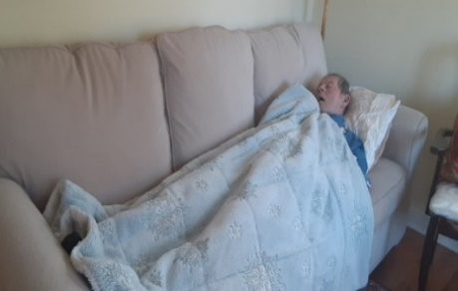
But there’s still more to this story…

Two months ago we began searching for a home of our own so we could have live-in care-givers, as Keith’s Alzheimers progresses. We needed a 3 bedroom house with rooms for visitors, a care-giver, a renter and the return to the lifestyle of hospitality that is our calling. But we did not have enough furniture for such a home. Just as our search intensified, Gloria, who welcomed us to the service this morning, (Christ Community Church) and her sister Brenda offered us Grace and Vic’s furniture, china and glassware. You remember that Vic died of Alzheimer several years ago and Grace just died this year. Gloria had planned to get the furniture out of her apartment by the beginning of December. Our own move into our new place was delayed so David Scoble and two friends from our house church hauled the furniture items from Gloria’s to our garage at Cherry St. It was very costly for that team of 3 because the 6 ½ foot sofa Gloria was giving us did not fit in the freight elevator and Marti, Kun and David had to maneuver it down 3 flights of stairs! In addition, there was also a loveseat, 2 bookcases, a chest of drawers, a large storage cabinet , a large casserole dish, a lovely big soup tureen (a symbol of hospitality), and a beautiful Egyptian picture painted on papyrus with a Tiffany style Egyptian looking lamp to go with it.. They rented a small uHaul it for those things. We had filled my van with boxes of glassware and china the day before! On moving day to our present home we had such an abundance of furniture that we hired a moving company to transport it all – and to save the backs of our friends! With all these gifts we have furnished the 20 x15 ft. family room, all 3 bedrooms, the living room, and dining room and have the china and glassware for multiple use by multiple people in 2022 and beyond! I wanted Gloria to see how Keith had immediately taken to the long sofa so I took a picture and emailed it to her. Here is her response: “Oh, this makes me so happy! Bless the dear man!” I knew both Grace and Vic so well and am privileged to have their precious items in our house. It’s a source pf praise for all of us.

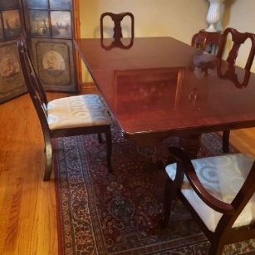
In addition, just before we moved, Michiko from our zoom house church offered another gift of great generosity. Michiko is my dear friend who was a visiting scholar at the U of Delaware 25 years ago. We met at an international Thanksgiving weekend, where I was the speaker. sponsored by InterVarsity International Student Fellowship,.That year she became a Christian and we have been connected ever since. As I described our new house and our hoped-for hospitality, she offered to pay for some things I needed. Three days earlier I had just purchased a lovely mahogany dining room table and chairs for our new dining room through Facebook Merchandise. Michiko’s gift is an equally significant part of our story because she has visited us from Japan twice before and we have sat together around our former dining room table. Now with a “new” dining room table and chairs we can continue sharing meals with people and hopefully Michiko herself can come in the next year to visit us and eat with us!

But that’s still not all . . .Carl Schneider came on moving day and moved all Keith’s clothes and books into Keith’s new room. It was a loving gift to help Keith feel settled in his new home. Now in our new home, from the day we moved in, we have had live-in caregivers for Keith, as well as the daytime caregivers 7 days a week. In addition, Chinese friends gave us $500 – that helped pay half the cost of the moving truck and our son Bruce and his wife Becky sent us another $500 for the new home. You’ll never guess what I did with that money. I went straight to Toms Price and took advantage of the 50% off rug sale and purchased a much needed warm pink rug for my office! That was my one splurge. I don’t normally shop at Toms Price!

So, dear friends, now when you walk in our front door at 1514 N. Washington St. you will see the Egyptian papyrus picture and Tiffany style lamp, an Asian picture of cherry blossoms Marti gave me for my birthday, colorful runners from different countries on the long entry table and dining room table, art objects from all over the world which say we welcome people from many nations, our new rugs in the living room and my office, the family room completely furnished with Grace and Vic sofas etcetera, etcetera, etcetera!

Why is all this a picture of God’s goodness? This is an important spiritual lesson, beloved.

We have owned 8 previous houses in our 61 years of marriage – 5 of them in Wheaton. But in this new home, every single room has been furnished by the generosity of our friends. We thought when we moved to Florida that we were following the Lord’s leading, so we sold or gave away most of our things. But when it was clear God was calling us back to Wheaton, it felt like a financial lose, lose. I had to restock all the things I had given away and my money was all tied up in the house I purchased with Bruce and Becky in Florida. I felt sad and not a little frustrated at the turn of events. But God has done a new thing because God overflows in generous love to us and has given that spirit to His people as well! Our new house is a demonstration of Romans 8:28 – all things work together for good for those who love God and are called according to His purpose. We call this house goodness and mercy!!

So now the challenge I present to you today is for all of us to live in this overflowing goodness of God. I’m sure you have stories too. Let’s share our experiences of God’s goodness and mercy with others – as I have today – to encourage their faith and bring praise to our Lord. Covid keeps turning the world upside down and causing great suffering and uncertainty and unsettledness. But Covid does not have the last word. God does. And we serve a God whose love is unconditional, unchanging and unending!
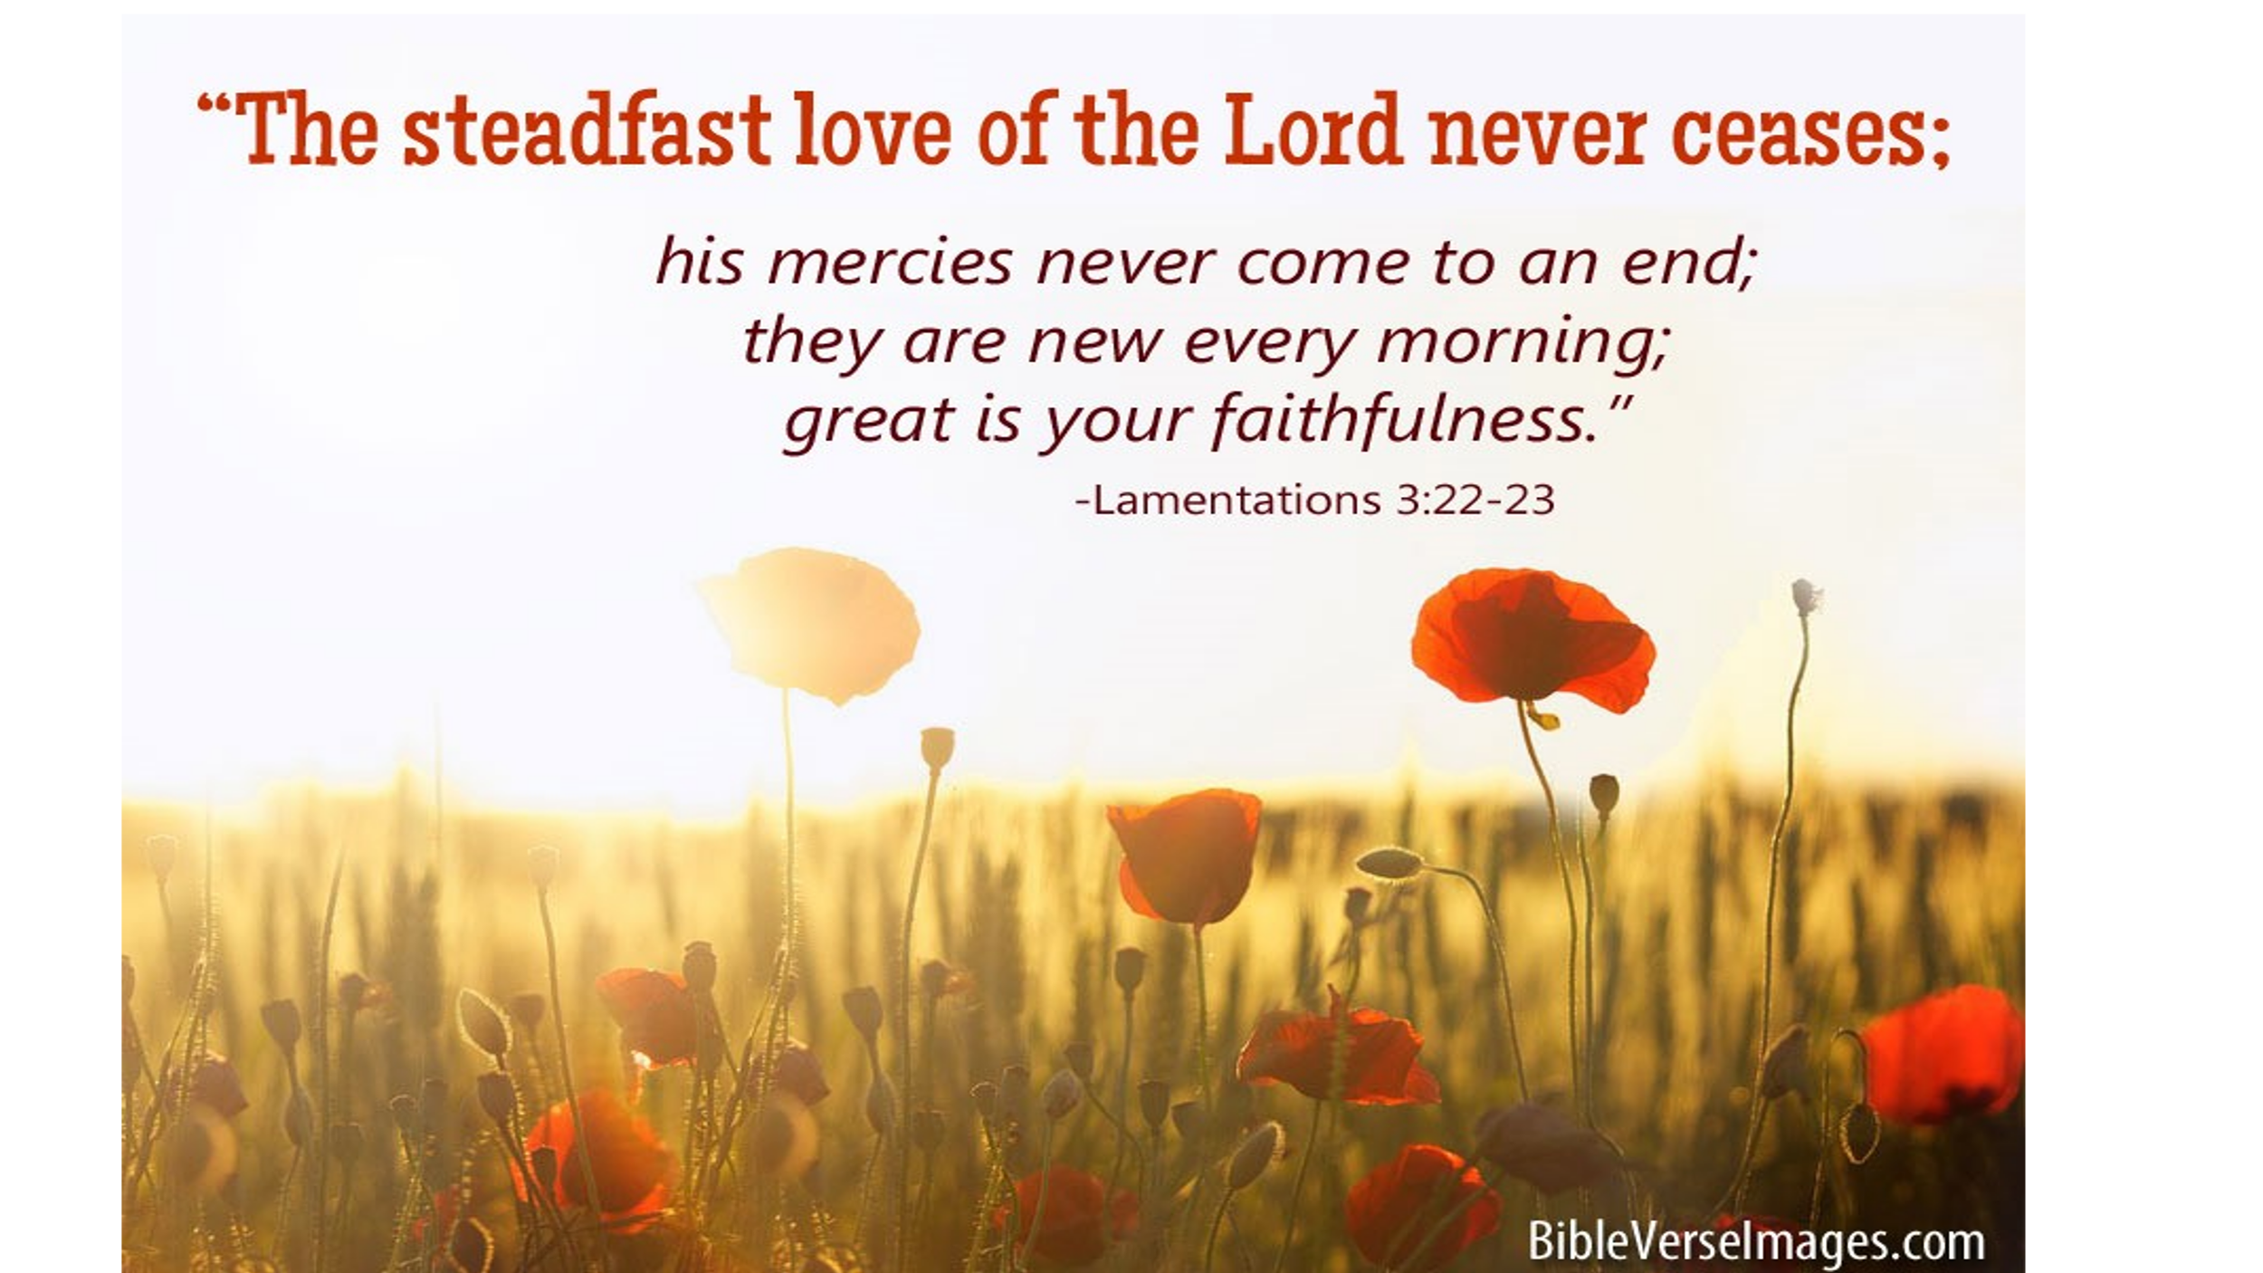
As the verse and song we know so well says: “The stedfast love of the Lord never ceases. His mercies never come to an end. They are new every morning. New every morning. Great is thy faithfulness O Lord. Great is thy faithfulness. “

In that confidence we close with the Don Moen song: God is good all the time. He put a song of praise in this heart of mine. Let’s pray. Amen. Dr. M.L. Codman-Wilson 1 16 22
Pastor New Hope Global Fellowship
Video: God is good, all the time. By Don Moen.

