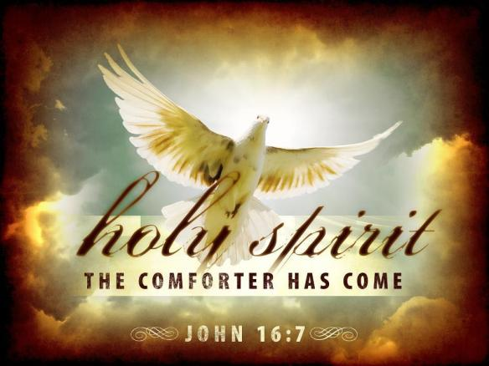
Weekly Sermon The Gift of the Spirit October 9 2022 (PP)

This Sunday we begin a new series on The Birth of the Church. It is all based on the gift of the Holy Spirit to Christ’s followers after His resurrection and Ascension. The Spirit, whom Jesus calls the Comforter, has come!!
(PP)
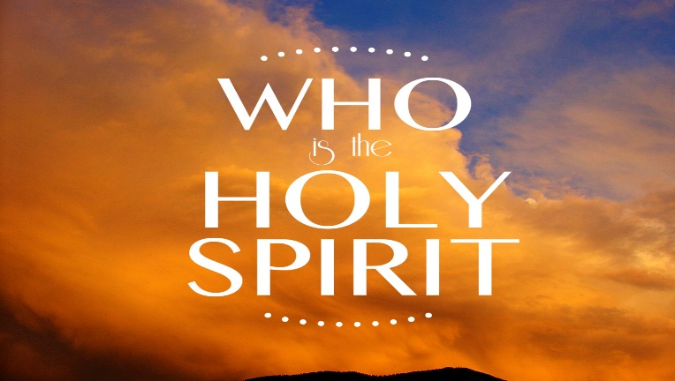
So we start with the question: Who is the Holy Spirit?

Today, I want to introduce the Spirit in a way that connects with our daily lives. Then the series will involve unpacking how the Holy Spirit gave birth to the Church, as seen throughout the book of Acts. Acts has been called the Acts of the Apostles. I think it would be better titled the Acts of the Holy Spirit.

Let me introduce our series with an illustration from Tony Evans:
There was a famous commercial a few years back [and most of us will remember it!] “Plop, plop, fizz, fizz; Oh what a relief it is!” the commercial advertised ? Alka-Selzer!! – a medicine designed to aid an upset stomach. Alka-Seltzer would be activated by dropping two tablets into water. The ensuing reaction is quite volcanic.
When people accept Christ as Savior, God drops the Holy Spirit into our new nature. The Spirit’s presence is designed to bring about a change for upset lives, upset minds, and upset circumstances. God did this so that His people would discover ‘oh what a relief it is!’ (Tony Evans, Tony Evans’ Book of Illustrations, Moody Press, 2009, p. 152)
Let us pray.

The Holy Spirit and the Church
There is much that has passed as Christianity today in the U.S., and around the world that is a form of religion but it is not true Christianity because it is Christianity without the life and power of the Holy Spirit. In the last days, Paul says, “people will be lovers of themselves, lovers of money, proud, abusive, disobedient to their parents, ungrateful, unholy, unforgiving, without self-control, lovers of pleasure rather than lovers of God – having a form of godliness but denying its power,” 2 Tim. 3:1-5. In many churches around the world there is this form of religion – a faithfulness to a denomination, a sense of priority to the doctrines or rituals or structures of church. People can attend regularly and call themselves Christians but this is a basic misunderstanding of God’s intentions about what a Christian is and what church is for.

It reminds me of the story of a little boy and his sister. The boy was taking care of his baby sister while his parents went to town shopping. He decided to go fishing and so had to take her along. “I’ll never do that again!” he told his mother that evening. “I didn’t catch a thing!” “Oh, next time I’m sure she’ll be quiet and not scare the fish away,” his mother said. The boy answered: “It wasn’t that. She ate all the bait.” (GCFL 12/15/99) She had a basic misunderstanding of the purpose of fishing. Bait is important. But you have to use it properly.

So too, structures and rituals and denomination are important but they are to be subject to God’s control, not our control in the church. God is not interested in a form of religion or godliness that has self, rather than the H.S., in charge. And yet this has been the trend. We focus on ourselves – What do we need to do – to be a good Christian or a good Muslim or a good Hindu? How do we need to act? What do we want to ask God about? How do we handle the hurt or rebuff or misunderstanding of others towards us? How do we deal with suffering? But that is the wrong focus. Why? Because we are at the center of it – not God. In Henry Blackaby’s book Experiencing God he says most Christians ask: “How can I know what God wants to do in my life?”

But it’s also the wrong question. We need to ask: “What is God already doing in the world – around me? And how can I connect to what God is already doing to join Him in His purposes?” Then we shift from a self-centered religion to a God-centered religion. God wants a relationship with Him that is made alive through the Holy Spirit. Christianity without the Spirit in God’s sight is dead. That’s why Jesus said to the disciples before the church was born: “Don’t leave Jerusalem until you have received the promised gift of the Holy Spirit.”

In the book of Acts we learn that the gift of the Holy Spirit was the catalyst for the creation of the church. The church became a momentous reality that evolved over time and totally changed history. That is still God’s intent today. The miracles are still available. The guidance is still available. The power is still available. The intimacy with God is still available.

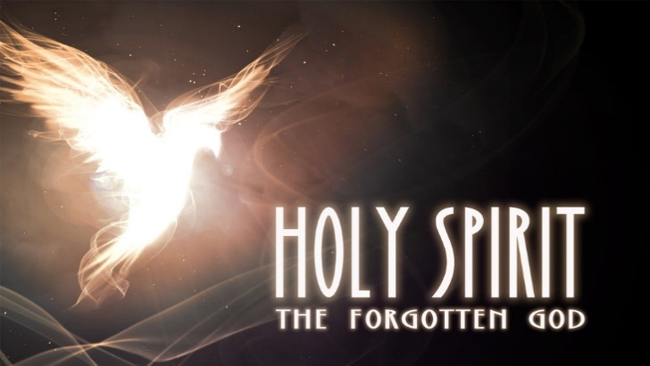
So why do we not see God manifested more all around us? Francis Chan gives one reason: because the Holy Spirit is the Forgotten God. (PP)

Think about it. Religious people will admit that God the Father exists. They recognize God’s hand in creation. They may say the Lord’s prayer which starts: “Our Father who art in heaven.” They often direct their prayers to God the Father. And God the Father is worthy of our worship and hears our prayers. He is the God mentioned in the Psalms.

In the same way people can think of Jesus as a great man, a teacher, a Savior, the One who died on the cross. They may even believe Jesus rose from the dead. They may know the Easter stories of resurrection and Christ’s appearances after his resurrection. And most Christian religious people know the children’s song’ “Jesus Love Me.” Let’s sing it: “Jesus loves me this I know, for the Bible tells me so; little ones to Him belong; they are weak but he is strong. Yes, Jesus loves me. Yes, Jesus loves me. Yes, Jesus loves me, the Bible tells me so. “ That is a wonderful part of the gospel to proclaim.

But God is revealed in the Bible as the Trinity – Father. Son and Holy Spirit. Jesus knew we needed the power of the Holy Spirit to live out God’s purposes in the world, in our churches and in our personal lives. It is the Spirit who makes Jesus real to believers.

The second reason churches may have a form of godliness but lack the power of God’s work in their midst is that they are operating like a sailboat anchored in the harbor with the sails tied to the masts. They have not unfurled and hoisted their programs, their ethos, their purposes like sails to catch the wind of the Spirit and be directed by God instead of themselves.

So who is the Holy Spirit?
When the Spirit birthed the church at Pentecost, it came as wind. Acts 2:2; “Suddenly a sound like the blowing of a violent wind came from heaven and filled the whole house where they were sitting.” (Acts 2:2) New Living Translation calls it “the roaring of a mighty windstorm.” So, we are introduced to the Holy Spirit in Acts first as a mighty wind coming from heaven.

That’s why our symbol of the Spirit this week is wind. Mighty wind. Wind that changed the lives of every disciple in that room on Pentecost and wind that has changed people’s lives ever since.
You can’t see wind. You can see and hear the effects of wind. You can sometimes even feel the force of the wind – as people did in Cuba and southwest Florida this past week when Ian roared through. But the Holy Spirit came as rushing wind at Pentecost - not to destroy but to give birth!

Notice in Acts 2:2 it did not say that the Spirit came as a gentle breeze while they were all gathered there. No! the Spirit came as a powerful wind. A little breeze cannot move a sailboat. A breeze can seem like a relief when it gently moves the still hot summer air, but a gentle breeze is not enough to fill the sails of a sailboat to move it across the water. The meaning of the Holy Spirit as wind is stronger than a breeze. It has more power; it gives more direction. It can fill and change what it touches.

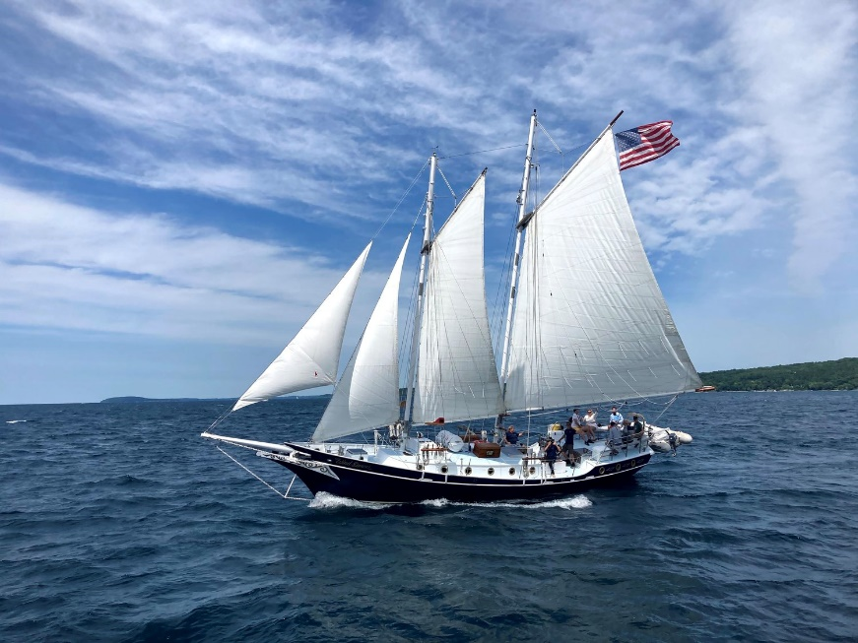
Yet we often seem content with only a H.S. breeze – some little work of God in us and around us that seems manageable, even if it is hardly noticeable. But that’s not Christianity as God intended it. God sent the Holy Spirit as a rushing wind after Christ rose because we need a radical Christianity driven by the wind of the Spirit. The church as a sailboat needs the power of God that can drive and direct and fill our lives so we can do what God only can empower us to be and do.

I bought this sailboat to keep the image of our church as a sailboat in front of us. (bring out the boat, set it on the stand.) Ogden Dunes Community Church is located at the tip of Lake Michigan. Water recreation is a big item here. So talking of the Holy Spirit as wind and the church as a sailboat is a contextual way to present God’s truth!!
How many of you own a sailboat? How many others have been sailing in a sailboat? You know, then, the importance of wind to fill the sails. (We are not counting those sailboats who are powered by motors these days!!)
I have two sailboat stories to start us off.
- Overheard on the marine radio – a distress call came in to the Coast Guard from someone whose sailboat was taking on water. “Help us or we will sink,” the voice said. “Ok,” replied the Coast Guard officer. “What is your position?” Distressed caller: “Vice President, State Street Bank!” Hardly what was needed for the rescue of that sailboat!

- Personally, I am a canoeist and not a sailboat owner. But some years ago I was discipling a young male college graduate. He owned a sailboat and one day asked me to go sailing with him. I love the outdoors, grew up around water, and was a swimming instructor. So I said, “Sure!” There was a gusty wind that day and he took his small sailboat – with no bells or whistles and no motor – and proceeded to get the boat to the edge of the water, get us in the boat and hoist the sails. Then, with great enthusiasm, he began cutting in and out of the wind to get the most power possible from the sails. I was expecting a smooth ride, basically flat along the top of the water. But no. Bill was an adventurous guy and wanted to show me all he could do. So we sailed along at a 45% angle to the water. He was yelling “wahoo” with gusto, and I was yelling “wa-hoo?” in sheer terror, expecting to capsize any moment.

However, that has NOT been my experience with the Holy Spirit. The Holy Spirit embodies all the love and goodness of God. I am safe and I am confident in the Spirit’s hands. The Holy Spirit is God’s greatest gift to us – the gift of Himself dwelling within us! And wanting to be at home in our church!
To continue the breath analogy, the Holy Spirit is the very breath we breathe, the oxygen of our souls. Like wind you can’t see it, but like oxygen you can’t live without it!
Jesus’ Words About the Spirit
It will ground us biblically to hear what Jesus says about the Spirit – just before He died, rose and ascended back to heaven. John 14:15-17 says If you love me my commandments. And I will ask the Father and he will give you another Helper to be with you forever, even the Spirit of trutth whom the world cannot receibe ceasue it neither sees him nor knows him. You know him for he dwells with you and will be in you.”

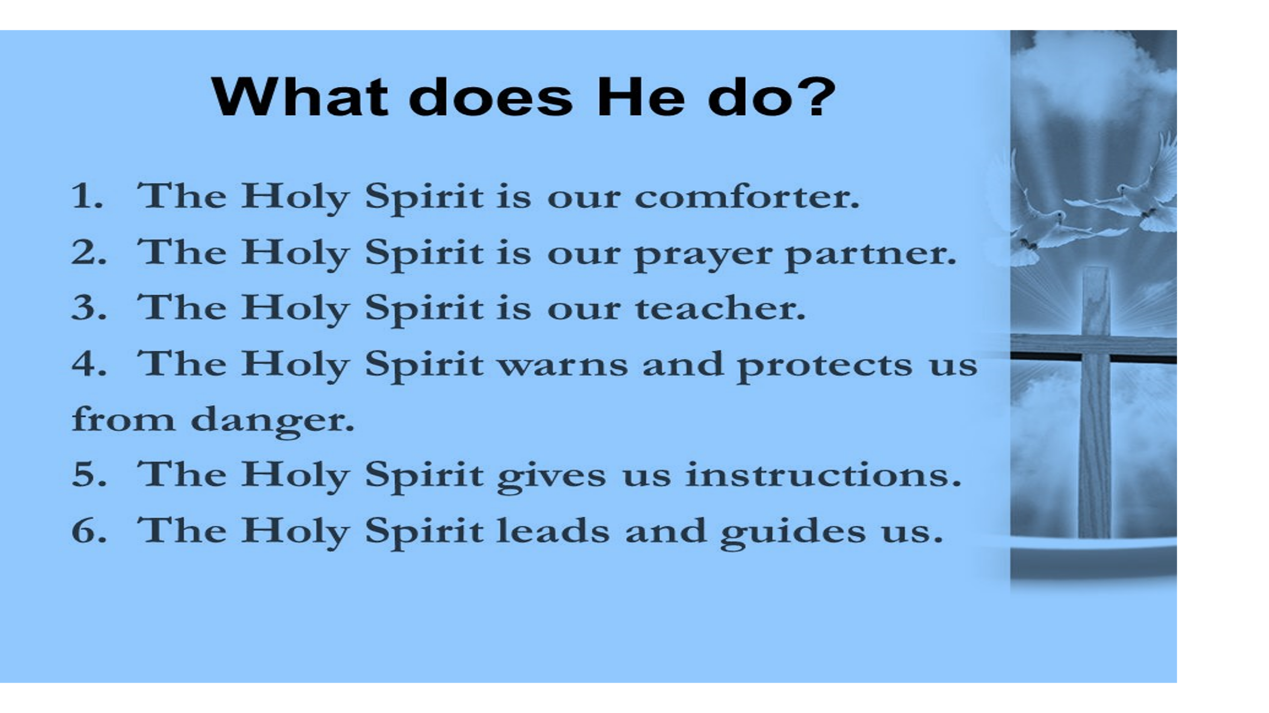
According to Christ’s teaching and the teaching in the rest of the New Testament we learn what the Spirit can do. The Holy Spirit is our comforter, our prayer partner, our teacher. The Holy Spirit warns and protects us from danger. The Spirit instructs, leads and guides us.

All these scriptures began to be fulfilled in the book of Acts. Therefore, we will approach our study of Acts in terms of the role of the Holy Spirit in Acts. That same Spirit so evident centuries ago in the founding of the church is the same Spirit that can transform our lives today.
Jesus called the Holy Spirit a gift from God. It is the Holy Spirit who breathes God’s new life into believers so we are born again. (Jn.3). It is the Spirit who pours God’s love into our hearts (Rom.5:5) and makes us family. It is the Spirit who reveals sin in the world. It is the Spirit who helps people know and receive Jesus as Savior and Lord.
It is the Spirit who wants to fill our church, like the wind fills the sails in a sailboat.

There are many symbols which describe the character and work of the Holy Spirit in Acts. Next week we will examine what actually happened at Pentecost and look at the Spirit as the symbol of fire – with the text: You will receive power when the Holy Spirit comes upon you.
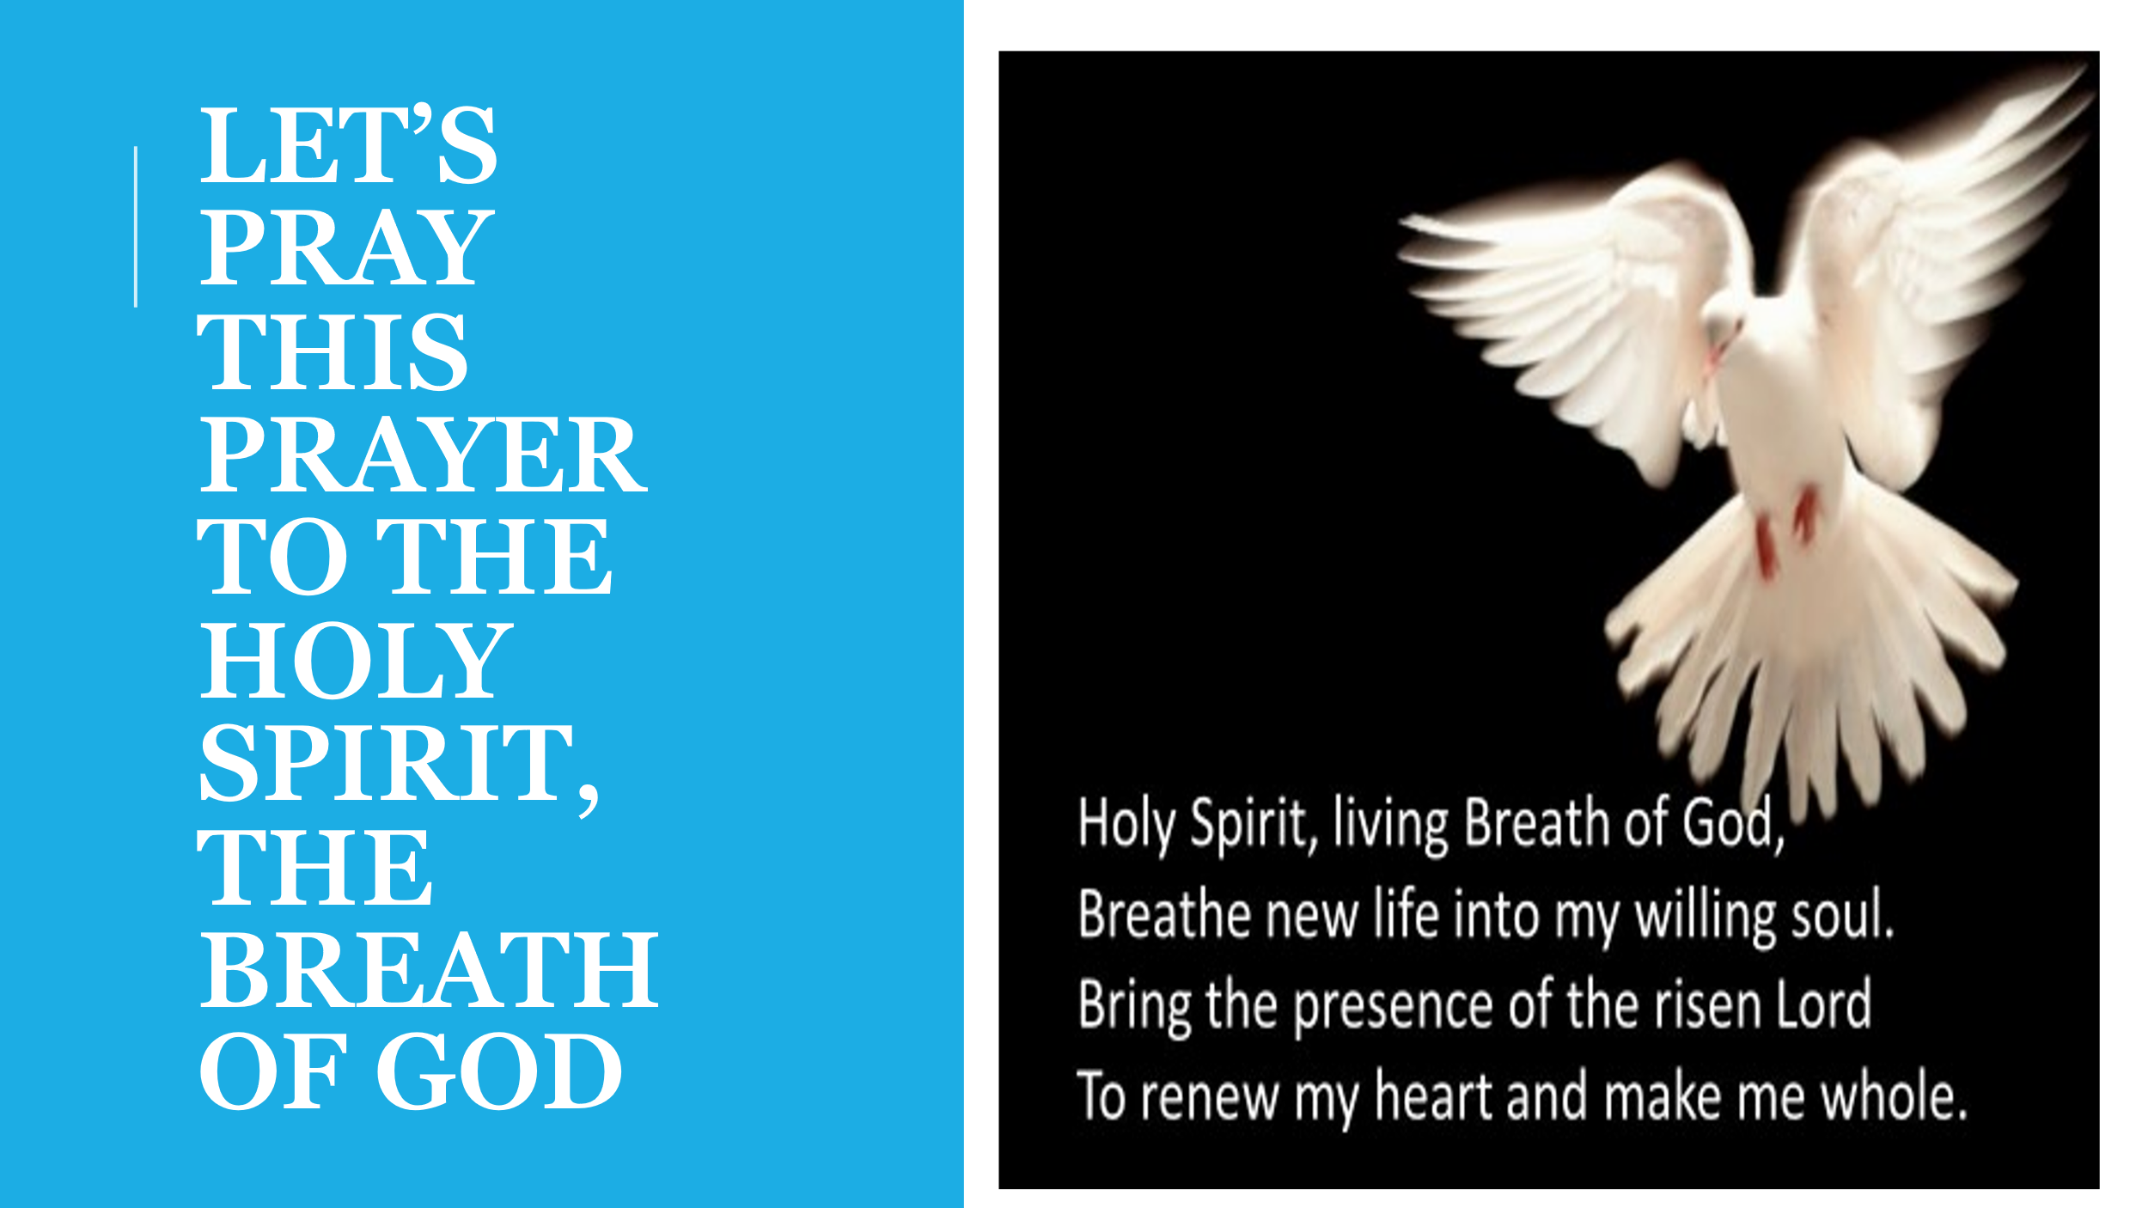
These stories involve one adventure after another. And I am looking forward to that adventure we will share as well as we study how the Holy Spirit birthed the church and gave it its identity, its power, its compassion and its wisdom. May it be so for us too!

Let’s pray together this prayer asking for the Spirit to work in our midst. First we will pray it for each of us individually, as it is printed. Then I want us to pray it together and substitute “our/us” for “my/me”:
Holy Spirit, living Breath of God breathe new life into our willing souls. Bring the presence of the risen Lord to renew our hearts and make us whole. Amen.

Dr. Mary Lou Codman-Wilson
Guest Preacher at Ogden Dunes Community Church. 10/09/22
Pastor: New Hope Global Fellowship

