Sermon: Growth of a Church 10 30 22: Acts 2:42-47 + Acts 4:23-24, 29-31, 32-37

Introduction:
Those of us who love the church and have been part of a church fellowship have many stories of joy and bondedness and even miracles in our midst. But many of us also have stories of pain because the church is made up of sinful people who alienate, wound, slander and abuse people through their words, power struggles, fragile egos and stained glass Christian priority that protects their reputations above all else. Over the centuries the reputation of the Church, to our shame, has a checkered history, the negative fallouts of which need to be acknowledged and repented of. There is no perfect church fellowship.

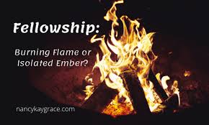
But, God created the church at Pentecost because He knew how much we needed each other to be beside us and help us come to God in all seasons of life. D. L. Moody was visiting a prominent Chicago citizen when the idea of church membership and involvement came up. "‘I believe I can be just as good a Christian outside the church as I can be inside it,’ the man said. Moody said nothing. Instead, he moved to the fireplace, blazing against the winter outside, removed one burning coal, and placed it on the hearth. The two men sat together and watched the ember die out. ‘I see,’ the other man said,” (Keith Long, Room to Grow [Hendrickson, 1999], quoted in Men of Integrity [3.2]).
When we are each walking with the Lord, the church is where we meet together to continually fan the flame of the Holy Spirit in our lives individually and together. We need God’s power and heart kindled fresh in us each week so we can go out to serve the world on God’s agenda.
How can we build and grow that kind of church? Lessons from the early church model can answer some of those questions. Let us Pray

Early Church Context
Just as stained glass Phariseeism was the context for the Holy Spirit’s arrival as fire in Pentecost, for cleansing, so there is an important context as the backstory to the early Christian community described in Acts 2 and Acts 4. First, Acts 2:5 tells us that the people at Pentecost came from all over the known world . Many had traveled long distances to celebrate the two feasts of Passover and Pentecost in the great temple in Jerusalem. (find distances) Motels and hotels did not exist in those days and some of the Inns that did exist were notoriously dangerous and known for their sordid lifestyles, robbery and generally unsafe conditions. So, in keeping with the cultures of the Middle East, most of these pilgrims had likely found food and shelter with friends and kinsfolk from their home cultures. Hospitality would be practiced as people found their own kin and were welcomed in their ethnic communities within Jerusalem. So many of the pilgrims already had some experience of living in community.

But, after the 3000 new converts from Pentecost Day become Christians, these new converts joined the existing Christian community of the 109 or so who were in Jerusalem at Jesus’ command.

I did a good deal of my research for these texts we heard in our Bible reading from the African Bible Commentary because I knew the communal consciousness among Africans would provide wisdom for us in interpreting the communal context of our scripture passages today. So here is my exposition of these two passages with an African perspective!

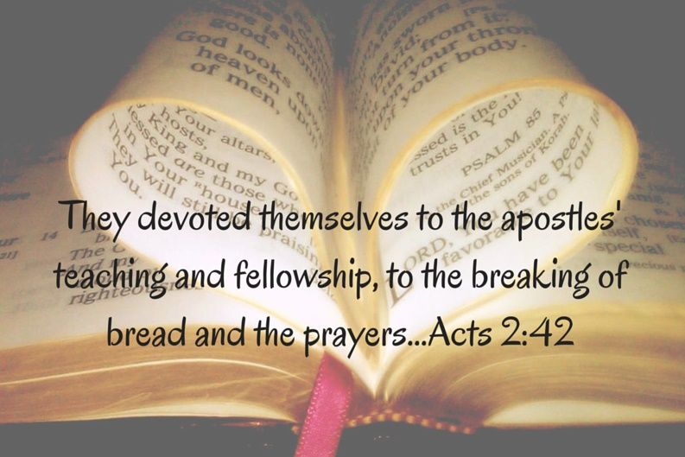
There are several clear, identifiable factors in this new large “church! Acts 2 42-47 says the believers (PP) “devoted themselves to the apostles’ teaching and to the fellowship, to the breaking of bread and to prayer.” African Bible Commentator Paul Mumo says, “The word ‘devoted’ shows that these new believers were willing learners. Their readiness to learn was matched by the apostles’ who were willing teachers.” (Mumo, p. 1303.) That devotion, we learn in Acts 4, turned them into a powerful praying, sharing community. And these two crucial markers of their growing church can certainly be the hallmarks of our church as WE ARE devoted to one another and stick close together.

In her book Grapes of Wrath Or Grace, Barabra Brokhoff tells the story of: “A group of American tourists were taking a bus tour in Rome led by an English-speaking guide. Their first stop was a basilica in a piazza, which was surrounded by several lanes of relentless Roman traffic. After the tourists were all safely dropped off, the group climbed the steps for a quick tour of the church. Then they spread out to board the bus, which was now parked across the street from the church. The frantic guide shouted for the group to stay together. He hollered out to them, "You cross one by one, they hit you one by one. But if you cross together, they think you will hurt the car! They won't hit you." There is always much to be said for unity, especially unity of the Spirit. (Barbara Brokhoff, Grapes of Wrath or Grace (CSS Publishing, 1994), page 12.)

Beloved, one of the things I love most about this church is our fellowship. This is a place where people care and pray and share together, so this is a place where I believe God has laid a foundation that will allow us to grow under the powerful, loving hand of the Holy Spirit – as we stay together, pray together, experience God together and serve together.

United in Prayer
Prayer was one of the uniting factors for the early church. But what they prayed for is rather remarkable. In Acts 4 Peter and John had just been arrested by the religious leaders for preaching about Jesus in the temple and were told they should never preach about Jesus again. Their lives were threatened if they disobeyed that edict. But what did Peter and John do? They went straight to the early church community, laid out their situation and they all prayed together:
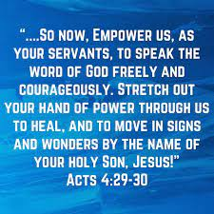
²³ “O Sovereign Lord, Creator of heaven and earth, the sea, and everything in them— ²⁵ you spoke long ago by the Holy Spirit through our ancestor David, your servant, saying,. . .the rulers gathered together against the Lord and against his Messiah.’^{[ 27} “In fact, this has happened here in this very city! For Herod Antipas, Pontius Pilate the governor, the Gentiles, and the people of Israel were all united against Jesus, your holy servant, whom you anointed. ²⁸ But everything they did was determined beforehand according to your will.
(PP) ²⁹ And now, O Lord, hear their threats, and empower us, as your servants, to speak the Word of God freely and courageously. ³⁰ Stretch out your hand of power through us to heal, and to move in signs and wonders by the name of your holy Son Jesus.” ³¹
After this prayer, the meeting place shook, and they were all filled with the Holy Spirit. Then they preached the word of God with boldness.”

They didn’t pray and wring their hands in fear for their own safety. They didn’t pray God’s judgment and suffering on their enemies They prayed for God’s mission to go forward through them! They expected to see the Lord answer with more signs and wonders, confirming the truth of their message. And as the Spirit fell on all of them with renewed power, they went out and were used by God to perform miracles and preached the Word of God with boldness. They believed the Spirit would use them all, not just the apostles in this ministry. Their prayer was generic: “may miraculous signs and wonders be done through the name of Jesus…Give us your servants great boldness in preaching your word.”(v.29-30) Wow! That is Holy Spirit inspired courage. And faith. The anointing of power was requested and received for all the believers as they all were committed to God’s mission and God’s power. And so the Spirit’s continued birth of the church marched on.

Believing prayer by Christians in community still works miracles today. This was true of the prayers of a small West Virginia community when one of their young adults was heroically rescued from an Iraqi hospital a few years ago. Here’s the story:
“Jessica was captured in an ambush on March 23. She was rescued from the Iraqi hospital in which she had been held through the efforts of U.S. Armed Forces. Jessica's grandmother Lynch said, "How could we not feel anything but joy? It's a miracle; a true miracle." She also reported that the rescue could only be attributed to one thing: God and the power of prayer. The community had been praying for Jessica's safe return daily since her capture. At the high school, they even began each day with a moment of silence for Jessica and her fellow POWs. "This community is a community of faith," reported the school principal. "It is very typical of the faith in this community and a firm belief that she would return. We talked about the parade we were going to have when she came home"(Community Credits Prayer with Rescue of Soldier," Presidential Prayer Team website). That parade would be a show and tell demonstration to everyone in that West Virginia town of God’s miraculous power, defeat of evil, and answer to prayer!

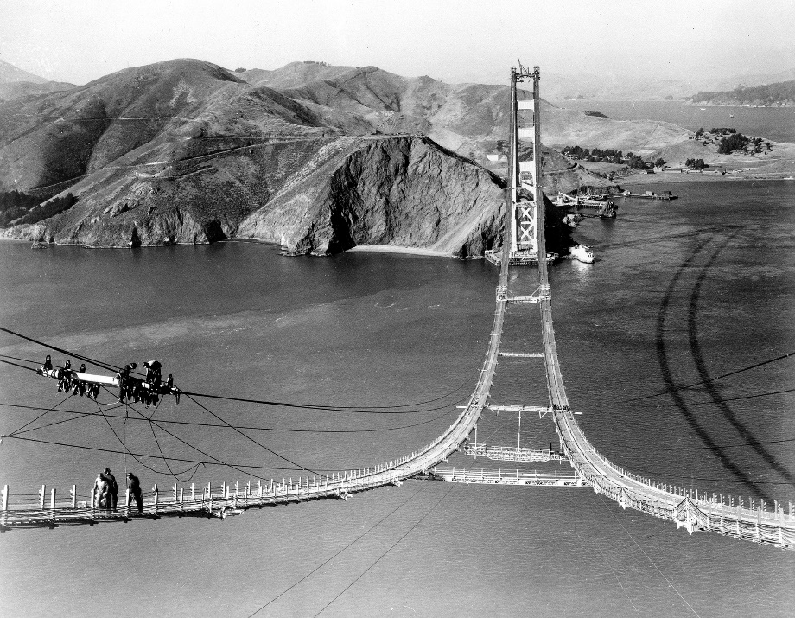
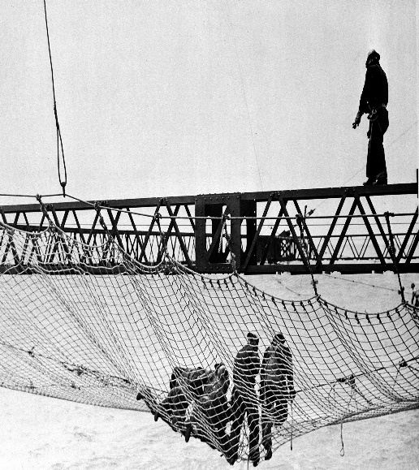
Prayer actually serves as the safety net of a growing church.. A striking example of the value of a safety net is how the Golden Gate Bridge in San Francisco was built. “Newspapers called it the "Dance of Danger"—bridge construction on top of swaying catwalks and high towers, sometimes hundreds of feet in the air, blown by ill winds. (PP) This dance had even yielded a calculated fatality rate: For every one million dollars spent, one life would be lost. But engineers on the Golden Gate Bridge believed the risks could be lowered. When construction began in 1932, numerous safety measures were put into place: mandatory use of hard hats, prescription filtered eye glasses, no show-boating (cause for automatic firing), tie-off lines, and an on-site hospital helped to greatly reduce the casualty rate. After nearly four years of construction and $20 million dollars spent, only one worker had died.
The most effective safety device was the use of a (PP) trapeze net. This large net cost $130,000 and draped sixty feet below the roadbed under construction, extending ten feet to either side. So effective was the safety net that the newspapers began running box scores: "Score on the Gate Bridge Safety Net to Date: 8 Lives Saved!" Those men whose lives had been delivered by the net were said to have joined the "Halfway to Hell Club."
Beyond that, the net had another significant benefit: it freed many of the workers from an often paralyzing sense of fear. And that, many said, helped them work more productively.”

In the church persecution came to these new Christians. early on. There were problems within the fellowship, problems with their families when they returned home, problems from the Jews in various cities where Paul and his team planted new churches, and problems with the Roman authorities who, like the Jews, felt threatened by this new sect who would not bow down to the emperor or king and were accused of sedition and worse. The believers had legitimate fear of reprisals for their faith. For all these reasons and more, they needed to learn how to be a safety net for one another.

I believe this is another role for the growing church community. We become a safety net for one another. When dark times seem to threaten our fragile lives and journey toward wholeness, the church is to be that safety net through prayer, practical helps, scripture and encouragement so we can catch and rescue those who feel they are falling out of control. Robert Lewis with Rob Wilkins, The Church of Irresistible Influence (Zondervan, 2001), pp.140-
141.

Secondly, (PP) Sharing in the early church - one heart and one mind. As v. 34 says “there was no needy person among them.”
Secondly, Acts 4:32 says that the early church had “one heart and one mind.” They shared with one another because they were committed to care for one another and share what they had to meet each others’s needs. They were open-handed with their possessions .

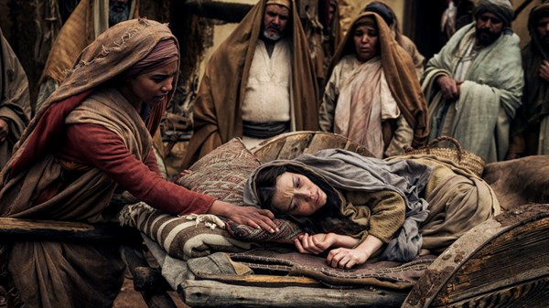
This selfless community life caught the attention of the larger community in which they lived, particularly in the church’s care for widows and orphans. In Roman society such persons were often neglected and subsequently very poor and on the fringes of society. Jewish law said that a widow’s kinsfolk were responsible for her care, but when that wasn’t possible, there were no social services in wider Roman society to take care of these two vulnerable groups of people. With the Spirit’s prompting, the new church stepped in the gap and helped meet their needs. We read in Acts 9 of the model of Dorcas, who was always making blankets and clothing for the widows. In fact, she was such a vital part of the church’s support system for widows that when she died, the church mourned greatly, called for Peter to come to them, and Peter raised her back to life! Similarly, in Acts 6 we read of the daily distribution of food for the widows provided by the church. We will return talk about the issues involved in that service next Sunday! The sharing in the early church had its own hurdles and obstacles to overcome.

Another contextual situation raised the need for the church to reach out and respond. Many new converts from the Pentecost story were pious Jews from around the known world (Acts 2:5) who had come to Jerusalem to celebrate the two holiday feasts – Passover and Pentecost. They would have had enough provisions, perhaps, for that 50 day visit. But when they became Christians, many evidently decided to remain in Jerusalem for a while to “become more grounded in their new faith,” (Mumo, pg.1304l). This would mean they would now be in need of essential sustenance during their extra stay. With the numbers expanding so greatly, it would become more than their individual ethnic communities could provide.

So Christians in the early church who had houses and lands, sold some of these and brought their proceedings to the Apostles’ feet. These sales provided for the extra daily needs of the new converts/sojourners. African Mumo clarifies a misconception about how communal their lifestyle really was. He says “Everyone did not sell all their possessions and put those monies in a common pool. Nor did they live together in exclusive community outside Jerusalem, as did the Qumran community in their desert isolation. . .The verbs “selling” and “giving” are in the imperfect tense, so it was not a continuous daily practice -the selling and giving occurred from time to time (Mumo 1304). It is also noteworthy that the new church’s model of serving one another was “a living out of what was considered an ideal model of friendship in the Greek world,” (Mumo 1305). That meant that their testimony to outsiders was God’s story as “great grace was upon them all” (Acts 4:33). Because of their sacrificial model of service Acts 2 says the church “ enjoyed the favor of all the people and the Lord added to their number daily those who were being saved” (Acts 2:47). Hallelujah! That’s our hope and prayer here at Ogden.

But we are living in a new time in history and so I want to add 3 more roles of the church that we will need to explore in the future. This is the church as a hospital, the church which demonstrates God’s redemptive reign and continues Jesus’ ministry to the world, and a church which is “grace-based and gift-shaped” (Craig Van Gelder, The Essence of the Church, Baker Books, 2000, p. 156).

The Church as a hospital
I believe, through the compassionate ministry of the Holy Spirit in our midst, (PP) the church needs to be a hospital where we pray for, attend to and serve the sick and wounded and help nurse them back to total health. A place where we reach out to minister grace and hope and healing to those in deep distress. Certainly not a place where we “shoot the wounded” through our judgment or rejection or unwillingness to walk with them in their distress.
Calvin Miller walked through Children's Hospital in Omaha not too long ago where he saw a little baby boy under two years of age, with tubes running in and out of his body. He was clearly very, very sick. Calvin asked the nurse about him, and she said, "I want to thank you for asking about him. He will die before he is 2, but the worst part is that his mother died in childbirth and his father's in the penitentiary. Nobody comes; nobody asks about him much, and he lays there. You're one of the first to even ask about him." Calvin walked out of the hospital that day thanking God that his two children were well and that it wasn't his baby. Then it seemed suddenly God spoke to him and said, "Yeah, that is your baby." [As a God’s servants] God wants us to respond with the prompting of the Spirit to the world you see and touch – [especially in and through the church.](Calvin Miller, "The Mind of a Servant," Preaching Today, Tape No. 51)

Tony Evans says “the church is like a hospital where people who are sick, broken, bruised, beaten and battered with life because of sin and unrighteousness come for help.” (Pg. 60 Tony Evan’s Book of Illustrations). Many of us have been wounded or bruised by others or life’s circumstances and found comfort and healing in the church. But I want to expand that concept Biblically: the church as a hospital must be a teaching hospital. It is not only caring for those who need God’s restoration to become whole again, it is also a place where people are equipped to know how to care for others, how to grow in their faith, how to be all God wants them to be. And it takes all the members working together under the Spirit’s direction to make this work.

One of the great blessings that has helped me in Keith’s long debilitating journey through Alzheimers is the Hospice team. His care is being managed by a rather sizable number of people: There is his primary nurse from hospice who visits with him twice a week, a certified nursing assistant who comes 3 times a week, a social service worker, chaplain and music therapist who make occasional visits, the doctor in charge of the hospice team who goes over Keith’s care in consultation with the other hospice workers every two weeks and the 5 individual caregivers I pay who rotate on day and nights shifts each week. There are also so many, like you, who faithfully uphold both Keith and I in prayer each week. That is a priceless gift to me. In the church, as we care for one another, a goal is that no member will suffer alone, weep alone, even die alone. Instead, as a community, we serve each other through each through our different gifts of prayer, counseling, nurture, practical helps, companionship and love. There are wonderful resources like Stephen’s Ministry we can use as we grow in our capacities to carry our healing ministry with grace and gentleness and wisdom.

This week I was also deeply challenged and encouraged by an excellent book I reviewed for my weekly book reviews sent out globally through marylousreviews.blogspot.com. The book is called The Essence of the Church, A Community Created by the Spirit by Craig Van Gelder. . It has affirmed the direction we are heading in this sermon series but also emphasized two additional models of the church I hope we can explore in the future that go beyond fervent united prayer and sacrificial giving in love. Here are the quotes that highlight these two additional roles of the church:

1.“The church belongs to God. It possesses a new nature given to it by God. The church living out of this new nature demonstrates both the reality and the power of God . . .(PP) The church is missionary in nature because God has sent it on a mission in the world under the leading of the Spirit. It is to bear witness to God’s redemptive reign (96,98).
The redemptive reign of God is about the power of God defeating the power of the evil one. (PP) The church is to be a new type of community that lives by God’s redemptive power through the presence of the Spirit. It is about this new community continuing the work Jesus has begun (83).” This reenforces the “show and tell” demonstration-of-the-power-of-God- role of the church mentioned earlier.
Quote #2: “The church’s ministry is to be grace-based and gift-shaped” (p. 156) “ Grace-based and Gift shaped.” I like that and would love to explore those markers together in the future.

Many people today come into a church community and go out the back door because of the sin they see in the members. We all share guilt in that area. But that is why we must be transparent in our own acknowledgement of confession, repentance, forgiveness and praise for God’s mercy and love. There is no perfect church. We will see that as our series continues. But God specializes in using broken people submitted to Him and obedient to the prompts of the Holy Spirit. (PP) God uses a church which IS committed to mirror the ministry and heart of our Lord Jesus.

May God do the same for us so that WE become known as a dynamic fellowship who are devoted to God’s Word, to the power of prayer for others and becomes a blessing and healing presence for those in our larger community

Our community may be small and mostly contained within the limits of the Ogden Dunes neighborhood itself, but when we model God’s redemptive reign, prayer for others and a willingness to love and serve one another sacrificially, we can become a “story for His glory”. Let us pray.

Dr. M.L. Codman-Wilson
Guest Preacher
Ogden Dunes Community Church
October 30, 2022

