New Hope Global Sermon March 2 2022 Great is God’s faithfulness

Introduction
On Friday this past week God brought me face to face with His own faithfulness over the years. In our turbulent times, when so many things seem unstable or deeply distressing, it seems like an important faith lesson for us all to be held firm by God’s faithfulness. It is even a theme found in creation. For those of us in climates where the cold of winter has relentlessly kept most of us indoors, we know that spring is coming. God has built that change of seasons into our geography. In Chicago we may (or may not) have had our last big snow storm, but no matter…we know soon the birds will return, the grass will become green and the flowers bloom again. Even with the ravages of global warming, there is still the promise of spring. God’s faithfulness is such a stabilizing, hopeful reality in our daily life.

So, I open with Lamentations 3:22-23: Because of the Lord’s great love we are not consumed, his compassions never fail. They are new every morning; great in your faithfulness.
And the song:
The steadfast love of the Lord never ceases; his mercies never will come to an end
They are new every morning, new every morning. Great is Your faithfulness, O Lord!
Great is Your faithfulness!
I invite you to sing this chorus in your heart (or out loud!) as we start thinking about God’s faithfulness together. It will put our hearts in a believing, positive framework.

My encounter
So often God’s revelations have a backstory and that is true of what God did for me last Friday. About 3 years ago, after a particularly hard winter the year before, the thought appeared at the back of my mind that it might be good to go to Florida for January and February in the next year. We could stay with Bruce and Becky and avoid the snow and ice and flu and all the downsides of winter. I realized we would have to drive, however, and that posed a problem. Because of my own health issues, I had not traveled distances for several years. Keith’s early stages of Dementia which were morphing into Alzheimers had also kept us homebound. So Marti and I devised a plan that for my day off at least 2 times a month we would take day trips that would get longer and longer to build my stamina. We did this for 7 months. On the Wednesdays when we didn’t travel, we still went on “outings” locally to give me an emotional breather from the progression of Keith’s disease.

One Wednesday in early 2019 God directed us to go to a church in Wheaton that has huge stained glass windows lining both sides of the sanctuary. I recognized God’s prompting in this idea because I love the colors and beauty of stained glass. And it did not disappoint. It turned out that each stained glass window was of one of the apostles - Matthew, Mark, Luke and John - with 2 individual stained glass windows of Jesus as Shepherd and Jesus as the light of the world plus a window each for Paul, John Wesley and Martin Luther! We were surrounded by the greats!! And that began our semi-frequent outings to Gary Memorial church on Main Street in Wheaton. The church architecture is reminiscent of the great cathedrals of Europe and with the sun pouring in through the stained glass windows, it became a refuge, a place of peace, a place where we could pray or sing or just sit in the silence. In 2019 at the church I found myself pouring out my heart to the Lord because of the stress from Keith’s Alzheimers. And time after time God met me there and renewed my strength.

End of backstory. Fast forward to last Friday February 25, 2022.

On that Friday Carl, Keith’s friend, took Keith out in the late afternoon to a café about a half hour away. Marti was here subbing as a caregiver, but that meant she and I were also able to have an outing of our own – something that is an infrequent but precious event this season. The only destination we had was to drop off my taxes for 2021 at my tax accountant’s house. After that was completed, we didn’t have an agenda. It is still winter here, so we couldn’t go on a walk around the lake or enjoy the parks, etc. We did various little side trips and then the thought came to go back to Gary Memorial Church and see the stained glass windows again. The church was actually locked when we arrived and the sign on the outside door said the office was closed for the day. But we ran the bell just in case and were let in by a gracious secretary. We asked if we could go into the sanctuary and enjoy the stained glass windows. I mentioned that my husband has Alzheimers and the sanctuary provided a place of beauty and comfort. She opened the sanctuary, turned on the lights, and let us just be there with the Lord for a half hour. That’s when God’s faithfulness came back to me in force. I remembered the times a few years back when I had cried out to the Lord and His peace and beauty met me there. This time I also walked around the perimeter of the sanctuary and immersed myself in the blessing each of the gospel writers and the Lord Himself have been. It felt like a genuine reunion!

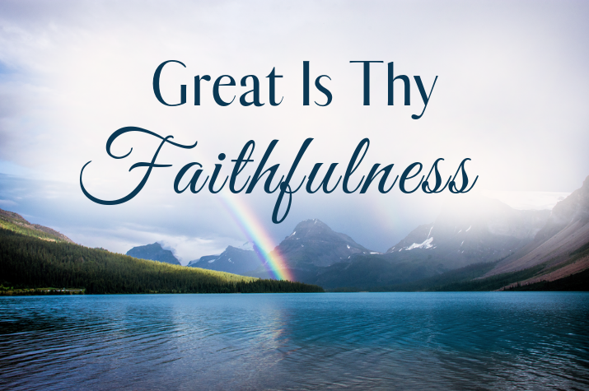
I am still dealing with Keith’s Alzheimers, which is definitely worse, and now face the tragedy of Alzheimer personality change as Keith experiences more confusion, belligerence and verbal abuse directed mostly at me when he is in an Alzheimer state. But God’s faithful love and help over the past three years was the theme that kept coming to me last Friday. God heard me back then 3 years ago and He still hears us when we cry. It is His faithfulness that has been my strength and sustaining power that enables me to press on in Jesus’s name. Morning by morning. Year by year.

That’s my context. But many of you have different contexts for suffering - because of the loss of a loved one, or the trauma of relocations, or war and oppression and unspeakable hardship. In all those contexts, we need the anchor of God’s faithfulness

I’ve chosen this graphic because there is the sense of distance representing years with the mountains receding; there is the mist symbolizing times when our future or even our present it is not all clear; there is the beauty of creation. And, there is the rainbow – a sign of God’s covenant of love that will never be revoked – all encompassing the great faithfulness of our God.

Two other Old Testament scriptures also speak of God’s faithfulness.
- In Psalm 91:4 God’s faithfulness is our protecting shield to keep us from harm.
- Isaiah 25:1, 4 says “O Lord, I will honor and praise your name, for you are my God. You do such wonderful things! You planned them long ago, and now you have accomplished them. . . You are a tower of refuge to the poor, O Lord, a tower of refuge to the needy in distress. You are a refuge from the storm and a shelter from the heat. NLT
Because of Keith’s Alzheimers, I have needed God as my refuge in my destress; I have needed His shelter; I have needed His faithful mercy. And God has been true to His promises. As Paul prays for the Thessalonians in I Thes. 5:23-24:
³ Now may the God of peace himself sanctify you completely, and may your whole spirit and soul and body be kept blameless at the coming of our Lord Jesus Christ. ²⁴ He who calls you is faithful; he will surely do it.ESV

God will do what He has said. These are the truths that came back to me Friday as I reunited with the apostles and the Lord and remembered: “The steadfast love of the Lord [really] never ceases, his mercies [really] never come to an end. They are [and have been] new every morning, new every morning, great is Your faithfulness.”

I believe we can count on this sustaining character of God to undergird each of us in the challenges, the disappointments. the struggles, and the great opportunities God will put before us in this year 2022..

With that confidence, I close with another old classic hymn: ”Great is Thy Faithfulness.” Do sing it as you read the words:
- Great is Thy Faithfulness, O God my Father! There is no shadow of turning with Thee.
Thou changest not, thy compassions they fail not; as Thou hast been, Thou forever wilt be.
Refrain: Great is Thy Faithfulness, Great is Thy Faithfulness, morning by morning new mercies I see.
All I have needed Thy hand hath provided. Great is Thy Faithfulness, Lord, unto me.
- Summer and winter and springtime and harvest, sun, moon and stars in their courses above., join with all nature in manifold witness to thy great faithfulness, mercy and love. Refrain
- Pardon for sin and a peace that endureth. Thine own dear presence to cheer and to guide; Strength for today and bright hope for tomorrow – blessings all mine, with ten thousand beside! Refrain
(words: Thomas Chrisholm, music: William Runyan).
Closing Prayer:
O Lord, how our hearts cry out with gratitude for Your constant love and faithfulness to us in every circumstance, every difficulty, and every possibility You lay before us. Your “own dear presence is what cheers and guides” us. You are the One who gives us “strength for today and bright hope for tomorrow.” You are the One who walks with us through the valley of the shadow of death and calls us to your eternal home (Ps.23:4, Jn.14:3). You have promised “never to leave us or forsake us” (Heb.13:5); You are the One who “multiplies grace and peace to us.” (2 Peter 1;2). You are our All in All. We love You, Lord, and are so grateful You faithfully care for us as Your own dear children! Hallelujah! Amen.
Dr. M.L. Codman-Wilson Pastor, New Hope Global Church, March 1, 2022

