Weekly Sermon September 18 Mission Our text is Col.4:5-6
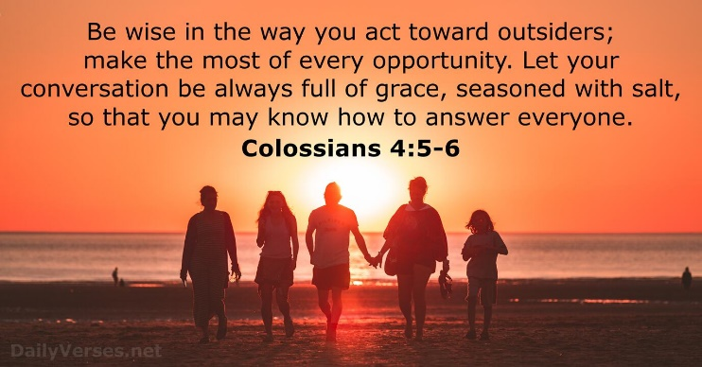

Be wise in the way you act toward outsiders.

Remember this Normal Rockwell painting?
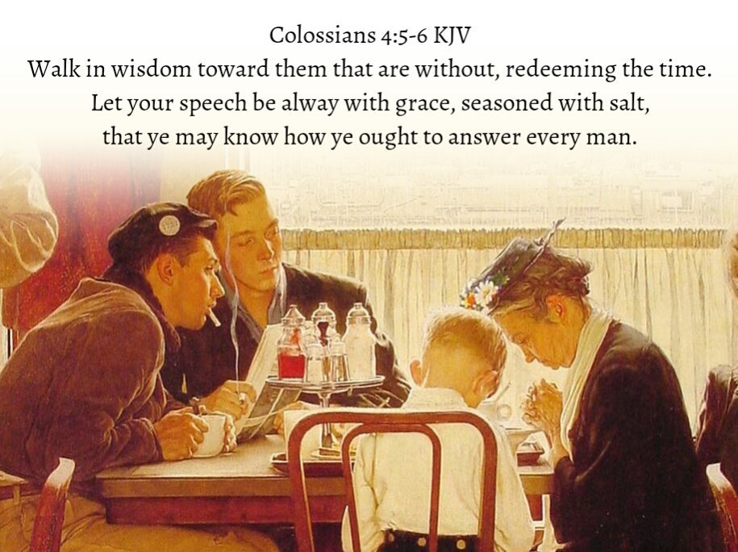
I guess even back then those guys had never seen a lady say grace before! Wonder what the conversation was like when she and her son lifted their heads up from prayer!:) Did she buy up this opportunity to gently explain to those young guys why she prays and who she prays to and then invite them to know her Jesus? Did she listen to their questions? Or endure their scoffing to her face? Did she “know how to answer everyone?

Our theme today is wise witness. Let us pray.

Introduction

In the Passion Translation this Colossians passage reads: “Walk in the wisdom of God as you live before the unbelievers and make it your duty to make him known. Let ever word you speak be drenched with grace and tempered with truth and clarity for then you will be prepared to give a respectful answer to anyone who asks about your faith. “

In the King James version which I memorized decades ago, the Colossians text put our wise witness into the context of “Redeeming the time.” The NIV says “making the most of every opportunity.“ The sense is that we need to make our witness to the reality of Christ a top priority. This causes us some pause, doesn’t it?

So we begin our exegesis of Col. 4:5-6 with a focus on our words. In this graphic that verbal witness has qualifiers, seen in the words “always,” “grace,” and “salt.”

The word “always” is that repeated tendency of the Lord to an all or nothing approach. The word “always” is in the company of the verses using the word “all:”
All have sinned and fallen short of the glory of God. Rom.3:23
Love the Lord you God with all your heart, all your soul, all your strength and all your mind. Mt. 22:37
Rejoice always, Phil.4:4
Do not be anxious about anything but in everything by prayer and petition present your requests to God. Phil.4:6
Whatever you do, do it all in the name of the Lord Jesus, giving thanks to God the Father through him.Col.3:17
“Be joyful always, pray continually, give thanks in all circumstances for this is God’s will for you in Christ Jesusl” I Thes 5:16-18.
Or this famous Old Testament proverb: Prov.3:5 “Trust in the Lord with all your heart and do not rely on your own insight. In all your ways acknowledge Him and He will make straight your paths.”

I don’t know where we get the notion that being religious is only a portion of our life’s priorities, a sidecar if you will, or a spare tire we keep in our car for emergencies. That is self-centered theology and utterly false. The alls have it and need to have us – all of our passions, goals, priorities, thoughts, energies. Everything. This includes our speech and our actions.

We start with a little test on our speech. Proverbs 10:19, 21 says “When words are many, sin is not absent, but he who holds his tongue is wise. . .The lips of the righteous nourish many.” I think the best description of these commands is in Eph.4:29 “Do not let any unwholesome talk come out of your mouth but only what is helpful for building others up according to their needs.” The Passion translation amplifies this: “Never let ugly or hateful words come from your mouth, but instead let our words become beautiful gifts that encourage others; do this by speaking word of grace to help them.” Our Colossians 4 text says “Let every word you speak be drench’ with grace and tempered with truth and clarity.” This is why the psalmist wisely asked God to “set a guard over my mouth, o Lord; keep watch over the door of my lips,” (Ps. 141:3). May our speech always be drenched in grace, as well as truth and clarity.

But a wise verbal witness is more than curbing our negative words or negative thoughts which invariably find their verbal expression. It’s about speaking with grace as we tell others of the great love and reality of God’s salvation in Jesus Christ. We are to redeem the time, making the most of every opportunity (Eph.5:16). Easier said than done. Joe Stowell, president of Moody Bible Institute, tells this story on himself of a missed opportunity:
"It was six o'clock in the morning, and I had just finished my early run. As I passed the local Starbucks, I decided to stop in and get a couple cups of our favorite lattes and take them home to [my wife], who would be waking up. Since the café had just opened, there was only one other person in line in front of me. But it wasn't your ordinary wait-in-line-for-coffee drill. The guy in front of me was in a tense argument with the clerk. In loud and no uncertain terms, the customer was complaining that all he wanted was the copy of the New York Times that he was holding in one hand while he was waving a fifty-dollar bill in the other. The fight was over the fact that the clerk did not have enough change yet to break the fifty-dollar bill, which made it impossible for him to sell the paper.
It dawned on me that this was an early morning opportunity to commit one intentional act of [goodness] by demonstrating the excellence of the generous spirit of Jesus. So I said to the clerk, "Hey, put the paper on my bill; I'll buy it for him." This immediately defused the tension, and the grateful New York Times guy walked away saying, "Thanks a lot. All I have is yours!" Which evidently did not include the fifty-dollar bill. To my surprise, when the barista handed me my coffee, he said, "Mister, that was a really nice thing for you to do. This world would be a lot better place to live if more people were like you."
His comments caught me totally off guard, and I knew that I could say something at that point that would point the glory upward…but nothing came. So I made some self-deprecating remark and walked out, haunted that I had missed a great opportunity to glorify God. As I was walking down the sidewalk, it came to me. I should have said, "Well, this world would not be a better place if more people were like me. But it would be a better place if more people were like Jesus, because he taught me how to do that." I turned around to go back and tell him that, only to remember that by the time I left there was a line waiting for coffee. It didn't seem to me that it would be a great idea to break into the line and make a religious speech. My only conclusion was the thought that I was wearing my Moody Bible Institute hat. So I prayed that he would have noticed my hat. That he would always remember that Bible people do things like that, and that the world would be a better place if there were more Bible people around (Joe Stowell, Jesus Nation, Tyndale, 2009, pp. 80-81).

Our speech seasoned with salt is a bit different!! In biblical times salt was used as a preservative, to keep food from going bad. It was a flavor enhancer certainly but more primarily a preservative. Our witness also need to keep people from becoming rotten inside and outside. It is about our being an ambassador in our words and deeds for Jesus and His kingdom – seeking to maximize every encounter, every opportunity to incarnate our Lord. This is about saying to a friend who doesn’t believe in God or comes from another religion, “I have seen Jesus Christ answer so many prayers I have made to him, can I pray for you now in Jesus’s name?”

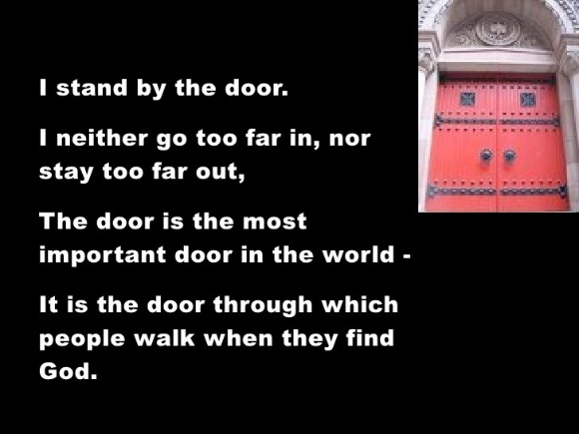
Rev. Sam Shoemaker calls this “Standing by the door.” This poem is his description of his life goal:
There’s no use my going way inside and staying there, when so many are still outside, and they, as much as I crave to know there the door is. And all that so many ever find is only the wall where the door ought to be. They creep along the way – thousands of them, millions of them, like blind men with outstretched, groping hands, feeling for a door, knowing there must be a door. Yet so many never find it… So I stand by the door.
I admire the people how go way in the door –way in to know the heights and depths of God. They may call outside to the rest of us how wonderful it is. But I wish they would not forget how it was before they got in. Then they would be able to help the people who have not yet even found the door. Or the people how want to run away from God. You can go in too deeply and stay in too long and forget the people outside the door. As for me, I shall take my accustomed place… Near enough to God to hear God and know God is there. But not so far from people as not to hear them and remember they are there too. Where? Outside the door – Thousands of them. Millions of them. Bur, more important for me, One of them. Two of them. Ten of them whose hands I want to put on the latch of the door. And help them find God. (Sam Shoemaker – I stand by the Door)

Is that your life passion, too, beloved? To help others outside a relationship with Christ – others who may not even know Christ’s name or believe God exists but who are still groping through life, trying to find meaning, trying to find healing, trying to make sense of their suffering? This passion to help others find God is what the Colossians passage is talking about.

People need the Lord and it is our job to help them find Him.

For the obedient Christian that goal will determine what we do with our lives, our priorities, our time, our vocation. But if God is in it, there will be fruit – eternal fruit – people will be in heaven because we were faithful witnesses for Jesus. Adoniram Judson was such a man.

This American missionary Adoniram Judson arrived in Burma, or Myanmar, in 1812, and died there thirty-eight years later in 1850. During that time, he suffered much for the cause of the gospel. He was imprisoned, tortured, and kept in shackles. After the death of his first wife, Ann, to whom he was devoted, for several months he was so depressed that he sat daily beside her tomb. Three years later, he wrote: God is to me the Great Unknown. I believe in him, but I cannot find him.
But Adoniram's faith sustained him, and he threw himself into the tasks to which he believed God had called him. He worked feverishly on his translation of the Bible. The New Testament had now been printed, and he finished the Old Testament in early 1834. Statistics are unclear, but there were only somewhere between twelve and twenty-five professing Christians in the country when he died, and there were not churches to speak of.

At the 150th anniversary of the translation of the Bible into the Burmese language, Paul Borthwick was addressing a group that was celebrating Judson's work. Just before he got up to speak, he noticed in small print on the first page the words: "Translated by Rev. A. Judson." So Borthwick turned to his interpreter, a Burmese man named Matthew Hia Win, and asked him, "Matthew, what do you know of this man?" Matthew began to weep as he said, “We know him—we know how he loved the Burmese people, how he suffered for the gospel because of us, out of love for us. He died a pauper, but left the Bible for us. When he died, there were few believers, but today there are over 600,000 of us, and every single one of us traces our spiritual heritage to one man: the Rev. Adoniram Judson.”

But Adoniram Judson never saw it! And that will be the case for some of us. We may be called to invest our lives in ministries for which we do not see much immediate fruit, trusting that the God of all grace who oversees our work will ensure that our labor is not in vain. Adapted from Julia Cameron, editor, Christ Our Reconciler (InterVarsity press, 2012), pp. 200-201

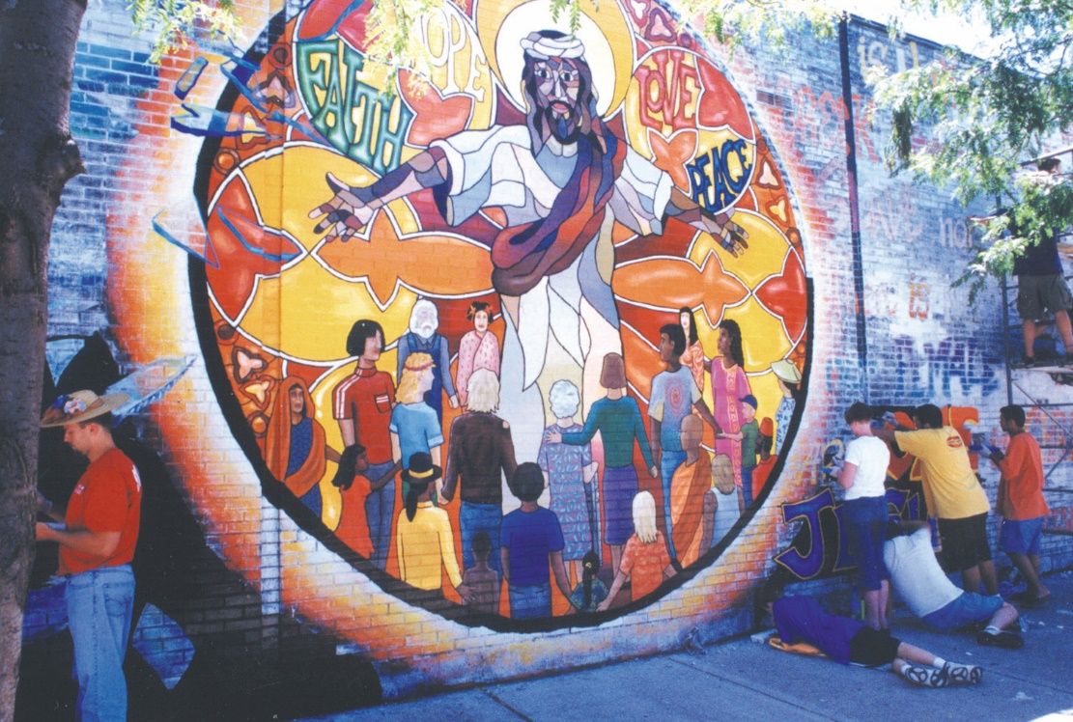
Judson incarnated Jesus as a missionary in Burma through Bible translation. How we witness is the work of the Holy Spirit, using our spiritual and natural gifts. Often it is in actions that this witness has the most power. For example, in Chicago there is an artist named Brian Bakke. He and his family live in the famous Uptown neighborhood – one of the lowest income, most unstable neighborhoods in the city. The neighborhood is known for its gang warfare and multinational mix of peoples from all over the world. Brian is white, but as a witness in his neighborhood he used his artistic gifts to invite gang members to join him in painting a huge mural of Jesus, and Christ’s redemptive message for all people, on the walls of factories and businesses in Uptown. Here is one result visually. The result spiritually is that it brought many street people and gang leaders to Christ. As many became painters in this huge mural project, they learned to know Jesus and His message through that art.

Brian has a passion to see people of every race and culture and language come to Jesus as Savior and Lord. That has been my passion as well.

After Jesus revealed Himself to me and I became a Christian – heart, soul, mind and strength, He gave me this vision of the future: When I stand before Him in heaven, my great privilege will be to say to Him – “Here I am Lord and the children you have given me.” And those “children” will be spiritual children who came to Christ from many nations and peoples and languages. Internationals, Caucasians, young and old – people who have chosen to follow Christ and be His witnesses now, too.

Let me give you a story from that ministry. A few decades ago my Sri Lankan colleague and I founded The Chicago Ashram of Jesus Christ as an outreach to the millions of Asian Indians in our city. We had discussions about the generational tensions in immigrant families between the parents or grandparents recently immigrated to America, who were living as if they were still in India with the same rules and values of their homeland. And the younger generations who were immersed in American cultures and clashed with the Indian rules and values from their elders. We knew of university students who had committed suicide over this issue because they had fallen love with someone on their campus who didn’t fit the stereotype of what the elders insister on. We also had Bible studies that introduced the Jesus of the Bible to our Hindu friends. We developed friendships of love and care.

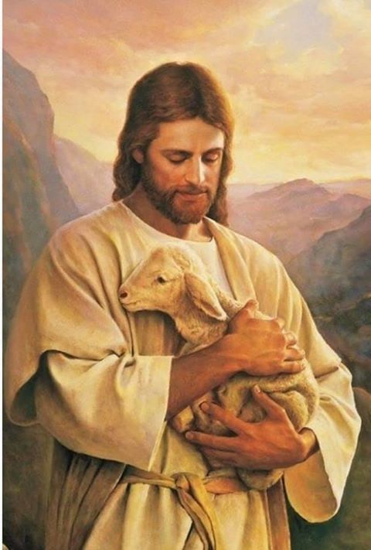
One of my friends was a woman who was a very devout Hindu. She had statues of various Hindu gods in her house, all encased in a large bookcase with a glass door. Every morning, she would open the door and start her worship of these various gods. She read Hindu scriptures, waved incense sticks, and prayed in that worship time. One evening at one of our meetings, however, she said she felt sick in her stomach. We laid hands and prayed for her in Jesus’ name and then encouraged her to go to the doctor to check out the pain she felt intensifying. Turns out she was experiencing what would become a ruptured appendix. She was rushed to the hospital, fighting for her life. She and I had been studying Psalm 23 together so when I visited her in recovery in the hospital, I brought her a picture of Jesus as the Good Shepherd.

It’s the famous picture of Jesus carrying a lamb in his arms. I wanted her to know that He loved her and would take care of her if she turned to him.

When she got home from the hospital, she put the picture on the top of her bookcase with the Hindu idols. And guess what happened? The next morning, all the Hindu idols has fallen over. Only the Jesus picture was still standing upright! We had many interesting discussions about that fact in the days that followed!!

Being on mission for God, buying up every opportunity with our words and our deeds, is an enormous privilege, beloved. But it is also every Christian’s calling. Let me summarize how the Apostle Paul describes this calling with two graphics from 2 Cor. 5:14-20
¹⁴ For Christ’s love compels us, because we are convinced that one died for all, and therefore all died. ¹⁵ And he died for all, that those who live should no longer live for themselves but for him who died for them and was raised again.
¹⁶ So from now on we regard no one from a worldly point of view. Though we once regarded Christ in this way, we do so no longer. ¹⁷ Therefore, if anyone is in Christ, the new creation has come:^{[a]} The old has gone, the new is here! ¹⁸ All this is from God, who reconciled us to himself through Christ and gave us the ministry of reconciliation: ¹⁹ that God was reconciling the world to himself in Christ, not counting people’s sins against them. And he has committed to us the message of reconciliation. ²⁰ We are therefore Christ’s ambassadors, as though God were making his appeal through us. We implore you on Christ’s behalf: Be reconciled to God. 2 Cor.5:14-21
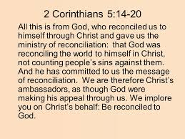
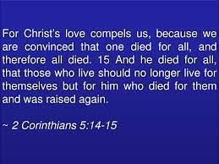
May this be your life goal too, beloved. For Jesus’ sake. Amen.

Dr. M.L. Codman-Wilson
Guest Preacher at Ogden Dunes Community Church 9 18 22.
This sermon is available on Dr. Mary Lou’sWebsite – maryloucodmanwilson.com.

Prayer of committal to God’s global agenda.

Song of Going forth: “Here I am, Lord, is it I Lord? I have heard Your calling in the night.”

Pastoral Benediction

