Sermon: Love God with all your mind

Introduction:
When I became a Christian as a secular college student, I did not believe the Bible. In fact, no one in my entire family tree believed the Bible. I thought the tales of Jonah and the whale and Noah and the ark were fairy tales and couldn’t understand how any intelligent adult could believe this stuff! Still, the teaching I heard about Jesus made some sense as did the lives I witnessed of the men in the conference I attended. They talked about a real relationship with God and answered prayer. Their lives showed integrity and they certainly seemed intelligent enough. So I began a tentative commitment to test God and see God was real, first of all, and if so, could I count on real truth, not fairy tales, in the Bible?

I was told two things by an InterVarsity staff member in those early months of testing out God: #1. “God can outreach but God will never outrage your reason.” That seemed reasonable enough. And #2. “In Jesus Christ are hid all the treasures of the wisdom and knowledge of God” (Col.2:3, I Cor. 1:24). Therefore, those who study His Word, day after day and year after year, will never exhaust the treasures of all His wisdom. An adult Christian would not be doomed to endless reruns of 5th grade Sunday school material, but could actually apply the best of their minds to the Lord and keep learning new things about God and about His Word all their lives.

And it has been so for me. In the 65 years since I committed my life to Jesus Christ, I have always been deeply refreshed and challenged by the truths of His Word. New insights and life applications applied by the Spirit and His Word have proven true over years of putting it to the test!

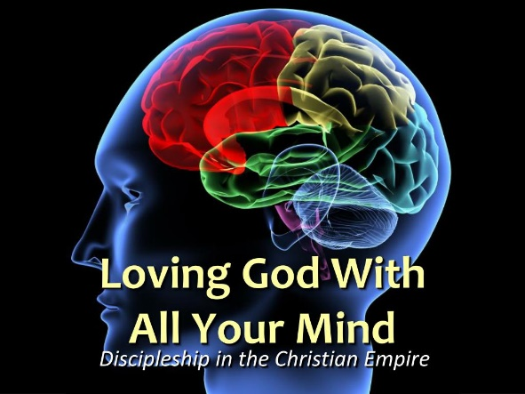
One of the earliest texts that I discovered applied to my life was the Great Commandment – to love God with all my heart, soul, mind and strength. My sermon text this week is based on one part of that Commandment “Love the Lord your God with all your mind.” Mt. 22:37 All your mind. It seems a particularly appropriate topic for our New Hope church members this week (since I am not preaching at Odgen and sharing my sermon with both churches together). When I look at the stats of the educational background of our New Hope faith family, 27 have Master’s degrees, and 15 have or are in the process of earning Phd’s. Forty-two out of our roughly sixty-four members in the last decade equals over half of our church! So I am sharing a topic that many of us have lived out. Plus, each of these members are using their advanced degrees for the glory of God – to serve people in their countries and institutions and non-profits as God leads them. They are loving God with their minds as well as their hearts, souls and strength!

Habits of the Mind
Over the last century there have been remarkable discoveries made in all areas of life by many very intelligent, mostly secular, people who have used their minds to serve others. But there have also been many noteworthy Biblical theologians and thinkers who exemplify what it means to maximize their thinking skills and training for God’s glory. To name a few from the West: Mark Noll, Os Guinness, Francis Schaeffer, Dallas Willard, N.T. Wright, John Stott, Karl Barth, Gordon Fee, C.S. Lewis, J.I Packer, Philip Yancey.
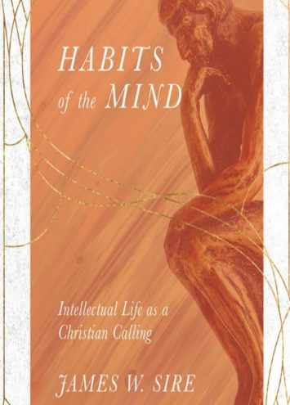
The luminary I want us to learn from today is James Sire. Sire was an apologist, author and senior editor of InterVarsity Press for over 30 years. He died in 2018. But in 2000 he wrote Habits of the Mind. It won the Christianity Today Book Award of the year in 2001.

If you had gone to Sire’s office or home, you would have found stacks and stacks of books. He was an avid reader with a voracious desire to learn and hone his thinking skills so they did truly glorify God. His Habits of the Mind is the book I am reviewing this week, so it seemed fitting to cull out some of his most provocative comments to discern what it means to love God with all our mind.

Before we start, I want to be sure we have none of the failings of intellectualism – a person who “pretends to have more intellect than he has”(p.20) or those who think they “have truth tacked down tight” (p.23) and so become “sophisticated, arrogant prigs” (p.26) or prone to “emotive thoughtlessness or New Age spiritobabble”(p.139- all quotes in this paragraph from James Sire, Habits of the Mind, IVP 2000). In maximizing our minds, we will want to stay clear of the vanity and grasp for power that can be endemic in the university community but ruin a Christian testimony.

So what is a description of a godly thinker?

James Sire said: “I am most interested in encouraging Christians to think and read well. Christians, of all people, should reflect the mind of their Maker. Learning to read well is a step toward loving God with your mind. It is a leap toward thinking God’s thoughts after Him.”

Thinking God’s thoughts after Him is one of the key components of loving God with our minds. Sire further defines this as thinking “with more accuracy, more attention to implications for life, more experience and acknowledgment of the presence of God in whatever is thought.” (p.13) He elaborates on this with a marvelous definition:
“An intellectual is one who loves ideas, is dedicated to
clarifying them, developing them, criticizing them, turning them over and over, seeing their implications,
stacking them atop one another, arranging them, sitting silent while new ideas pop up and old ones
seem to rearrange themselves, playing with them, punning with their terminology, laughing at them,
watching them clash, picking up the pieces, starting over,. . .changing them, bringing them into contact
with their counterparts in other systems of thought, inviting them to dine and have a ball but also suiting
them for service in workaday life.” (pp. 27-28)

A number of factors of loving God with our minds are explicit in this definition. Let’s examine four.

The essential starting point is in a mind devoted to God. Sire links this to a dual devotion to God’s truth and to holiness of life. This essential life-focus is what differentiates a Christian intellectual from a secular intellectual. He says, “ A Christian intellectual is everything an intellectual proper is but to the glory of God.” (p. 88) This means “having a passion to be like Christ” (90)…, a passion not only to know the truth but to do the truth: (91) It means having one’s mind set on what the Spirit desires (Rom.8:5). It is “doing what one claims to know” (p.105). It is a “yearning for knowing more so that we can obey more” (p.113).

He adds, ‘To pay attention first to God in Christ; this is the first task of the Christian thinker. Too many of us are thinking these days as the world thinks because we do not begin our thinking by thinking about God. Only by paying attention to God will we experience the ecstasy that leads to wisdom” (p.135).
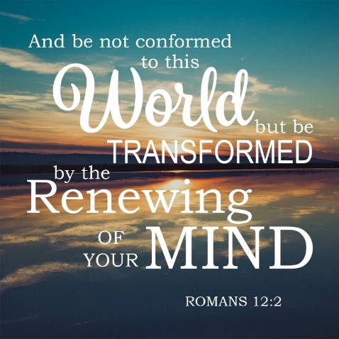
The Bible speaks to this issue directly as well. Paul teaches that there is the unrenewed mind that centers on meeting its own passion and desires and the renewed mind that centers on God. The unrenewed mind is a mind “blinded by Satan so people cannot see the light of the gospel of the glory of Christ who is the image of God.” (2 Cor.4:4). We must choose between these two forces in our minds. The Christian choice starts with letting the Holy Spirit transform our mind. The Corinthians prided themselves on their scholarly, active minds but Paul says, “The man without the Spirit does not accept the things that come from the Spirit of God for they are foolishness to him and he cannot understand them because they are spiritually discerned.. . But we have the mind of Christ. (I Cor. 2:14,16). We live in terms of the Spirit-controlled mind when we surrender ourselves to God – all our heart, soul, mind and strength. Rom.12:1-2 says:
“I urge you in view of God’s mercy to offer your bodies as living sacrifices, holy and pleasing to God – this is your spiritual act of worship. Do not conform to the world but by transformed by the renewing of your mind. Then you will be able to test and approve what
Is the acceptable will of God.
But it’s a constant battle. Joyce Meyer has said, “When you don’t renew your mind, your feelings will always take you back to what you got delivered from.” It is the Spirit who must replace the old negative pathways in our brain with the thoughts that come from God which build up, not tear down. Thoughts that renew one’s mind.

For me choosing this God-ward renewal is how I love God with my mind and that, in turn, is directly related to the ideas the Lord puts in my head. In fact, I have realized that God-inspired ideas are genuine companions. I love their presence. I become absorbed in their implications and interplays as I think of how they will encourage, nurture and challenge others. As King David says, “My meditation of Him shall be sweet. I will be glad in the Lord.” (Ps.104:34, KJV) This is true every time I see how God has given His ideas to me, not for my own sake, but to bring help and hope (and clear thinking!:) ) to others. It is Spirit-directed mind renewal.

And this relates to the second aspect of a mind devoted to God – the idea of playfulness. Sire notes, “The intelligence can only be led by desire. For there to be desire there must be pleasure and joy in the work. The intelligence only grows in joy. The joy of learning is as indispensable in study as breathing is in running.” (p. 132)

When God created the world and declared every part of his creation “good,” (Gen.1:26-27,31) I picture God greatly enjoying that creative process. This joy of a mind devoted to the Lord offsets the misconceptions that an intellectual life is somber, cloistered, judgmental, and b-o-r-i-n-g.

Rather, the mind in playfulness reminds me of Mihaly Czikszentmihalyi’s understanding of flow. One enters into flow in the world of the mind when there is
“a sense of discovery, a creative feeling of transporting the person into a new reality, a push to higher levels of performance and previously undreamed-of states of consciousness. . .a genuine growth of self. . .It is how people feel when they most enjoy themselves. . . when one’s psychic energy is released as one pursues the goals chosen for one’s life and thus becomes a stronger, more confident self” (M. Csikszentmihalyi, Flow, the Psychology of Optimal Experience, Harper Perennial,1990, pp.74,4, 40).
For me in academia in all my studies, it was when the aha’s of congruent ideas came together in the delight of discovery. Now, years later, I still always ask God for His directing wisdom in every task I do, sermon I write, letter I compose, book I am authoring. Then when I see God answer that prayer for wisdom as pieces come together that will bring meaning to others, I experience joy. That is another way to describe the “playfulness” Sire advocates in the midst of serious study and mental work. Pray for wisdom. Seek the ahas. Move with their implication. Help others through your discoveries. Find the joy.

Third, loving God with our mind means our thinking directs our reading. Reading books has always been a source of learning since the invention of the printing press. But now most people in the developing world have access to computers and the issue of selective reading and how one directs one’s mind has become paramount. The internet provides easy access to a vast array of misinformation, scamming content, and false news, all of which rely of distortions of the truth. A Christian must use the discernment and wisdom available through God to distinguish the true from the false. In addition, in reading there must be a thorough “mining of a text for its information, perspective, scholarly insight and the use of critical discernment to see why the writer has made a certain claim and the authenticity of research and reputable scholars who can support or debunk it.“

It never ceases to amaze me how narrowminded people are and how willingly they will trust misinformation if it furthers or confirms their own limited perspective. Spuing out false news and lies has become an industry all of its own. But it is not an industry that should inform thoughtful followers of the truth in Jesus Christ. As Sire says, “we read to learn the truth, to know and participate in the reality God has created, not the reality only imagined by others.”(pp.163-164). But we must read with humility so we can recognize and replace “many of our cherished ideas [which] simply are not true.”(120)
This means we need to read “worldviewishly, (166) i.e., “reading books in terms of the worldview they primarily embody.. . .[This kind of reading] is a vicarious experiential participation in the world of the book and a standing over against the work and asking the critical questions that must be considered as a reader takes on the task of searching for the truth.” (166). The Apostle Paul gives sage advice for the choice of our reading material and its clear effect on our thought life. “Keep your thoughts continually fixed on all that is authentic and real, honorable and admirable, beautiful and respectful, pure and holy, merciful and kind. And fasten your thoughts on every glorious work of God, praising him always” (Phil. 4:8) Passion translation) .
Indeed, “the quality of your thinking determines the quality of your life.”(A.R. Bernard)

And fourth, loving God with our mind means we seek truth in order to serve others; it means we use our mind to think and do, a mind that “suits ideas for service in workaday life.” Not the cloistered, ivory-tower intellectual who makes grand pronouncements from a place removed from society, but a person who is engaged with every aspect of life and chooses to adapt his or her revelations and discoveries to the needs of the very present world outside of academia or the workplace.

The Bible’s foundation for this entire perspective is that we are made in the image of God- the very God who thought and
spoke the universe into being. The mind is an integral, essential part of our humanness. We are therefore thinking
creatures just be being made by God. The Bible also maintains that Christians are to “set our minds on things above where
Christ is seated at the right hand of God (Col3:2)- to determine in our minds what we choose to focus on, prioritize, and
make our life direction. It is about growing to have the “mind of Christ.”
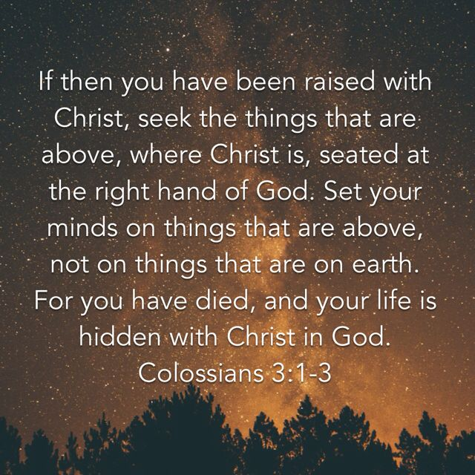
Loving God with all our minds, then, is one of the highest ways we can live for God’s glory – the most significant way we
can be His instruments for peace and growth and wholeness and help in the world. Loving God with all our minds is not a
selfish journey into self-promotion – when we use our intellect to advance ourselves. It is an issue of surrender to God’s
truth in thought and virtue and character - thinking and doing for the glory of God.

In an age of knowledge which puffs up (I Cor. 8:2), we are called to champion the issues, the methodologies, the people
and forces of history, humanity and nature which God has built into universe. We are called to devote ourselves – our
whole selves, heart, soul, mind and strength - to serve God’s kingdom agenda. This should be the life purpose of every
Christian from every culture.

Then, when we choose to live life from this perspective, God will meet us day after day, in His Word, in our reading, in
our interaction with others, in revealing what He is doing in the world, in our pursuit of learning and in our application of
that learning to life itself. As a thinking human, created in God’s image, this makes life worthwhile, challenging, and
satisfying despite all the sufferings and obstacles we face.

May we allow the Holy Spirit to so transform our minds as well as our hearts that we will think God’s thoughts after Him
And then act on them to the glory of His name. Amen.
Dr. M.L. Codman-Wilson 9 2 22
Pastor, New Hope Global Fellowshsp

