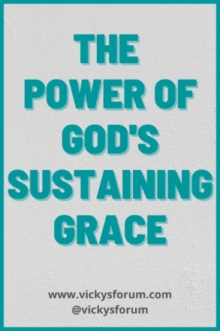
New Hope Sermon 8 /7/22 Sustained by the Power of God’s Word

Introduction:
Often God uses a song or a poem to make his truths real in our lives.That was my experience this week. Many of you know the difficulties of Keith’s journey through Alzheimer’s disease for several years. An incident became acute these past 2 weeks so we had to move him out of his current Memory Care Center back home while we looked for a more suitable location for him. God never left us in our struggles, but Keith’s agitated Alzheimer behaviors continued and I became exhausted.

I am currently doing a sermon series on Living Christ as the guest preaching pastor at Ogden Dunes Community Church in Indiana, and God has been blessing that in amazing ways. But this Sunday August 7th I am not on at Ogden, so I woke Wednesday morning asking God what my sermon should be for New Hope this Sunday. Immediately the Spirit had me singing “Fear Not I am with you. O be not afraid, for I am your God and will still give you aid. I’ll strengthen you, help you and cause you to stand, upheld by My righteous, omnipotent hand.” Other verses also came to mind and I realized it was the words to the old hymn “How Firm a Foundation.“ It is actually a classic hymn from 1787 that is still in most contemporary hymnals today (i.e., Worship and Rejoice #411, The Presbyterian Hymnal #361, The Worshipping Church #612.) As I read through all five verses, I realized this hymn summarized all God has done these many weeks and so it is the framework for my sermon this week. Here are all the verses: (If you recognize it, sing along as you go over the stanzas)
- “How firm a foundation you saints of the Lord is laid for your faith in his excellent Word.
What more can he say than to you he has said, to you who for refuge to Jesus have fled.
- Fear not I am with you. O be not afraid, for I am your God and will still give you aid. I’ll strengthen you, help you and cause you to stand, upheld by My righteous, omnipotent hand.
- When through the deep waters I call you to go, the rivers of sorrow shall not overflow;
For I will be with you in trouble to bless and sanctify to you your deepest distress.
- When through fiery trials your pathway shall lie, my grace, all sufficient, shall be your supply.
The flame shall not hurt you, I only design your dross to consume and your gold to refine.
- The soul that on Jesus still leans for repose, I will not, I will not desert to its foes.
That soul though all hell should endeavor to shake, I’ll never, no, never, no, never forsake”
Let me frame the truths of this hymn in terms of the problems of life, the promises of God and the praises as we watch God fulfill those promises for us. Then you will see how I got the title for today’s sermon “Sustained by the Power of God’s Word!”

The Problems of Life
The hymn describes life’s problems as
- deep waters
- rivers of sorrow
- deep distress
- the fear of being overwhelmed
- fiery trials
- experiencing the pain of a refining process in Christian character
- foes who oppose Christians trying to live out God’s plans for people, nations and the future
- and, all hell which endeavors to shake Christians from their committed walk in partnership with God and in fellowship with one another (often in storms, we tend to isolate ourselves and thus cut off our life support system.)
That’s a pretty all-encompassing list! And there are sometimes very concentrated periods when these problems seem to converge in our lives all at once and threaten to undue us. They are part of Satan’s strategy to “oppress or wear out the saints” (Daniel 7: 25). Satan uses exhaustion, doubt, depression, discouragement, hopelessness defeat – any strategy to “steal, kill and destroy” God’s people and purposes (Jn.10:10). Alzheimer’s Disease is one method Satan uses to achieve those goals. As Keith’s wife and caregiver that is a strategy Satan uses against me. But, as the hymn says, Jesus’ sustaining power is greater and this hymn celebrates Christ’s victory – all based on the sure foundation of His word. Here are the promises listed from the hymn.

God’s Promises
God is our refuge
God’s Word is a sure foundation to build our lives upon
God promises to be with us and strengthen us, help us and cause us to stand upheld by His righteous, omnipotent hand
God supplies us with all-sufficient grace
God makes sure the flames from fiery trials do not burn us. He will bring us through.
God will bless us in our troubles and sanctify us in our distress. He will bring us through.
God promises never to leave us nor forsake us
God will never desert us to our foes (which come against us in force to defeat us in the storms)

Let me unpack the promise of the firm foundation of God’s Word as the umbrella concept behind all the other promises. It brings to mind the parable Jesus told of the two men who built houses – on the sand and on the rock. Most of us who have gone to a beach with children have experienced making marvelous sandcastles. My kids did it with moats and turrets and the whole shebang! But. . .when the tide came in that sand masterpiece disintegrated pretty quickly. However, Jesus says when you build your house on a rock – a FIRM foundation- the waves can crash against it and winds can beat upon the house but it will not fall because it has its foundation on a rock. We build our lives on the Rock when we hear Christ’s words and put them into practice ! Amen. (Mt. 7:24-25) This is why we study and memorize Scripture, beloved. It is our investment and guarantee that God will be our protector; God will be our sustainer; God will keep us from being destroyed by all the battering storms that come our way. God will bring us through. God will bring us through.

Another song comes to mind which describes this place of safety and security. It is Still by Reuben Morgan. In our New Hope House Church Sam Lau taught us that song about 4 years ago, as he faced his own storms. I have never forgotten it and sung it back to the Lord many times since:
“Hide me now under Your wings. Cover me within Your mighty hand. Refrain: When the oceans rise and thunders roar, I will soar with You above the storm; Father, You are King over the flood; I will be still and know You are God. I will be still and know You are God.

Find rest my soul in Christ alone. Know his power in quietness and trust.
Refrain: When the oceans rise and thunders roar, I will soar with You above the storm; Father, You are King over the flood; I will be still and know You are God. I will be still and know You are God. “3 times

It’s the same concept. There is safety under God’s mighty hands. There is confidence in Christ our Rock, our salvation, our Lord who is King over the flood. So we can find rest for our souls despite the storms and be at peace in Him. Hallelujah!

Some Praises as we soar above the storm.
God is enthroned on the praises of His people, so let me enumerate some praises from the last two weeks in my life that prove God’s intervention and sustaining grace in the midst of our battles.

In her book Restoring the Christian Soul Leann Payne notes:
“Christians who enter the battle against the powers of darkness cannot persevere without a life-support system., a supportive fellowship, that continually holds up its members in intercession to the living God… [We need] the foot soldiers who trudge alongside us, persevering in the same battle. Micah 7:7 says ‘as for me, I watch and hope for the Lord I wait for God my Savior; my God will hear me.’ And God does. If we are obedient and stand in Him, our God has an incredible way of turning our battle wounds into healing power for others, even while he is yet pouring his healing grace and light into the worst of our gashes” (LeAnne Payne Restoring the Christian Soul, 1991, p.190).

When I felt the exhaustion and wearing down effect from Satan last week, I texted my needs to a prayer team who supports me. Alex Zhou, my co-author in our new book Supracultural Gospel wrote back in reply from Macau: “Thank you for your update and words about Satan’s attack. Satan always tries to attach/tempt us when we are weak or facing difficult situations. But certainly those are Satan’s lies. God will provide us with the way out. I will continue to pray for you and Keith.” (8/1/22) Similarly other prayer partners wrote expressing their commitment to pray for God’s resurrection strength, great wisdom in handling my situation, peace for Keith and abundant grace to persevere with hope – a vital life-support system!

Similarly, a prayer partner from Florida came to stay for 4 days and was also a gifted caregiver for Keith and me; another friend came to watch Keith (while he was still at home in transition) so my Florida friend and I could have a day of respite at a nearby lake, old friends came down from Wisconsin to our home in Illinois to be with me and help me practically in the home, as well as strengthen my soul; Keith’s sister flew up from Florida for a day to be with him to encourage him; Keith’s hospice team has given me great wisdom and help regarding Keith’s meds, prognosis and care; the people at the church in Indiana (many of them also older Christians) have been amazingly welcoming for me and a supportive community while I am their preaching pastor for these months, and God has faithfully kept speaking to me in His Word and in the victory granted in my own physical body and spirit day by day. God has sustained me by the power of His Word.

2 Corinthians 1:20-21 says “No matter how many promises God has made, they are “Yes” in Christ. And so through him the “amen” is spoken by us to the glory of God. Now it is God who makes both us and you stand firm in Christ.” I have experienced Christ, just as all the promises the hymn How Firm a Foundation has enumerated, at this very difficult season of our lives. As this graphic says:
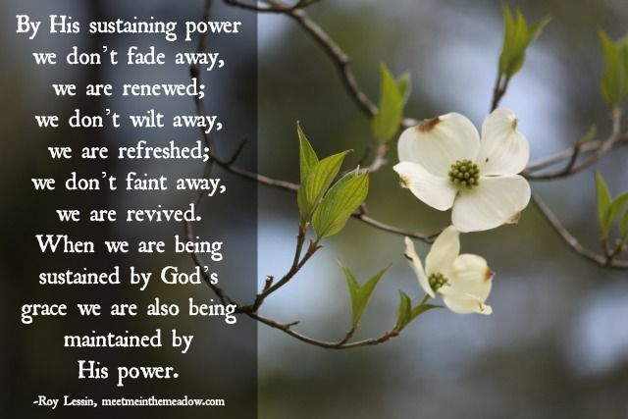

May it be so for all of us. God is our Sustainer, our Victor in the battles we face, our Peace as He shepherds us through them. Amen and Amen.
Dr. Mary Lou 8/5/22

Mary Lou Codman-Wilson, PhD., Pastoral Psychology, Psychological Anthropology, Christian Education and Buddhism.
Pastor at New Hope Global Fellowship, Guest Preaching Pastor at Ogden Dunes Community Church,
Co-author with Alex Zhou of Supracultural Gospel, recently published by William Carey Publishers.

