Weekly Sermon July 2022 God Empowered Forgiveness
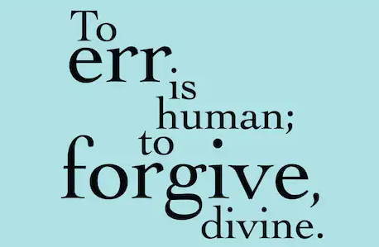
Today our theme is God-Empowered Forgiveness. It’s been said: “To err is human, to forgive is divine.” And how true that is, particularly when it comes to our forgiving those who have wronged us.

Forgiveness is relevant no matter how old you are and if you are married or single. Here’s a testimony from a 50th wedding celebration:
During their 50th anniversary wedding celebration at a banquet in their honor, my Dad was asked to give a brief account of the benefits achieved from being married for so long. My father stood up, thought for a long moment, then said, "Well, I've learned that marriage is the best teacher of all. It teaches you loyalty, meekness, forbearance, self-restraint, forgiveness, and...." he paused.
"And?" someone cried out from the back of the room.
"...and a great many other qualities you wouldn't have needed if you'd stayed single!" my father exclaimed (GCFN 8 29 2016).
Let us pray.

Seven truths about forgiveness
Forgiveness is a very complex, multilayered issue in human life. Sinning is a reflection of our human nature. But forgiveness is an evidence of God’s life in us – our living Christ in the world. So, today I want us to consider seven truths about forgiveness.

First, we need to address the issue of our forgiveness by God. For that to happen we need to acknowledge our sin and confess it to God.
That is not often our first response. We justify, we turn a deaf ear to the Spirit, we minimize, we blame God for our problems, but we don’t confess our sin. What happens is clear in Ps. 32. Hear verses 3-7:
³ When I refused to confess my sin, my body wasted away, and I groaned all day long. Day and night your hand of discipline was heavy on me. My strength evaporated like water in the summer heat. ⁵ Finally, I confessed all my sins to you and stopped trying to hide my guilt. I said to myself, “I will confess my rebellion to the Lord.” And you forgave me! All my guilt is gone. ⁶ Therefore, let all the godly pray to you while there is still time, that they may not drown in the floodwaters of judgment. ⁷ For you are my hiding place; you protect me from trouble. You surround me with songs of victory. NLT
God has built a moral universe so there are consequences in our body, mind and spirit if we do not
confess our sins and repent from them.

God’s intervention after repentance is like the experience this woman had:
She said that as a girl she was poor. In her words: “I grew up in a cold water flat, but I married a man who had money. And he took me up to a place where I had flowers and I had gardens and I had grass. It was wonderful. And we had children.
Then suddenly I became physically sick. I went to the hospital and the doctors ran all sorts of tests. One night the doctor came into my room and with a long look on his fact, said ‘I’m sorry to tell you this but your liver has stopped working.’ I said, ‘Doctor, wait a minute. Wait a minute. Are you telling me that I am dying?’ He said, “I can’t tell you any more than that. Your liver has stopped working. We’ve done everything we can to start it.’ And he walked out.
I knew I was dying. I was so weak, I had to feel my way along the corridor down to the chapel of the hospital. I wanted to tell God off. I wanted to tell God, ‘You are a shyster! You’ve been passing yourself off as a loving God for 2,000 years but every time anyone begins to get happy, you pull the rug out from under them.’ I wanted this to be a face-to-face telling off of God.
And just as I got into the center aisle of the chapel, I tripped, I swooned, I fainted. When I looked up, there stenciled along the step into the sanctuary where the altar is, I saw these words, “LORD, BE MERCIFUL TO ME A SINNER.’ I know God spoke to me that night. I know he did. He said ‘You know what this is all about. It’s about the moment of surrender; it’s about bringing you to that moment when you will surrender everything to me. These doctors, they do the best they can, but they only treat. I’m the only one who can cure you.” And there with my head down on my folded arms in the center of the chapel repeating, ‘Lord, be merciful to me a sinner,’ I surrender to God.
I found my way back to my hospital bed, weak as I was. The next morning, after the doctor ran the blood tests and the urinalysis and so forth, he said ‘Your liver has started working again. We don’t know why. We don’t know why it stopped and we don’t know why it started up again.” And I said in my heart ‘But I know. Oh but I know. God has brought me to the brink of disaster just to get me to turn my life over to him.” (John Powell, Prayer as surrender, Preaching Today, Tape NO. 108).

When King David was confronted directly by the prophet Nathan on his adultery with Bathsheba and murder of her husband., he realized his sin, confessed it and repented. Ps. 51 is his penitential response:
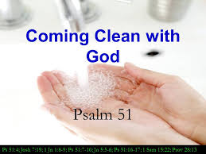
Have mercy on me, O God, because of your unfailing love. Because of your great compassion, blot out the stain of my sins. ² Wash me clean from my guilt. Purify me from my sin.
³ For I recognize my rebellion; it haunts me day and night. ⁴ Against you, and you alone, have I sinned and have done what is evil in your sight. . . .⁷ Purify me from my sins,^{[c]} and I will be clean; wash me, and I will be whiter than snow. ⁸ Oh, give me back my joy again; you have broken me—now let me rejoice. ⁹ Don’t keep looking at my sins. Remove the stain of my guilt.¹⁰ Create in me a clean heart, O God. Renew a loyal spirit within me. ¹¹ Do not banish me from your presence, and don’t take your Holy Spirit^{[d]} from me. ¹² Restore to me the joy of your salvation, and make me willing to obey you. ¹³ Then I will teach your ways to rebels, and they will return to you (V.1-13NLT).

How tragic it is when we don’t get past this first law of the kingdom. We harbor resentment. We rehearse grievances,; we become bitter or wounded,; we want revenge and justice. And we don’t realize that such attitudes create a wall of separation in our relationship with God. In fact, I would venture to add that many times we don’t really understand what God’s forgiveness entails. God’s style of forgiveness is to remove the confessed sin entirely from God’s memory and our memory as well - to cast it as far away as the end of the ocean. And that’s a terrific promise. It’s what we claim each Sunday in our Assurance of Forgiveness in our liturgy. But without our confessions and repentance, the wall between us and God exists.

The problem people face is that Satan and we ourselves often don’t forget the hurt done to us or the sin we caused, so even if God forgives, we don’t let go of the problem. Here’s what one man shared:
I had an entire year without any growth in my Christian life. As I began my third year as
a Christian, I developed a bitter spirit against a brother in Christ. I knew it was a sin to harbor this bitterness, so I went to the Lord and confessed it. On the basis of my earnest confession and God's promises in His Word, I knew He had forgiven me. He buried my sin in the depths of the sea and remembered it no more.
Yes, God had forgotten all about it. But there were two persons who didn't forget--the Devil and me. So, the Devil would remind me of my sin and accuse me of being an insincere Christian. After all, if I were a true follower of Christ, I wouldn't have done such a thing. I would agree, and bring it up to the Lord again. This cycle was repeated for a whole year.
Finally, the Lord made clear to me that I was truly forgiven, and the pattern was broken. I was able to go to my brother and work it out with him as well.
Is your walk of daily discipleship hindered either by unconfessed sin or unacceptance of God's forgiveness? I lost a year of Christian growth because of my failure to believe God's Word.

Second, still on the side of our forgiveness from God, the Holy Spirit has been given to believers to convict us of our sin so it can be confessed.
“A preacher went to his church office on Monday morning and discovered a dead mule in the church yard. He called the police. Since there did not appear to be any foul play, the police referred the preacher to the health department. They said since there was no health threat that he should call the sanitation department. The sanitation manager said he could not pick up the mule without authorization from the mayor.
Now the preacher knew the mayor and was not too eager to call him. The mayor had a bad temper and was generally hard to deal with, but the preacher called him anyway. The mayor did not disappoint. He immediately began to rant and rave at the pastor and finally said, “Why did you call me anyway? Isn’t it your job to bury the dead?”
The preacher paused for a brief prayer and asked the Lord to direct his response. Then he replied, “ Yes, Mayor, it is my job to bury the dead, but I always like to notify the next of kin first!” (GCFN 6/3/02).

I expect when that pastor hung up the phone in his office, the Holy Spirit spoke to him about his attitude and choice of words that tore down and did not build up others. Confession and then forgiveness was in order –because of his harsh words. We trust the preacher heeded the Spirit’s voice and did confess his destructive words right then to the Lord.

Has confession ever been in order for you recently in your relationships? I expect so. The Holy Spirit is still in the role of pointing out our sin in thought, word and dead. May we respond to the Spirit’s prompting, confess our sin, and seek God’s forgiveness as well as the forgiveness of the one we spoke so negatively about or to. God grant us a hearing, receptive heart to Him
Third (and now we get to the harder issue of forgiveness between people): Forgiving others is not dependent on their repentance or their even admitting the wrong they have done. I think this is what makes forgiveness so difficult in so many instances. When we’ve been wronged, oppressed, slandered, hurt for another, we want justice. We want retribution. We want to be immediately healed from the cost of the sin against us. And none of those things may happen. God, of course, will ultimately right all wrongs, but not necessarily in our lifetime. So we need to cry out to the Lord for His mercy and compassion in our situation and for His strength and courage to forgive the other, even if the damage never seems to be rectified. WE need to be free – both within ourselves and with the Lord because holding onto bitterness or woundedness will separate us from the Lord, not just from others around us.
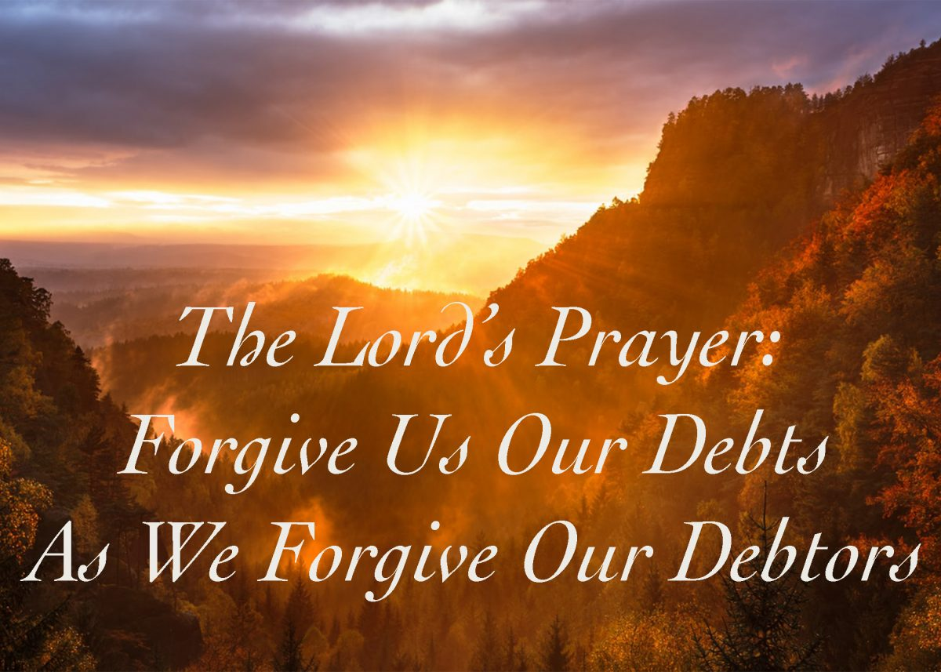
Fourth, the standard of forgiveness in human relationships is AS The Father Has Forgiven You. This is from our text in Col. 3:13. “Bear with one another and forgive whatever grievances you may have against one another. Forgive as the Lord forgave you.”
Do you realize that each time you pray the Lord’s Prayer, you potentially invite burning coals on your head? In praying “forgive us our sins AS we forgive the sins of others against us,” we are signing on to a moral religion and standard we cannot keep. We are inviting God’s judgment and are guilty of holy double-talk. We don’t really want God to forgive us AS we forgive others because then we wouldn’t receive much of His forgiveness at all. Our pious language is called hypocrisy by our scoffers. It’s true, isn’t it? Most of us have enough years under our belt that we can think of someone or several someones in our past whom we have NOT forgiven! So have mercy Lord – and maybe excise this phrase from the Lord’s Prayer?!

Sing song on forgiving others

Fifth, the Holy Spirit has been given to us to do what we cannot do. When Corrie ten Boom and her family were in a Nazi concentration camp for Jews and Jewish supporters in World War Two, they suffered terribly. All her other family members died. After Corrie was freed, years later, she met the chief nurse at the concentration camp who had been responsible for hers and Betsy’s cruelest torture. Immediately bitterness and rage filled her heart and it seemed impossible for her to forgive the woman. She agonized with God over this issue. Here is the story in her words:
I said, ‘Oh Lord, I cannot, I am not able [to forgive her for what she did to us].’ And suddenly I saw it. I cashed the check of Romans 5:5. I said, ‘Thank you, Lord Jesus, that you have brought into my heart God’s love through the Holy Spirit who is given to me, and thank you, Father, that your love in me is stronger than my bitterness and hatred.’ I could go to that nurse, and I could shake hands with her, and I had the joy to be used by the Lord to bring her to this decision for the Lord Jesus. What a joy.”
When God empowers us to do what we cannot do on our own, then comes the blessing of knowing God’s pleasure and feeling the light of His countenance of grace resting on us.

Six: Forgiveness of others, or even of God in this case, involves giving up the hope that the past could have been any different.
In forgiveness we give up the hope that the past could have been different. But to do that we need to “cast all our care onto the Lord” – we leave our burdens with Him – including the hurts of the past which are history now and cannot be taken back. But we also need to give up the anger that they happened. We need to trust God to redeem the past. He can use the pain and suffering we experience to bring His comfort to us so with that comfort, we can comfort others (2 Cor. 1:3-5). He is the God of all comfort, after all. It’s been said that forgiveness does not change the past, but it does enlarge the future (when we can view it through God’s perspective).

And finally, number Seven: God Empowered Forgiveness brings freedom.
Psalm 32:1-2 says “Oh, what joy for those whose disobedience is forgiven, whose sin is put out of sight! ² Yes, what joy for those whose record the Lord has cleared of guilt, whose lives are lived in complete honesty!”

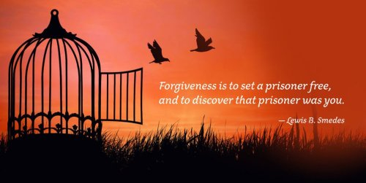
What joy, indeed! Forgiveness brings freedom to our minds and hearts and bodies. It is God’s tonic for our wounded, diseased souls. May God grant us the courage, the wisdom, the grace, and the love to be set free from all the prisons we put ourselves and others in because we tend to nurture our own self-pity or rage.

May we echo Jesus’ words “If the Son shall make you free, you shall be free indeed!” (Jn.8: 36).

To summarize: God Empowered forgiveness involves confession, Holy Spirit conviction, it is not dependent on others repentance, the standard is to forgive others AS God has forgiven you, there is Holy Spirit empowerment to enable us to do this, and help us realize the past can’t be changed, But God’s forgiveness truly sets us free. It is all about what Jesus makes possible in our relationship with God and with each other. So, our song of going forth is “Blessing and honor and Glory all to him.” Let us pray.
Rev. Dr. Mary Lou Codman-Wilson 7 24 22
Sermon for New Hope Global Fellowship
And Ogden Dunes Community Church

