Ogden sermon - Acts 3: The Miracles Begin

Without a doubt, one of my favorite stories in the Bible is captured in this graphic from our text in Acts 3. 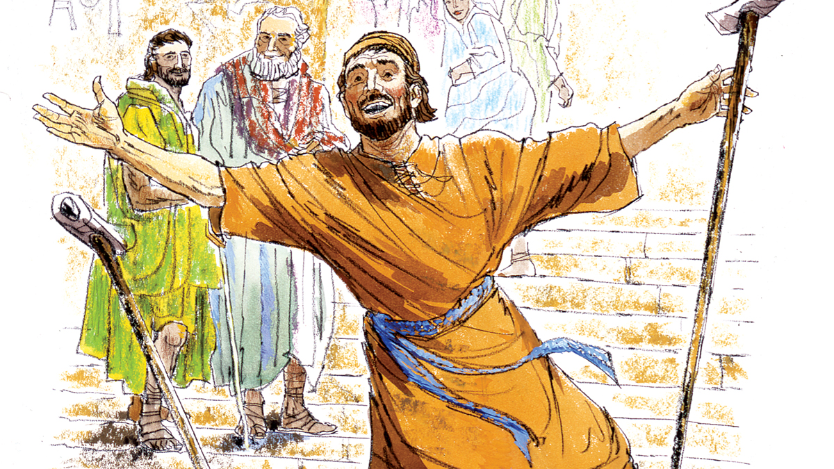

When the Spirit fell at Pentecost, there were tongues of fire and there was a sound of a great rushing, violent wind and they were filled with the Holy Spirit. Acts 2:2-4 This is not just the Spirit coming to live in their hearts – this is power for service and victory –power that would transform those disciples into “men who have turned the world upside down.” Acts 17:6.

The first evidence of that power after Pentecost is a miracle story! It comes from our text today in Acts 3:1-17 (in the Passion translation.) As a result of three different components in this story, the new church birthed in Pentecost almost doubled and grew by 2000 new converts! As we think about our future here at Ogden Dunes Community Church, think about what could happen if we even caught portions of this model! The three components are the power of miracles, the power of witness, and the power of the proclaimed Word of God. We have the same Holy Spirit the early church did, so let’s see what the Lord might want to do among us from this marvelous story.
Let us pray.

First, the power of miracles.
The healing of the lame beggar was a “dynamic powerful work of the Spirit.” It was a definite miracle! Secular people and atheists don’t believe in miracles so let’s first define what constitutes a miracle. A miracle is a “periodic and temporary interference with the laws of nature so that God’s presence, power, and/or purpose might be understood.” The very reliable secular Websters New Collegiate Dictionary defines miracle as “a “an event or action that apparently contradicts known scientific laws and is hence thought to be due to supernatural causes, especially an act of God.”(2008, Wiley Publishing, p.919). Now, of course, since by definition secularists, agnostics and atheists don’t even believe in God, they will not accept supernatural causes for anything! But their presuppositions have blinded them to the true reality – beyond scientifically proven facts. Miracles, acts of God, exist!

Actually, since the coming of the Spirit at Pentecost, there have been innumerable miracles around the world over the centuries. Often they have been done in more private, even remote village settings or explained away as the act of medicine and doctors. But miracles ARE happening even today – miracles that point to the reality of God, His answers to prayer, and the healing power of the Spirit. Let me start with such a miracle story from a fairly remote hospital in Kenya run by Christians:
Sahome Wanjiru, 10 years old, had been motionless and in a coma for two weeks when Mercy came to speak with her mother. Mercy, a Kenyan and long time hospital chaplain at BethanyKids, is a ray of hope for mothers who are in despair. Mercy’s words that day would prove to be life changing for Sahome as well as her mother, Mary.
Sahome was admitted to the hospital with a severe case of meningitis. Not long afterward, she slipped into a coma. There was nothing else that could be done; the child was going to die. After two weeks, Sahome still lay in a coma with no hope of recovery. Mary no longer felt scared or hopeful. She was detached from her child and unable to cope with the pain---waiting for the death she knew was inevitable. This is when Mercy sat her down and forcefully said, “No, you will not lose hope. If you give up now, your child will die.” She explained to Mary that the Lord has given her authority for her child, and what Mary needed to do was pray fervently. “Just as Hannah gave the life of her son, Samuel, to God, so must she offer Sahome to the Lord”---to approach the throne of God with confidence on behalf of this child who could not speak for herself.
At this, Mary began to pray. “Mercy was right,” she said. “God had given me this child and it was my responsibility to pray for her.” Mary called home and instructed her village to pray. For hours a day you could find Mary leaning over her sleeping child in prayer. She was not pleading with the Lord, but rather confidently confessing to God and everyone else that her child was going to live. “In the name of Jesus Christ,” she would pray, “Sahome will live.”
Two days after Mercy spoke with Mary, the 10 year old woke up. The following day she no longer needed her breathing tube. Her feeding tube was removed after that. Two days later, the nurses were able to remove her catheter. For a child who was labeled “Do Not Resuscitate”, Sahome had come a long way. She spent two weeks as an outpatient before sitting down with me to tell her story, 100% healthy. The Lord chose to heal this child, but more than that, honored Mary’s faithfulness and commitment. It has been five weeks since Sahome slipped into a coma, and today her smile is as bright as ever. She knows the Lord has healed her, and she will never forget it. And all those associated with the Bethany Kids ministry and the Bethany Hospital near Kijabe Kenya will not forget it either!
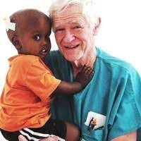
I know of the story because the head doctor of that hospital was Dr. Dick Bransford – he was part of our Baltimore college/graduate ministry in the 80’s while he was training to be a doctor at Johns Hopkins School of Medicine. He just died this past July but his acclaim globally is outstanding. Here is what was written about him in a release from Johns Hopkins School of Medicine May 31, 2022:
The Johns Hopkins Alumni Association has bestowed its Knowledge for the World Award to Richard Bransford, M.D., a 1967 graduate of The Johns Hopkins School of Medicine. The award is given once every two years to distinguished alumni for their humanitarian achievements. . . Bransford’s work as a globe-trotting surgeon and a medical missionary has touched the lives of thousands of disabled children in some of the world’s most disadvantaged regions.
“Dr. Bransford and his family moved to Kenya in 1977 where he became a rehabilitation surgeon at Kijabe Hospital in 1978. In 1998, he founded the Bethany Crippled Children’s Centre adjacent to the hospital and served as its medical director and rehabilitation pediatric surgeon until 2004. The center is a 36-bed facility that provides treatment for burn contractures, hydrocephalus, spina bifida, cleft lip and cleft palate, club feet, polio, cerebral palsy and muscular dystrophies. In 2004, Bransford co-founded BethanyKids at Kijabe Hospital, a 67-bed facility that has become widely known in Africa as a referral center for disabled children and is supported by a network of 14 outreach clinics across Kenya. He is honored as a physician who has dramatically improved health care internationally.
Because of our long-term connection with Dick Bransford, we know of the miracle stories associated with his work in Africa; some of those stories have certainly found an international audience. But our miracle story in the early church had an even greater global impact. This miracle was done in a very public, very sacred space, at a prominent time in the day when many pious Jews had come to the Temple for the 3:00 pm prayer service. And at a very prominent time in history when the Holy Spirit was launching the newly created Christian Church after Christ’s ascension. Many of the Jews involved in the miracle story of the healed cripple had witnessed and called for the crucifixion of Jesus Christ. Now, these same men personally witnessed the reality of the miracle attributed to Jesus Christ’s risen power after his ascension. The power of Jesus Christ in miracles is dynamic and real.
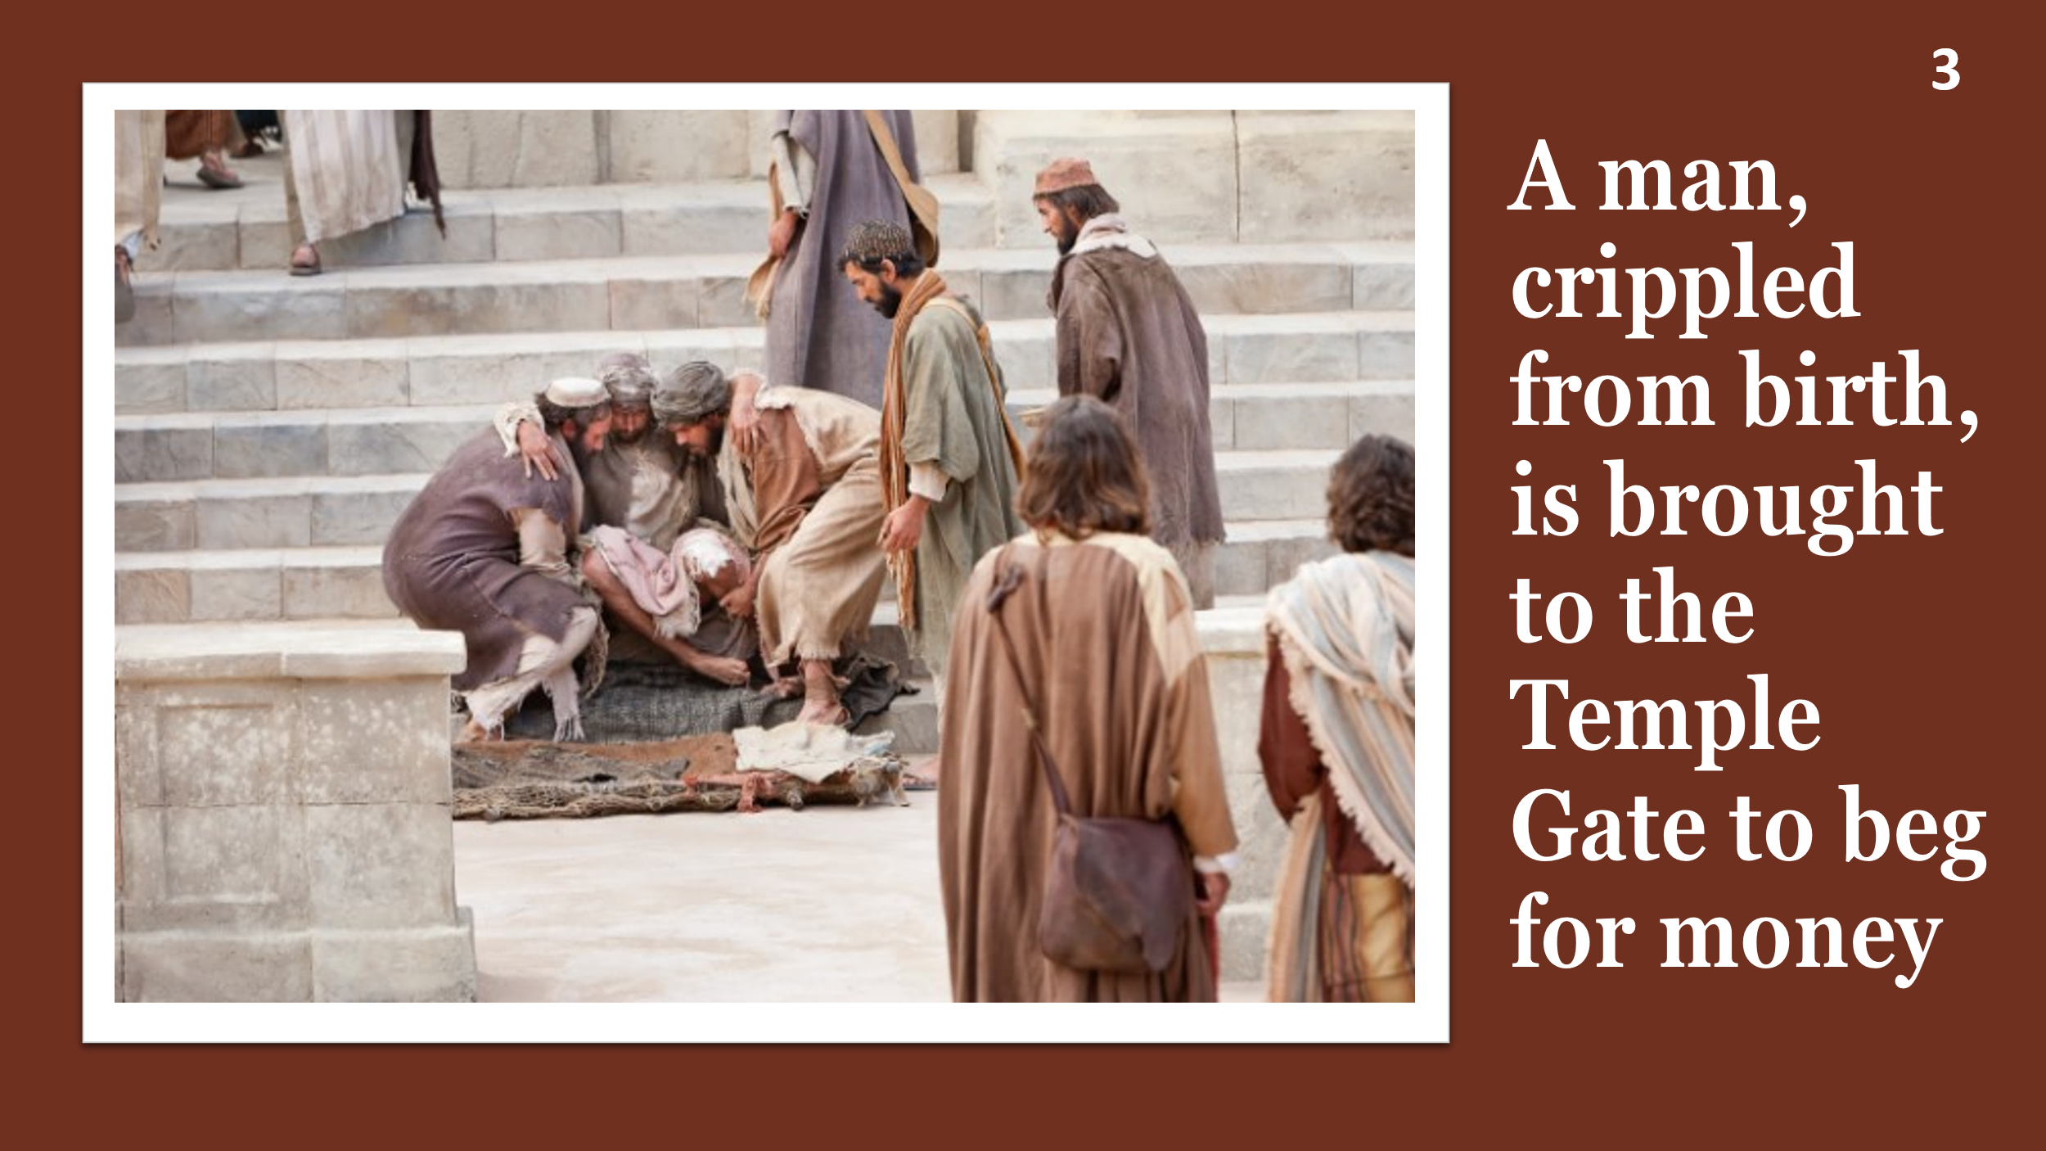
2 The Power of a Witness
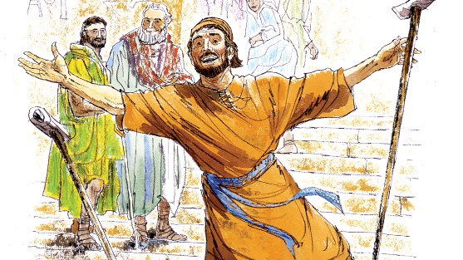
There is also the power of witness involved in this story. The man healed was a lame beggar whom the pious Jews at the 3:00 pm prayer service recognized as the one laying outside the temple gate . He had been crippled since birth and was often brought to lay outside the temple and beg for money. Now, he was inside the temple leaping and shouting praises to God! He created quite a commotion with his jumping and loud shouts of praise. Most prayer services in many religions are pious, rather somber, quiet affairs. But not this time. Not by this man! Verse 10 in the Passion translation says “Astonishment swept over the crowd for they were amazed over what had happened to him.” So amazed they then rushed to where Peter and John and the beggar were “standing” by Solomon’s Porch in the temple. This was not a small, though equally significant, miracle done in some remote area of the world. This was center stage in the Jews’ most holy place right after the death, resurrection and ascension of Christ. It was a miracle witnessed by hundreds of religious temple-going Jews. In fact, the result of this miracle was that many more believed in Jesus – with the numbers since Pentecost when 3000 believed, now reaching 5000 men! (Acts 4:4). The overt witness of the healed man was a major factor in their belief.
In application, beloved, how enthusiastic are we in church over the evidence of God’s miraculous interventions in our lives? I am so glad that we have time for both joys and concerns in our worship service at Ogden and celebrated when both Sue and Peggy gave testimonies of praise last week.
In our house churches I also always allotted significant time for praise sharing and shortened my sermon time because I believe these witnesses can easily become the high point of our worship together and may be the best sermons we will hear that day!

Prior to the house churches, in my work as a Young Life leader in my college days, we had a song that involved this kind of enthusiasm the cripple demonstrated. Young Life is a high school outreach so the energy can be boundless! The song was “Let the redeemed of the Lord say so, say so. Let the redeemed of the Lord say so!!” With each repeat of that chorus, the volume of the singing often turned to loud shouts of praise. It was attention-getting to be sure!

Now this is a different time and we are older adults BUT some of the issues we face do have huge implications and so when God answers strongly, it will be a time of ostensible celebration, maybe meriting jumping and leaping and praising God! I hope we will become more free to be living “show and tell” Christians at worship. That will mean that when newcomers or old former members return to worship, they will see that God is alive in our midst and want to join in what God is doing here! As a safeguard not to touch God’s glory in this process, we need to give our testimonies not as stained glass Christians, drawing attention to ourselves and the power of our prayers etc, but as transparent Christians, drawing attention to the power and love and mercy of our Lord Jesus who lives in us and dwells in our community among us.

3. The Power of the Spoken Word
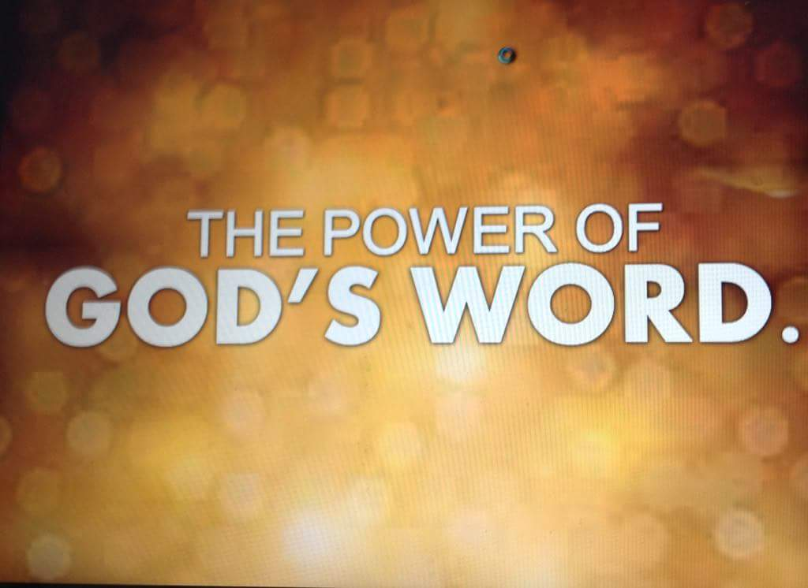
That miracle in the Temple in the early church doubled the new church’s membership. That’s an awesome goal and model maybe God can do with us. But there is a third factor that had a direct effect on the outcome– Peter’s sermon. When all those stunned Jews came racing over to Peter and John and the healed man standing in the temple, Peter began to preach to them. Preach as he had at Pentecost with the tongues of fire over him that gave power to his words. It was quite a sermon and his progression also has application lessons for us.

Peter started with the Patriarchs, not first with Jesus. He went from “the known to the unknown.’ (African Bible Commentary). This is wise strategy any time we are sharing the gospel. Actually, in Muslim outreach, this principle has become pivotal to the success of bringing Muslims to Christ. They also believe in a transcendent God and the prophets Abraham, Isaac and Jacob. As Christians study the Bible with Muslims, they start at Genesis, and participants learn how God becomes real in their daily lives. Then over time and experience of God’s truth in the Bible, the Muslims become more open and are willing to reconsider the Biblical truths about Christ’s death and resurrection. Connecting to common ground we share with our hearers is very important.

Peter also immediately deflected any credit being given to him for the power of the miracle. (He was demonstrating the lesson from Pentecost not to be a stained glass Christian!) Instead, he made clear the power came from Jesus Christ, whom they had condemned to die, but whom God raised from the dead. That led to the apostles’ testimony of having been witnesses of Christ’s resurrection. Then Peter cycled back to the common ground of the Jewish belief in Moses, Samuel and the prophets and urged his hearers to repent of their complicity in killing Christ, the Author of Life, and receive the blessing God had promised when they turn from their wicked ways.

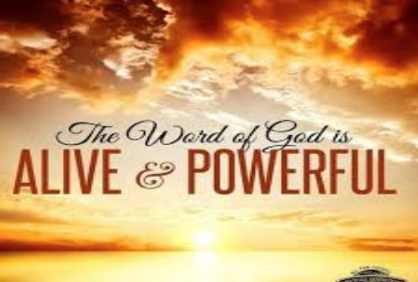
At that point in his sermon the Jewish religious leaders came and arrested Peter and John while they were preaching to the people. Yet, even the next day when Peter and John, both uneducated fishermen, gave their defense before these “rulers, elders and teachers of he law” in Jerusalem, the Holy Spirit’s power of witness remained on Peter and he spoke boldly, not worrying about what the Jewish officials would do. His defense was so powerful all the religious leaders “noted the apostles’ courage” and recognized it was “because they had been with Jesus.”

The defense was also powerful because Peter was preaching from the Bible. God’s Word is alive and powerful. God’s promise is whenever we use Scripture, it will not return void; it will accomplish His purposes (Isaiah 55:11). And both facts provide amazing encouragement for all of us. When we get into conversations or debates or challenging dialogues with those who oppose Christ, and speak with Holy Spirit power, there is the likelihood people will be able to recognize that we have been with Jesus. In other words, they will see Jesus in us and then have to turn their attention to Christ! Plus, when we use the Word of God, we can trust God for the power of His Word to do its work in our audience.

Summary
To summarize the story, the Spirit orchestrated this rather spectacular miracle right after Jesus’ death, resurrection and ascension to demonstrate to the Jews of that time the dynamic power of God and the reality of Christ’s resurrection and healing power. The cripple’s own enthusiastic joy in his healing added to the power of that testimony. And Peter’s anointed sermon gave the truth foundation to what these religious Jews were witnessing. This, coming right after Pentecost, was like a rocket which helped get the church off the ground!
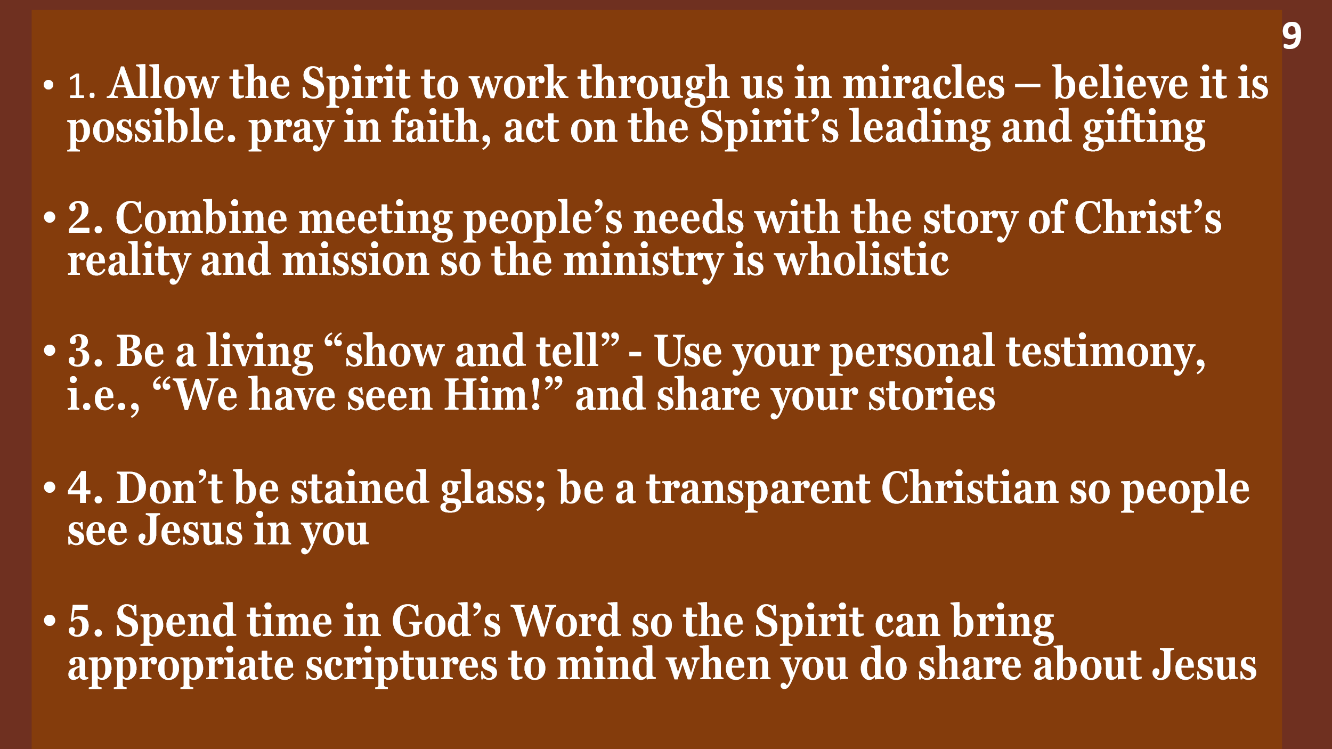
Here is a summary of our applications as well.
Let’s pray. Do it, Lord. We go forward in holy anticipation and faith. For Jesus’s Sake. Amen.

Dr. M.L. Codman-Wilson
Guest Preacher at Ogden Dunes Community Church 10/23/22

