New Hope Sermon The Spirit of Generosity

Introduction
According to the TV ads, store sales and online shopping offers, the Christmas season is already upon us. It is a season of giving for sure, and the commercials all point to the gifts you can give (and receive). There can be abundant generosity since many of those gifts require chunks of money. So generosity is a fitting theme for this Christmas season. Today, I want to focus on the Spirit of Generosity through “deeds of love and mercy.” That was the phrase the Spirit brought to mind as I was meditating on generosity this week. It comes from the hymn Lead on O King Eternal. This is a spiritual warfare song, but verse two actually fits the Christmas season:
“Lead on, O King Eternal, till sins’ fierce war shall cease, and holiness shall whisper the sweet Amen of peace. But not with swords loud clashing nor roll of stirring drums, with deeds of love and mercy the heavenly kingdom comes.” (words :Ermest Shurtleff, music: Henry Smart).

When Jesus was born, the world was embroiled in “swords loud clashing and the roll of stirring drums. “Human sin has created a warring madness for centuries, so the angels’ proclamation heralding the birth of the Prince of Peace was a sign that “the heavenly kingdom” was at hand. “Peace on earth, good will towards men” is still desperately needed as wars continue to wreck their suffering globally. This Christmas we all need to rest in the care of Jesus, the Prince of Peace and share His peace with others.

But Jesus also demonstrated “deeds of love and mercy.” In Him they were signature evidences of God’s presence.

They still are.

Deeds of love and mercy
Someone once said, “Your actions speak so loudly, I can’t hear what you say.” Aleksandra Layland says it a bit differently: “Actions speak louder than words. Words cost nothing. Actions can cost everything.” The generosity we’ve experienced here in Wheaton in the last few months has been very costly for the givers. But it’s a witness to God’s grace. So let me start this meditation on generosity with how we have experienced deeds of love and mercy extended to us as others have lived out the Spirit of Generosity.

Here’s our story.

In late spring when it was clear we would be moving back to Wheaton, we experienced generosity both in Orlando and in Wheaton. Bruce and Becky in Orlando worked hard to help us get packed up, get the moving truck packed and get the various documents in order that we would need. Marti in Wheaton began her search for all kinds of furniture and household items we had to have back in Wheaton (since we had sold or given away most of our stuff when we left Wheaton 2 years previously). She found things on BNNN (an amazing group called Buy Nothing North Naperville), as well as through friends and her persistent scavenger hunting for things we needed. Then she hired a small U Haul in June to get the stuff to 921 Cherry. As a result, when we arrived from Orlando, there were 2 new additional beds already set up and made with fresh linens, a long table to eat at, furniture for the living room, an iron and ironing board, a coffee maker, a blender and many other kitchen household items. There was a team of New Hope church members who were here who helped unload the van and our car and set things up for us. Since then Marti and others have continued to find things we need – all free. It’s been so kind.

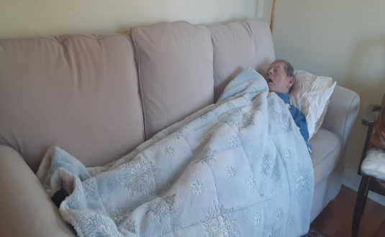
Then, this past week, as we signed a contract to rent a bigger house here in Wheaton, starting in January, another dear friend demonstrated a remarkable Spirit of Generosity. Gloria is a member of the church I pastored before the house church. This week she offered us her mother’s furniture, china and glassware. Gloria’s father died of Alzheimer several years ago and her mother just died this year of cancer and a multitude of other ailments. We are moving into a 3 bedroom house where we will now have rooms for visitors and renters and the lifestyle of hospitality that is our calling. But not enough furniture to furnish the space. This week’s costly generosity was in the hauling of several big furniture items from Gloria’s to our current home on Cherry St. It was very costly for the team of 3 because the 6 ½ foot sofa Gloria was giving us did not fit in the freight elevator and Marti, Kun and David had to maneuver it down 3 flights of stairs! There was also a loveseat, 2 bookcases, a chest of drawers, a large storage cabinet , a large casserole dish, a lovely big soup tureen (a symbol of hospitality), and a beautiful Egyptian picture painted on papyrus with a Tiffany style Egyptian looking lamp to go with it.. We had filled my van with boxes of glassware and china the day before! All these gifts will help us furnish the 20 x15 ft. family room, all 3 bedrooms and have the china and glassware for multiple use by multiple people in 2022 and beyond! I wanted Gloria to see how Keith had immediately taken to the long sofa and was sound asleep on it, so I took a picture and emailed it to her. Here is her response: “Oh, this makes me so happy! Bless the dear man!” That’s the love behind the great generosity.

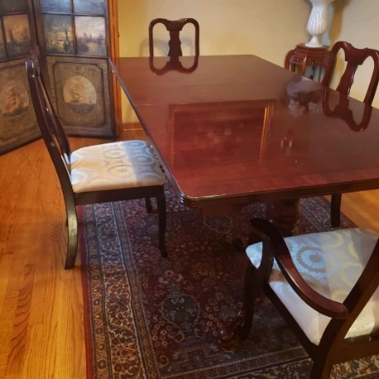
Then also this week in our Saturday zoom church time, Michiko offered another gift of great generosity. Michiko is my dear friend who was a visiting scholar at the U of Delaware 25 years ago. We met at an international Thanksgiving weekend where I was the speaker. That year she became a Christian and we have been connected ever since. As I described our new house and the hospitality we were so grateful to resume, she offered to pay for some things I need. Three days earlier I had purchased a lovely mahogany dining room table and chairs for our new dining room. We found it on Facebook Merchandise and our caregiver picked it up and Given came to unload it from my car. This gift is especially significant to come from Michiko because she has visited us from Japan before and we have sat together around our former dining room table. Now with a “new” dining room table and chairs we can continue sharing meals with people and hopefully Michiko herself can come in the next year to visit us and eat with us!

Then today, December 6^{th,} I just got word that a friend in Orlando was able to sell some of the many books I had to leave behind. Marti had sold some of the books here in Chicago before I left for Orlando. Cathy just sent me the first $97. from the sale of my books in Orlando. She had gone back to our Orlando house after we left, packed up all the Christian books and then contacted seminary friends in the area who took the books there. Another evidence of generosity in love and deed!

So, starting in January when you walk in our front door at 1514 N. Washington St. you will see the Egyptian papyrus picture and Tiffany style lamp, an Asian picture of cherry blossoms Marti gave me for my birthday, colorful runners from different countries on the long entry table. the dining room table and coffee table, and other gifts which say that we are a global family, welcoming people from all over the world.

That’s our story, but the New Testament has similar stories of the Spirit of Generosity. The Christian woman Dorcas is cited in the book of Acts as a costly giver in deed and love. She made clothing for the poor widows in the church. Luke says, “she was always doing good and helping the poor.” Acts 9:16. In fact, she was so beloved and valuable to that early church community in Joppa that Peter raised her from the dead, so she could keep on serving!

Generous giving
Traditionally, the concept of generosity is associated with money – especially with the emphasis on gifts for Christmas. And even there, Keith and I have been blessed. Some of you remember two months or so ago when Keith accidently threw away his hearing aids as he discarded his face mask in a Jewel garbage bin! They were outside of warranty coverage. But both Alex and Jingjing teamed up to send us the $3,000 for new hearing aids for Keith. Then Kun and Yandan, in discovering that we didn’t have nice lawn chairs and a very small indoor dining room table, bought those items for us. That table will now be available for our renter and caregivers in the family room when they want privacy. Precious generosity.

The Apostle Paul cites the Macedonian churches, in his letter to the Corinthians, as a model of such costly giving. He says: “Beloved ones, we must tell you about the grace God poured out upon the churches of Macedonia. ² For even during a season of severe difficulty, tremendous suffering, and extreme poverty, their super-abundant joy overflowed into an act of extravagant generosity. ³ For I can verify that they spontaneously gave, not only according to their means but far beyond what they could afford.” (2 Cor. 8:1-3) . Then he adds:
⁸ Yes, God is more than ready to overwhelm you with every form of grace, so that you will have more than enough of everything^{[a]}—every moment and in every way. He will make you overflow with abundance in every good thing you do. ⁹ Just as the Scriptures say about the one who trusts in him: Because he has sown extravagantly and given to the poor, his kindness and generous deeds will never be forgotten.^{[b] 10} This generous God who supplies abundant seed^{[c]} for the farmer. . .is even more extravagant toward you. First he supplies^{[e]} every need, plus more. Then he multiplies the seed as you sow it, so that the harvest of your generosity^{[f]} will grow. ¹¹ You will be abundantly enriched in every way as you give generously on every occasion,^{[g]} for when we take your gifts to those in need,^{[h]} it causes many to give thanks to God. ¹² The priestly ministry^{[i]} you are providing through your offering not only supplies what is lacking for God’s people, it inspires an outpouring^{[j]} of praises and thanksgiving to God himself. Passion

A Change of Perspective
This is why I wanted to chronicle all the ways people have been generous to us. And that praise has now taken on new meaning for me as God granted me an aha as I wrote our story down. Both Bruce and Becky and Keith and I felt God was leading us in our move to Orlando Florida. So we packed up some of our things and gave away or sold all the rest, thinking that we would not need these extra things in Orlando. That was still be true even in renting the very small house we are currently sharing in Wheaton with another couple. But as we realized we needed more space and opportunity for the hosting/hospitality ministry we are called to, I felt sad and chagrined and even guilty that we must have made a mistake in our Florida move because now we needed to get everything resupplied for a bigger Wheaton house. The “aha” came as I realized that this new house is actually a testimony to God’s mercy and grace – the idea of Romans 8:28. Every room you go into at our new house has furnishings and gifts in it as a testimony to God’s provision and the love of God’s people. We have owned 7 other houses, each with their own story, but this house is the epitome of the Spirit of Generosity. It gives me great praise and thanksgiving as I think about it. And I hope this aha will encourage many others who are trying to make sense of the twists and turns of their own lives. God has given me new eyes to see His love visibly expressed. All through the Spirit of Generosity. Hallelujah!

Conclusion
This Christmas many people will not have the funds to give with extravagant generosity to those they love. But as was modeled by the poor Macedonian churches, we can still give beyond what we can afford when we give with deeds of love and mercy. That has always been God’s model of generosity. Remember the words about Jesus from 2 Corinthians 8:9? “For you have experienced the extravagant grace of our Lord Jesus Christ, that although he was infinitely rich, he impoverished himself for our sake, so that by his poverty, we become rich beyond measure.”

May God empower us this season to help others also become rich in Him and grant us the continuing Spirit of Generosity so many others can “taste and see how good the Lord is!” (Psalm 34:8). Amen.
Dr. Mary Lou Codman-Wilson 12 8 21
Pastor, New Hope Global Fellowship

