New Hope Global Sermon 9 22 21 supporting ligaments

Introduction
A few weeks ago I wrote the sermon on Christians being established by God – established in our deliverance from darkness and distress, established in His direction for our lives, (God sets our feet upon a firm foundation and establishes the path we are to walk on), established in the work of our hands, i.e. the ministry He calls us to. But in the weeks since that sermon, I have asked the question: What is needed to get established in each of these areas? And the answer came - through our connection and participation in a specific Body of Christ.

The scripture that brought this to my attention was Eph.4:16. Its context is in v. 12-16 . God gives leaders in the church:
¹² to equip his people for works of service, so that the body of Christ may be built up ¹³ until we all reach unity in the faith and in the knowledge of the Son of God and become mature, attaining to the whole measure of the fullness of Christ. ¹⁴ Then we will no longer be infants, tossed back and forth by the waves, and blown here and there by every wind of teaching and by the cunning and craftiness of people in their deceitful scheming. ¹⁵ Instead, speaking the truth in love, we will grow to become in every respect the mature body of hHm who is the Head, that is, Christ. ¹⁶ From Him the whole body, joined and held together by every supporting ligament, grows and builds itself up in love, as each part does its work. NIV

Supporting ligaments. Ever thought about ligaments in the human body? I hadn’t until my heels caught on the back hem of my long winter coat and fell headlong down a flight of stairs in our first Wheaton home. There was no banister to grab onto to as I started my journey down those stairs, so I instinctively just reached my hands above my head so they would take the brunt of the fall rather than my head. And they did, but I broke my wrist in that process. The bones had gotten torn out of place so first the doctor physically manipulated my bones back into proper alignment (without any anesthesia!). Then he put a plaster cast on my wrist so the torn ligaments could grow back into place. To secure the bone fusion. Naturally, people signed my cast and it became rather colorful in the weeks it took for the inner body healing of connection to occur.
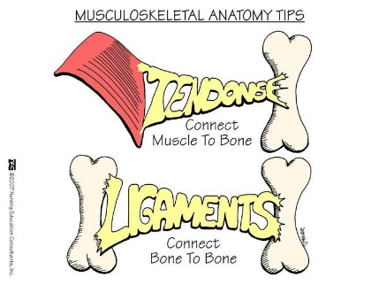
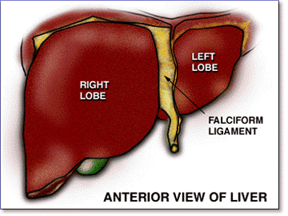
The dictionary defines ligaments as “the band of tough tissue connecting bones or holding organs in place.” (Webster’s New World Collegiate Dictionary 4th edition, Wiley Publishing, 2008, p. 829). Supporting ligaments are essential to body health and growth! Just like Jesus holds the universe together by the word of his power (Col.1: 17), so God has created ligaments to hold each human body together internally.

So, explore with me the implication of this simple fact to see how any ministry or work of our hands gets established.

The Essential Roles of the Body of Christ
The Ephesian passage gives 4 key roles of the Body of Christ, which are essential for the establishment of a healthy, growing church or ministry.

First, we have to be vitally connected to a specific Body of Christ. Contrary to western practice, Christianity is not an individually-based religion. It is based on our connection to our Lord and Savior and through His Spirit to all the other members of faith in God’s family.

Second, the goal of that connection is in v. 13 – that we become mature, attaining to the whole measure of the fullness of Christ. Together.

Third, we are joined and held together by every supporting ligament.

And fourth, we grow when each member of the Body of Christ (in a specific group or calling), fulfills their part.
Each one is to contribute to the others based on the spiritual gifts given to each individual. I Cor. 12 lists those gifts as:
Now to each one the manifestation of the Spirit is given for the common good. ⁸ To one there is given through the Spirit a message of wisdom, to another a message of knowledge by means of the same Spirit, ⁹ to another faith by the same Spirit, to another gifts of healing by that one Spirit, ¹⁰ to another miraculous powers, to another prophecy, to another distinguishing between spirits, to another speaking in different kinds of tongues,^{[a]} and to still another the interpretation of tongues.^{[b]} ¹¹ All these are the work of one and the same Spirit, and he distributes them to each one, just as he determines. (NIV)

Romans 12: 4-8 says:
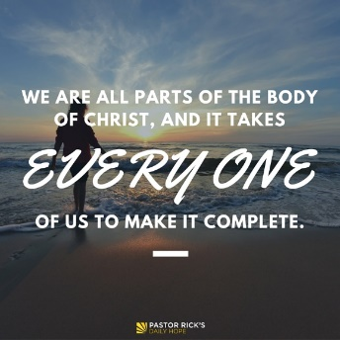
For just as each of us has one body with many members, and these members do not all have the same function, ⁵ so in Christ we, though many, form one body, and each member belongs to all the others. ⁶ We have different gifts, according to the grace given to each of us. If your gift is prophesying, then prophesy in accordance with your^{[a]} faith; ⁷ if it is serving, then serve; if it is teaching, then teach; ⁸ if it is to encourage, then give encouragement; if it is giving, then give generously; if it is to lead,^{[b]} do it diligently; if it is to show mercy, do it cheerfully.” A healthy Body of Christ occurs when each part if working properly for the common good.

Ephesians 4 says: “So Christ himself gave the apostles, the prophets, the evangelists, the pastors and teachers.” They are the ones who equip all the other members of a church or organization to use their gifts.

A Practical Example
Here’s how the Lord applied this to our context in Wheaton. We had our first meeting of IGGF (International Grad Garage Fellowship) three Saturdays ago. We had 16 adults in attendance and 2 little children. Those adults represented the countries of China, India, Indonesia, Japan, Korea, Mozambique, Singapore and the U.S. We started with people introducing themselves to one another informally, then continued those conversations over an international potluck, and finally came together as a whole group to share stories of how we have seen God work and prayer requests of how we now want to see God work – in our countries, in our lives as individual students, in whatever practical issue is on the forefront of people’s minds. And we concluded in prayer. Both Emmie and Marti were present from our former house church at 911 Washington, and they began our prayer time in praise for the joy of a new diverse community from around the world where God can encourage and build each one up. We acknowledged the strengths of a multicultural community as an important balance to their immersion experiences in Wheaton at a white academic institution and the majority of white churches.

However, as I thought about the Eph.4:16 text, I realized that IGGF is definitely not established yet. It will take the various participants to choose to belong to the group because we need supporting ligaments to hold the group together. And this is the understanding I believe needs to anchor the establishment of any thriving ministry. We won’t all have gifts to speak God’s words of edification to one another; we won’t all cook; we won’t all provide transportation or clean up. We won’t all work on the computer connections of communication; we won’t all be healers or administrators, or have the gifts of helps in service. We won’t all have the gifts of vision-casting or wisdom. We won’t all be leaders. But as each person chooses to belong to the group, we can each play our part and be supporting ligaments for the growth in love and maturity that is God’s intent. Ministries of this kind flourish when we are interdependent, interactive, multicultural, equal participants in establishing a new venture under the Spirit’s direction.

So how is this developing at IGGF? This time around in Wheaton I don’t think God’s purpose is for us to plant a sizeable growing house church. Instead, the Spirit seems to be leading us to establish a family of freedom and faith in Jesus Christ - freedom to speak, freedom to be heard, freedom to support and nurture and to be valued, freedom to intentionally bear one another’s burdens and celebrate one another’s blessings, freedom to walk alongside and grow into maturity in Christ. Within this small, intimate family of faith we will seek community, wholeness and spiritual growth as we journey together. The vision models what Gordon and Gail MacDonald created “as an extended family where there would be a deep commitment to meet with one another regularly, to share life and its challenges, and to help each other find out what God was saying to us., . .[where] each of us is held to higher standards of Christlikeness., . .[and where ] having gathered you all together at my hearth, I warm myself at your fire and find my Christian love burn and grow” (Gordon MacDonald, A Resilient Life, Thomas Nelson, 2004, pp. 206, 223, 219). We are trusting God for the supporting ligaments and necessary members of His Body to make that happen.

Now, beloved, in your context, how are you a supporting ligament in the work of God’s kingdom? If it is a new venture or new path God has led you to with other believers in the Spirit, trust God to help you (plural!) live out His promise of a future and a hope. Trust Him that your own “Christian love can burn and grow” as a vital part of a Body of Christ. This is God’s purpose as each part is working properly” (Eph.4: 16).

Prayer: Do it, Lord, according to Your Word and the power and direction of Your Spirit. For Your glory. Amen.
Dr. M.L. Codman-Wilson, Pastor
New Hope Global Fellowship
9 22 21

