Sermon August 28 Dealing with a Sovereign

Tony Evan’s Analogy:
“I know people who will say that they can’t go two hours with smoking. But put them on a plane to England and they’ll go eight hours without smoking. How can people who can’t go two hours without smoking get on a plane for 8 hours and not smoke? Because the commander of the plane tells them that they are on a nonsmoking flight. They can’t smoke on the plane; If people who smoke want to get from one point to another, they have to give us something. The commander of the ship has told them that they can’t take the trip if they don’t abide by the rules.
As Christians, our problem is not an inability to change. Our problem is that we don’t know who we are talking to. If we really knew that we were dealing with the “Commander,” the all-powerful God, then we would realize that a change in behavior might definitely be in order!” (Tony Evan’s Book of Illustrations. Moody Publishers, 2009, p. 297)

The Bible is full of stories of various commanders – commanders of armies, local authorities, Kings and Queens. Some kings were good – though flawed – David, Solomon, Hezekiah. Some were the off-with-your-head types who like King Darius would throw those who disobeyed them to the lions, or Nero who lit Christians as torches on the Appian Way. They had power and authority and you did not disobey their rules lightly.

However today, most of us don’t live under a monarch or sovereign king.
For the few monarchies that still exist around the world, many are mere figureheads of a lovely or not so lovely tradition. But because we are not under their authority, we don’t feel compelled to obey them. We see many of them as anacronisms, no longer relevant for our age.
Instead today authoritarian despots have arisen who ravage peoples, wage war, and create extraordinary suffering. And people either capitulate to these despots or suffer the dire consequences.
Granted, however not all kings are like that. One man from Morocco has established a real relationship with his king. Listen to this:

“John Kass, a columnist for the Chicago Tribune wrote about a waiter named Bouch who works at a tavern in Chicago. Bouch decided to write to the king of his homeland, Morocco. The king, Mohammed VI, is intensely popular because he often interacts with his subjects in public. When Bouch wrote to him from Chicago, King Mohammed VI, true to nature, wrote back. “Look at the letters,” said Bouch. “These are letters from the king. If I meet him, I’ll be so happy.”
Columnist Kass muses, “How many guys hauling beer and burgers in a Chicago tavern have a correspondence going with a royal monarch?” Kass talked to Morocco’s deputy counsel general in Chicago and was told that it isn’t unusual for this king to write personal letters to his subjects abroad. “It happens a lot,” the official said. “He loves his subjects.”
You think King Mohammed VI loves his subjects? You ought to meet Jesus, the King of kings, and read his precious letters to you.” The Bible is intended for us as a letter from God. (Lee Eclov, citing Kass, Chicago Tribune, 7/23/01)
Isn’t that amazing? Jesus Christ alone is King of Kings and Lord of Lords. He is the commander of the armies of heaven. He is the Sovereign Ruler over the entire universe. He is sinless and reigns in righteousness and truth. Nothing capricious or self-centered or destructive about Him. And He gave up His rights as a royal to become human and die in our place – all out of His extraordinary love for us. Now He reigns from heaven – as King of Kings and Lord of Lords. My response to Him and His sacrifice should be that the love of Christ controls us. We no longer live for ourselves but for Him. 2 Cor. 5.

But I feel many Christians don’t really know the extent of Christ’s love or His power or His mercy or His goodness. They don’t really know who He is so they are content to claim his sacrifice as their Savior, but they neglect to turn their whole lives over to Him as their Lord.

But, this is wrong theology, beloved! For the Christian Jesus Christ is both Savior and Lord. And he expects and deserves our total obedience and honor that comes with His titles. This is the point Paul is making to the Colossians.
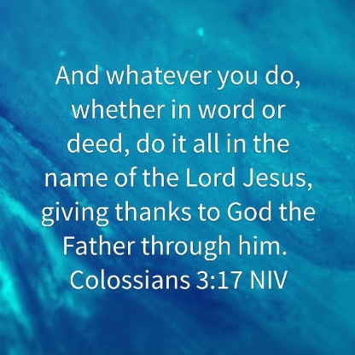
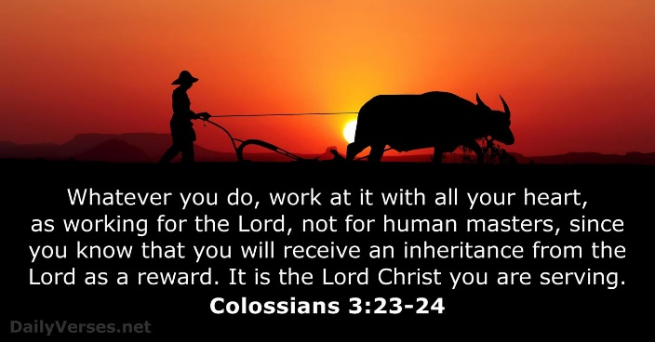
Colossians 3:17 says “whatever you do, whether in word or deed, do it all in the name of the Lord Jesus, giving thanks to the Father through him. “Do everything in the name of the Lord Jesus.” That’s an all-inclusive command for our daily life. Paul continues this emphasis in Col. 3:23-24, “Whatever you do, work at it with all your heart, as working for the Lord, not fur human masters, since you know that you will receive an inheritance from the Lord as a reward. It is the Lord Christ you are serving.”

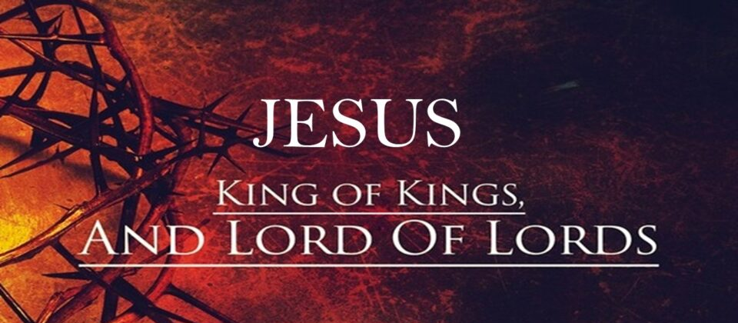
Living with Jesus as Lord affects how we trust Him in life’s crises, how we pray in Jesus’ name, how we serve others with His love and power . It’s all about how He becomes incarnated in our transformed lives so that others can realize that Jesus is King of Kings and Lord of Lords.

I believe, practically, this means at least four things.
First, it is the commitment of our heart to the alls – Love the Lord your God with all your heart, soul, mind and strength and love your neighbor as yourself.
One man expressed it like this: (PP)
I'm part of the fellowship of the unashamed. l have Holy Spirit power…l have stepped over the line. The decision has been made. I'm a disciple of His… My past is redeemed, my present makes sense, my future is secure. I'm finished and done with sight walking, small planning, smooth knees, tamed vision, cheap giving, and dwarfed goals. I no longer need preeminence, prosperity, or popularity. I don't have to be right, to be first, or be recognized. I now live by faith, lean on Christ’s presence, lifted by prayer, and labor by His power. I won't give up, shut up, or let up for the cause of Christ. [Jesus is Lord.] I must serve 'til He comes…l am His disciple. (My commitment as a Christian, Bob Moorehead).
Jesus as Lord involves the disciples’ willingness of giving Him our alls.

Second, living with Jesus as Lord means that we also realize He is sovereign over all the events in the world and in our lives. We don’t have to fret or worry. And when life’s crises seem beyond our control (and many are!!), we cast all our cares back on Him because He alone can handle them as the Sovereign Lord in the universe.

Last week, having had a wonderful morning last Sunday with all of you, I came home and received a phone call about 2pm that Keith had fallen again. He is still very unsteady and a high fall risk, so now I needed to add daytime caregivers as well to the nighttime caregivers for his one-on-one care. It is extraordinarily expense and I found myself singing the Care Chorus we sang here a few weeks ago. As Keith’s disease progresses, I find I don’t know what to do many time, but I know Jesus the Lord DOES know how to handle it, so I lay my burdens down at his feet.
I want us to sing this chorus again this morning as a faith commitment and as you sing, I want each of you to think of a burden you need to lay down at the Lord’s feet in confidence that he can manage it (PP).
I cast all my cares upon you.
I lay all my burdens down at your feet,
Andy anytime that I don’t know what to do,
I will cast all my cares upon you. (words and music: Kelly Willard)

Jesus the Lord is our Burden Bearer. Knowing Jesus is Lord is also the basic attitude changer! On a more humorous side:
There once was a woman who woke up one morning, Looked in the mirror, and noticed she had only three hairs on her head. Well,' she said, 'I think I'll braid my hair today?' So she did and she had a wonderful day.
The next day she woke up, looked in the mirror and saw that she had only two hairs on her head. 'H-M-M,' she said, 'I think I'll part my hair down the middle today.' So she did and she had a grand day.
The next day she woke up, looked in the mirror and noticed that she had only one hair on her head. 'Well,' she said, 'today I'm going to wear my hair in a pony tail.' So she did and she had a fun, fun day.
The 4th day she woke up, looked in the mirror and noticed that there wasn't a single hair on her head. 'YEA!' she exclaimed, 'I don't have to fix my hair today!'
Attitude is everything.
Life isn't about waiting for the storm to pass... It's about learning to dance in the rain.

Another little old lady trusted God for everything as her Lord, so every morning she stepped our on her front porch
“raised her arms to the sky and shouted, "PRAISE THE LORD!" However, one day an atheist moved
into the house next door. He became irritated at the little old lady. So every morning he'd step onto his
front porch after her and yell: "THERE IS NO LORD!" Time passed with the two of them carrying
on this way every day.
One morning, in the middle of winter, the little old lady stepped onto her front porch and shouted: "PRAISE THE LORD! Please Lord, I have no food and I am starving, provide for me, oh Lord!" The next morning she stepped out onto her porch and there were two huge bags of groceries sitting there. "PRAISE THE LORD!" she cried out. "HE HAS PROVIDED GROCERIES FOR ME!"
The atheist neighbor jumped out of the hedges and shouted: "THERE IS NO LORD; I BOUGHT THOSE GROCERIES!!" The little old lady threw her arms into the air and shouted: "PRAISE THE LORD! HE HAS PROVIDED ME WITH GROCERIES AND MADE THE DEVIL PAY FOR THEM!" GCFN Received from Donald Pohlner. Trusting Jesus as Lord with all our cares and needs.

Third, Believing Jesus is Lord also means that you can trust God that nothing is impossible with God. When God leads us in a certain direction, there is nothing too hard for God to conquer as we face various obstacles. The gospels have story after story proving this truth. You remember when the angel Gabriel appeared to Mary to tell her she will be the mother of the Messiah, he said she was a virgin and undoubtedly had a myriad of other impossibilities in her mind. But Gabriel’s answer was that “even Elizabeth your relative is going to have a child in her old age and she who was said to be barren is in her sixth month. For nothing is impossible with God.” Luke 2:36-37. That’s the bedrock truth of Jesus’ lordship.

Humorously, Edgar Guest’s poem delightfully captures this attitude.
Somebody said that it couldn’t be done, but he with a chuckle replied, That ‘maybe it couldn’t but
he would be the one who wouldn’t say so till he tried.” So he buckled right in with the trace of a grin.
If he worried, he hid it. He started to sing as he tackled the thing that couldn’t be done, and he did it.
Somebody scoffed: “Oh, you’ll never do that; at least no one ever has done it.” But he took off his
coat and he took off his hat and the first thing we knew he’s begun it. With a lift of his chin and a bit of
a grin, without any doubting or quiddit, he started to sing as he tacked the thing that couldn’t be done,
and he did it. (Edgar Guest, “ It couldn’t be done,” The path to Home when Day is Done, Reilly and Lee Company, 1919, p. 37)

When God gives a directive, we don’t look at circumstances or the “impossibilities”, we look to the Lord for whom nothing is impossible and proceed.

Fourth, living with Jesus as Lord affects how we treat others. Under Christ’s Lordship, we are called and equipped to serve one another. Occasionally? No, as a lifestyle.

Serving others may mean going to visit them in the hospital, sending a note of encouragement, praying for them daily until God’s work is manifested in them and his victory won over what is distressing them. It may mean bringing flowers to share the beauty of the Lord with another or offering rides and sharing tools and whatever we have that can help another. In these little acts of service, this is actually ministering to the Lord. This is how Jesus described it in Mt. 25: 35-36
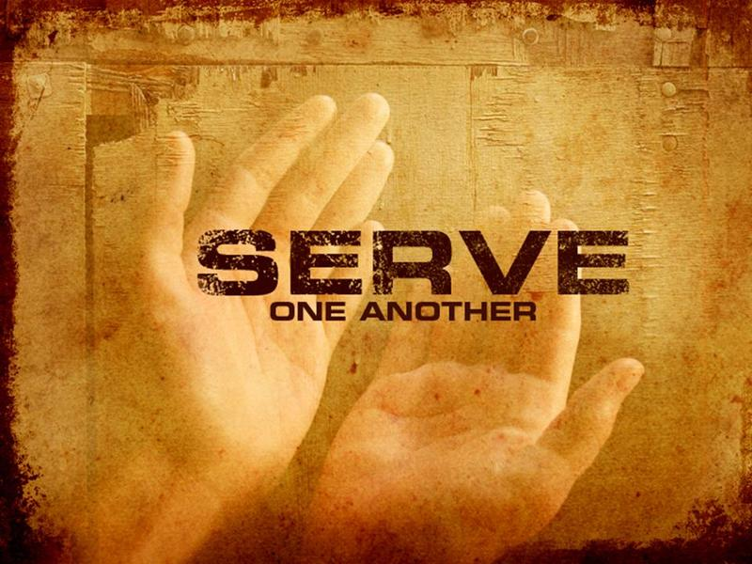
³⁵ For I was hungry, and you fed me. I was
thirsty, and you gave me a drink. I was a
stranger, and you invited me into your home.
³⁶ I was naked, and you gave me clothing. I was
sick, and you cared for me. I was in prison, and you visited
me.’

Serving others in the name of our Lord Jesus is very practical. How do we know what to do? I suggest when you wake up in the morning, you ask, “Lord, what is on your agenda for me today? Who can I love and serve in Your name today?” Then it means heeding God’s prompting and being His hands and voice to bless others.

There’s a hymn I learned in my early life as a Christian. It is
called “All for Jesus”. Here is how this hymn spells it out. Say it with me, would you, please?
“All for Jesus, all for Jesus, all my being’s ransomed powers. All my thoughts and words and doings, all my days and all my hours. Let my hands perform His bidding; let my feet run in His ways. Let mine eyes see Jesus only; let my lips pour forth His praise.” (words Mary James, music: john Stainer, “All for Jesus” #129 in Hymns, Inter-Varsity Press, 1959)

May it be so, Lord for Your glory. It’s our great privilege to serve You Lord. We love You. Amen.
Dr. Mary Lou Codman-Wilson, Guest Preacher Ogden Dunes Community Church August 28, 2022

