New Hope sermon the veil torn in two

Human longing and restlessness:
Psalmist: (in anguish) Oh that I might know where I might find Him.

Tagore: I am restless – India –
I am restless
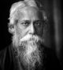
I am restless. I am athirst for far-away things.
My soul goes out in a longing to touch the skirt of the dim distance.
O Great Beyond, O the keen call of thy flute!
I forget, I ever forget, that I have no wings to fly, that I am bound in this spot evermore.
I am eager and wakeful, I am a stranger in a strange land.
Thy breath comes to me whispering an impossible hope.
I forget, I ever forget, that I know not the way, that I have not the winged horse.
I am listless, I am a wanderer in my heart.
O Farthest end, O the keen call of thy flute!
I forget, I ever forget, that the gates are shut everywhere in the house where I dwell alone!

Loneliness by Faiz Ahmed Faiz – Pakistani -
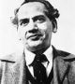
Someone is at the door again, my weeping heart, no, no one
Perhaps a passerby, who will go somewhere else
The night has passed, waiting, the star-dust is settling
Sleepy candle-flames are flickering in distant palaces
Every pathway has passed into sleep, tired of waiting
Close and lock your sleepless doors; no one, no one will come here now.

Maya Angelou an African American poet –
Lying, thinking
Last night
How to find my soul a home
Where water is not thirsty
And bread loaf is not stone
I came up with one thing
And I don't believe I'm wrong
That nobody,
But nobody
Can make it out here alone.
Alone, all alone
Nobody, but nobody
Can make it out here alone.
Now if you listen closely
I'll tell you what I know
Storm clouds are gathering
The wind is gonna blow
The race of man is suffering
And I can hear the moan,
'Cause nobody,
But nobody
Can make it out here alone.
Alone, all alone
Nobody, but nobody
Can make it out here alone.
Kobayashi Issa – Japanese -
Don’t weep, insects –
Lovers, stars themselves,
Must part.
Everything I touch
with tenderness, alas,
pricks like a bramble…
Trusting the Buddha, good and bad,
I bid farewell
To the departing year…
Last time, I think,
I'll brush the flies
from my father's face.
A bath when you're born,
a bath when you die,
how stupid.
St. Augustine summarized the human condition as “our hearts are restless until they find their rest in
Thee.” Today I believe we can only understand the real significance of the temple veil tearing in two when we enter into the pain and restlessness of people around the world. They cry out. They seek. They despair. They look for God.

The Old Covenant way to approach God
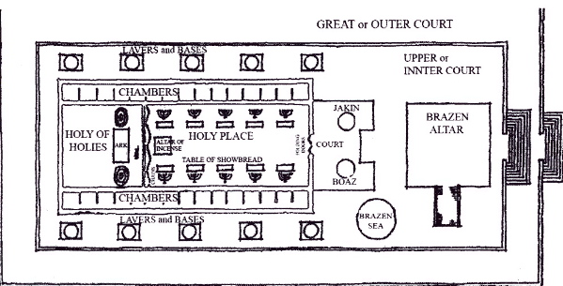
In the days of Israel’s worship God directed Solomon to build a temple where the people could begin to draw near to their terrible and awesome God – though only under certain conditions. If you look at this graphic of the Temple, you can see the steps God established to make a relationship with Him possible. First the temple had an inner and an outer court. The lavers and basins you see along the perimeter contained water that that priest used for all the ceremonial washings required in worship. The brazen altar was where the animal sacrifices were performed because God had established that without the shedding of blood is no remission of sin.
There were elaborate ceremonies for the sprinkling of the blood and the cleansing of the people. But the centerpiece of access to God was the Holy place and the Holy of Holies. These were the two inner sections of the Tabernacle. The first section, in which were the lampstand and the table and the bread of the Presence is called the Holy Place. ³ Behind the second curtain (or veil) was a second section^{[c]} called the Most Holy Place, ⁴ having the golden altar of incense and the ark of the covenant covered on all sides with gold, in which was a golden urn holding the manna, and Aaron's staff that budded, and the tablets of the covenant. ⁵ Above it were the cherubim of glory overshadowing the mercy seat….The priests go regularly into the first section, performing their ritual duties, ⁷ but into the second only the high priest goes, and he but once a year, and not without taking blood, which he offers for himself and for the unintentional sins of the people. Heb. 9:2-7
In the Holy Place the altar of incense burned continually. It was lit with 10 menoras that were also burning constantly. The veil separating the Holy Place from the Holy of Holies was a 60 high curtain woven of purple, red, blue and white threads. Two seraphims were embroidered on that veil. The walls of both the Holy Place and the Holy of holies were overlaid with gold. Once a year, on the day of atonement the High Priest took the blood of the ram for his own sin and the sacrificed lamb for the sins of the people into the Holy of Holies, the very Presence of God, and sprinkled that blood on the mercy seat, the seat of atonement.

And that’s the key.

When Jesus died, Matthew tells us that the veil of the temple was torn in two - the veil that separated the Holy Place from the Holy of Holies. Here’s what one commentator says about this:
“The 60 foot high curtain was split from top to bottom, which is a sign that God himself abolished the separation from the Holy of Holies, signifying that the new and living way is now open for all people to enter into his presence through the sacrifice of Jesus on the cross….No longer is the high priest alone allowed access to the Most Holy Place to commune with God. No longer are any high priestly sacrifices necessary. (Heb 10:10-22). All who are cleansed from sin by the blood of Jesus are a holy priesthood to God and live in his presence constantly through his indwelling in our hearts and the ever-present comfort of God’s Spirit.” (Michael Wilkes, NIV Application Commentary, Matthew, Zondervan, 2004,p. 919)

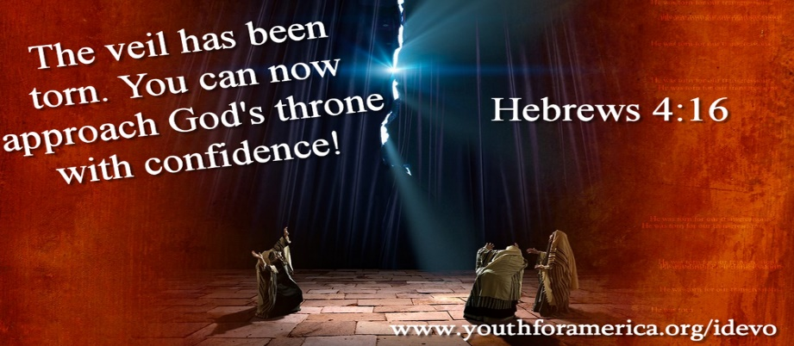
As Hebrews 4:16 says, “The veil has been torn; you can now approach God’s throne with confidence.”
Hebrews 10:19-25 continues this theme: Believers in Jesus can now have confidence to enter the Most Holy Place by the blood of Jesus – by the new and living way he opened for us through the curtain that is his body. He has made the way open. “New in v.20 (prosphatos) is only used once in the N.T. Its original meaning was “freshly slaughtered”. Jesus is the new way, the freshly slaughtered sacrifice who opens the way to God. It seems contradictory that the freshly slaughtered way would be the living way. But Jesus’ death conquered death and gives life. His death is the only way to life everlasting.” (J.MacArthur, MacArthur New Testament Commentary, Moody Press, 1983, p. 223)

Bible scholar FF Bruce explains further:
“Those who have been cleansed within, consecrated and made perfect by the sacrifice of Christ, have received a free right of access into the holy presence; and our author urges his readers to avail themselves fully of this free right…Jesus as our High Priest has entered into the presence of God through the way He opened so His people can follow Him there. (p. 244 – F.F. Bruce, Eerdmans, International Commentary on the New Testament, 1964 ) .

All because of God’s mercy shown us in Christ’s sacrifice. As a result, we can now draw near to God with a sincere heart in full assurance of faith, having our hearts sprinkled to cleanse us from a guilty conscience and having our bodies washed with pure water – confession and forgiveness of sin.

So how is this related to the power of the gospel globally, beloved? Let’s go back to the cries we heard from poets around the world. Cries of loneliness, restlessness, meaninglessness. The answer for all of them is in what happened when the veil that was torn asunder at Christ’s death. As F.F.Bruce says, “In the death of Jesus, we are to understand [through the rending the veil to the HOLY OF HOLIES] that God Himself is unveiled to us and the way of access to Him is thrown wide open.” P. 246ff Bruce Commentary on Hebrews.

For many, knowing a God whom they can approach and who answers prayer is a key. It was for me. Before I became a Christian, I tried praying, hoping there was a God out there, but my prayers felt like they didn’t go higher than the ceiling in my room. So when I met true Christians who had a close relationship with the real God and who could tell stories of how God answered their prayers, I was intrigued. I saw the difference in their moral character, their purpose in life, and they attributed it all to Jesus Christ. That was the key to my becoming a Christian.

My story can be duplicated countless times around the world. This is part of the power of the gospel. But the ability to approach God directly is also directly connected to the wisdom we need to live as Christ’s witness. It’s a true story from Chinese evangelist Watchmen Nee:
A brother in South China had rice field in the middle of the hill. In time of drou8ght he used a waterwheel, worked by a treadmill to lift water from the irrigation stream into his field. His neighbor had two fields below his and one night made a breach in the dividing bank and drained off all his water. When the brother repaired the breach and pumped in more water, his neighbor did the same thing again. And this was repeated three or four times. So his consulted his brethren:”I have tried to be patient and not to retaliate,” he said. “But is it right?” After they had prayed together about it, one of them replied, “if we only try to do the right thing, surely we are very poor Christians. We have to do something more than what is right.” The brother was much impressed. Next morning he pumped water to the two fields below and in the afternoon pumped water for his own field. After that, the water stayed in his field. His neighbor was so amazed at his actions that he began to inquire the reason, and in course of time, he, too, became a Christian.” (Watchman Nee, Sit, Walk Stand, CLC/Tyndale House Publishers, 1977, pp. 32-33)
Notice how prayer in that Chinese community became the way God gave wisdom for the action of the beseiged farmer. And how his powerful witness ultimately brought the neighbor to Christ.

Alfred Lloyd Tennyson said, “More things are wrought by prayer than this world dreams of.” This true! I can’t wait to hear in heaven of all the answers to prayer from God’s people around the world!. What a message of good news this is for those who are seeking meaning in life and answer to the greatest questions in life –How can we deal with suffering? Is there a way to know God? Where does our significance and hope come from? Salvation in Christ brings the answers to those questions. But prayer also opens the door to all God’s resources so we can ask for wisdom and courage to live a powerful witness before our non-Christians countrymen.

Thank God for Christ’s death on the cross. Thank God for the resulting earthquake that tore the temple veil from top to bottom. Now, gratefully through Jesus Christ, let us as believers “approach the throne of grace with confidence, so that we may receive mercy and find grace to help us in our time of need.” And then with that mercy and grace, turn around and help others!
For Jesus’ sake. Amen. Let us pray.
Dr. M.L. Codman-Wilson 4/7/19
Song of response: Sweet hour of prayer

