Sermon Holy Spirit Wisdom in Conflict Mediation 11/7/22

A Conflict Management Tool
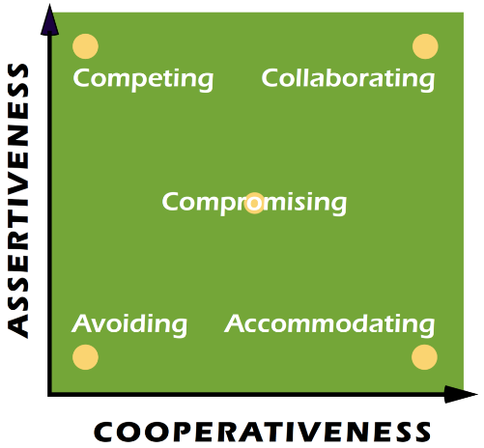
Our theme today is conflict mediation. Since this issue is endemic in daily life, I want to introduce a global conflict assessment tool that I have found extremely helpful. This tool identifies how we approach conflict in terms of people’s personality/behavioral styles. (PP)It is called the Thomas-Kilmann Assessment Tool. Look at the diagram: Starting at the top left. There are the competing folks who pursue their own agenda for their benefit at the other’s expense. Drop down on the left – the Avoiders who go silent or pretend the issue does not exist. To the right at the bottom the accommodaters who neglect their own concerns to satisfy the concerns of the other and bring peace. Actually both the accommodaters and the avoiders lose their voice and that sets them up for resentment, and distrust toward the other. In the middle of the diagram are the compromisers who settle on a solution that only partially satisfies both parties (but ultimately leaves parts of the conflicting areas untouched.). Each of these 4 ways are insufficient and unsatisfactory. Instead, what we want to develop is the style of a collaborator. These people work with others to find a solution which satisfies the underlying needs of both parties. It is a win/win.
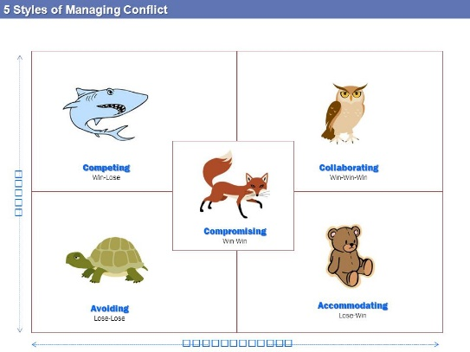
(PP) These 5 types have even been pictured with animal figures: The shark (top left) is the competitor who is out for self. The Avoider is the turtle who goes within his shell. The teddy bear is the Accommodator who just wants to please. The fox is cunning and will work only for a partial solution. It is the wise old owl who symbolizes the collaborator, working for the good of all parties involved.

I believe these secular tools can be very helpful as we each live out the relationships in life. But there is more. We can take the insights from these tools and then apply them to our Christian walk. That is my intent today.

Our text today from Acts 6 is a God-based model of how collaboration works through the wisdom and power of the Holy Spirit. It is a model which can help any church or relationship situation be developed with grace and wisdom. It is the model we see lived out in the early church and that’s our theme today. Let us pray.

The Context of the early church
I start with the famous Disney story of Cinderella to set the stage for the conflict that occurred between the Hebraic believers in Christ and the Hellenistic believers in Christ. (People coming from different cultures and languages, Hebrew and Greek.) The Cinderella story will help us understand the dynamic behind their conflict in Acts 6.

Cinderella was in a household that was not in her birthline. She was being raised by a cruel stepmother and her daughters and treated like a servant. When the King announced a royal ball in which the prince would find his wife, she was forbidden to go. She was an outcast in the stepmother’s household. Yet, because of the magic of the fairy godmother and her team, she was dressed with a gown, given a chariot of gold with horses and footmen and driven to the ball. She entered and the prince (whom she had met by accident in the words earlier,) saw her, fell in love with her and wanted her to be his wife. Naturally, the evil stepmother tried in every way she could to prevent the prince from locating Cinderella after Cinderella fled from the ball as the clock struck midnight. The stepmother lied when the prince came to their home to see if anyone fit into the glass slipper Cinderella had left at the ball; she forbade Cinderella from even trying on the slipper; she falsely accused Cinderella of misconduct etc. But it was Cinderella who fit the slipper and became the Prince’s wife. She was the one whom the Prince loved and elevated to be beside Him.

This is much like Jesus has done with the Gentiles – all those of us from other nations outside the Jews. Christ has broken down the walls of hostility and separateness that have kept the Gentiles outside the favor of God. Instead through the reconciliation He made possible through the cross and resurrection He now provides all believers amazing access to all His grace and wisdom and life in the Spirit. We are His Cinderella. In the early church there were issues of Privilege. Insiders and Outsiders -those with a vested interest and those who were perceived to be excluded. How did the Spirit bring collaboration?

The problem of diversity in the early church
It is clear in the Bible that God set his heart from the beginning of time on people from all nations coming into His family. God convinced Paul and then Peter that salvation was equally for Gentiles, not only for Jews. These new Gentile believers as His Cinderella were dressed in Christ’s righteousness, given equal access to all the privileges of the Kingdom in Christ, were equally loved as part of God’s family, and actually came to have predominance in the early church. But the shift in power and lifestyle and priorities was a problem for the church. Why?

The Jewish converts reasoned that Jesus was a Jew. His earliest Apostles were Jews who held Jewish interpretations about the Messiah from the Abrahamic tradition and the Scriptures. They believed that they were a race chosen by God and that the promised Messiah would come from their race and bring them redemption. The Messiah was for their nation. The promises were for their people. They had a history with Yahweh. They had traditions. They had God’s laws and commandments for how all daily living was to be administered. Anyone who sought to worship the Hebrew God were thus converts to Judaism and must abide by Jewish laws and customs. These new Hellenistic converts were an aberration yet claimed equal identity in Christ and equal access to all the new church offered. That included the feeding of their widows.

In the timeline of the story in Acts 6 it is thought that there was probably not an intentional overlooking of the
Hellenistic widows. Perhaps the Hebrew leaders were used to feeding the Hebraic widows and simply overlooked the Hellenistic widows. Remember, the numbers were now astronomical and had exploded almost overnight. But still, the Hellenistic widows were left out and so they complained. The word for “complain” in our text is not a pretty word. It is the same word used for the murmuring of the Jews against Moses in the desert (Exod. 16:7, Num.14:27). Murmuring and complaining will often simmer just below the surface in a relationship or organization and it has a cancerous effect on the whole body.

In fact, this crisis could have split and killed the church from the very beginning. But the way it was handled illustrates the wonderful wisdom of the Holy Spirit who orchestrated the solution. I want to share the principles involved in this solution by using the acrostic RESOLVE.

(PP Resolve- Recognize right away_)
R – Recognize, right away- (V. 1 problem appeared) the situation was Recognized and handled Right Away – the longer you let tensions or dissonance go on the more it develops a life of its own and poison and distrust begin to creep into the mix. As soon as the grumbling started, the leaders of the church recognized it and handled it right away.

(PP rEsolve- Everyone is involved) )
E –Everyone - (v.2 So the Twelve gathered all the disciples together) Everyone was involved in the solution-seeking

(PP reSolve – Seek a Satisfactory solution)
S – Satisfactory solution (v.3 – brothers, choose seven men from among you who are known to be full of the Spirit and wisdom. We will turn this responsibility over to them) Find a Satisfactory Solution

(PP resolve – own )
O – Own (v. 5 The proposal pleased the whole group. They chose 7 men, all Hellenists) Everyone must own the solution. In unsatisfactory conflict management one party dominates and the others submit or accommodate to ease the tension. But in this situation those who spoke the same language as the aggrieved widows were chosen to take leadership. They knew their people and could be especially sensitive to their needs and represent them well.

(PP resoLve – listen)
L – Listen – (v. 6 The seven were presented to the apostles who prayed and laid their hands on them) – each party in the conflict listened to the others to reach the satisfactory solution. Often conflicts are argument controlled and each party fails to listen to the other because they are waiting and preparing their rebuttal. A good listener will rephrase the other’s position and ask “This is what I thought was most important to you. Is this what you said/intend?”

(PP resolve – voice)
V – Voice - each party in the conflict had a voice. The choice of the seven Hellenists balanced the dominance of the apostles who were Jewish. Now Hellenists had important leadership responsibilities in the whole church – In my earlier church leadership as I have tried to incorporate people of various nationalities to be active members in the church, it always came down to whether they could have leadership and balance the dominant voice of the usually white men who ran the church. Everyone having a voice means the people of lesser power or numbers do not go silent to accommodate the powerful. If not, we engage in what I call vertical violence. We need to beware ourselves of our own vested interests, prejudices, and voices which can silence, offend or alienate others who differ from us. Notice in the family graphic the violence involved covering the others’ mouths.

(PP resolvE – effect)
E Effect v.7 – “So the word of God spread. The number of disciples in Jerusalem increased rapidly. And a large number of priests became obedient to the faith”. A win/win solution has an Effect -which ripples out for good in every widening circles.

Because of the Spirit’s guidance and control the Hellenists were not disregarded nor silenced. They were wisely incorporated as those who belonged in the church family. And seven of their leaders were given important responsibility as leaders alongside the apostles.

This is Holy Spirit inspired wisdom in conflict mediation, beloved. Notice that the men chosen for this new responsibility had to be recognized as having two dominant characteristics: they had to be full of the Spirit and wisdom. With those new wise Spirit-filled leaders, the conflict and the mutually chosen solution would be able to be handled well so the problem would not keep recurring and escalating. All the leaders would be able to apply these 7 principle whenever future conflicts came up.

The 7 principles are– 1. Recognize right away, 2. Have Everyone involved participate in solution seeking 3. Come to a Satisfactory Solution for everyone. 4. To be satisfactory, it must be owned by everyone 5.. That solution will happen if everyone is listening with Spirit-filled attention and compassion 6. And everyone has a Voice. The powerful or those with vested interest do not control those who are challenging the solution or are of lesser power or status. The effect of the God-empowered solution would be the ever widening spread of the work and presence of God. (PP)

Summary
Conflict has plagued relationships since the beginning of time and so it is essential for the church to model following the Spirit’s direction and leadership in finding satisfactory solutions for everyone involved. I know this church has been working on these issues for the last couple of years. (PP) May God grant us all increased kindness, forgiveness, peace-making skills and an openness to grow, so we can see a widening effect of God’s work in our community. In Jesus’ name. and for His sake. Amen.
Dr. M.L. Codman-Wilson, Guest Preacher, Ogden Dunes Community Church November 6, 2022

Actually, taking holy communion together is one way we can show unity, honor and harmony to all those with whom we share community. That is our privilege as our worship service continues. When it is time in our communion preparation, I invite us to sing verses 1-3 of the communion hymn I Come with Joy

