Weekly Sermon Tuning in to Heaven’s Frequency 7 17 22

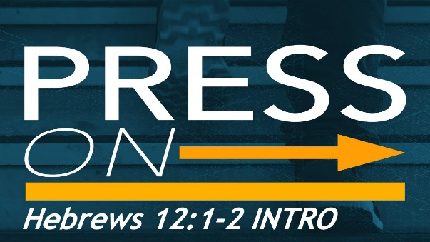
Years ago a friend made me this plaque which pictured the last words my father gave me before he died: “Press On.” I believe Dad became a Christian at the end of his life and then finally understood what my life was about after the decades Keith and I and our children lived out the life of Jesus before him. His admonition to me has always been a great encouragement. Life is hard. As the song by the contemporary Christian group Selah sings: “When the valley is deep, when the mountain is steep, When the body is weary, when we stumble and fall, When the choices are hard, when we’re battered and scarred, When we’ve spent our resources, when we’ve given our all, In Jesus’ name we press on, In Jesus’ name we press on, Dear Lord with the prize clear before our eyes, we find the strength to press on. (words and music: Dan Burgess)

This morning I want to challenge and encourage all of us to press on in our walk with God by tuning into God’s frequency. I believe as we do that we can tune into the heartbeat of God. Using Colossians 3:1-4 as our text, we will look at 4 practical implications of living out this idea in daily life. Let us pray.

Introduction
Living Christ, our theme for the summer sermon series, means having the long view from above – a view like Christ’s. It is about how we think about reality in the present and in the future. That’s another way to say that is: we need to tune into heaven’s frequency – like a transistor radio that needs to tune into the correct radio wavelengths for proper two way conversation. Let me give you an example:

In the early 1980’s when I served as Mission Coordinator for our Presbyterian church in Baltimore,
we took a team of 12 collegians with our family to work for missionaries in the jungle of Ecuador. The
missionaries on site arranged for all of our team to fly deep into the jungle to paint all the buildings in the town
square of Arahono a robin egg blue – the sewing building, the one room school building, the town hall etc.
This was only a few decades after the famous murder by Auca Indian tribesmen of the 5 missionaries from the States
who were trying to reach them with the gospel. Among those 5 were Jim Elliott and Nate Saint.

We actually stayed in Jim and Betty Elliott’s former house. But it was a very isolated jungle spot. We were
given a transistor radio and told that any emergencies would have to be taken care of by God, but there would be a
transistor connection every other night with one of the missionaries on the base. Several emergencies occurred
when we were out for a week, and it proved how important the right frequency connection was with our base.
For example, three nights into our stay, when one of our collegians had borrowed a machete from a
young Indian boy to help cut the grass, our guy got a machete wound on his arm. Within a day, it was very swollen
and infected and we watched a red line begin up his arm. Blood poisoning. We couldn’t contact the base that night
so we just prayed for God to stop the progression of blood poisoning to his heart so we could get him treated back
at the base. The red line didn’t advance any further.

But a couple of night later we were all meeting inside the Elliotts’ wood frame house when the refrigerator exploded, and the stove caught
on fire! The pump for the water inside the house was out so team members were frantically running outside to get water
from a pump in the village square and back. The concern, of course was that the whole building not catch on fire. So,
while most team members were dousing the fire with water as best they could, another teammate I went into a separate room
to pray; I felt this was a direct attack of Satan to try to destroy us! Before long, the fire was put out, all of us were safe and
we had quite a rousing prayer and praise time as a team in our meeting that night. You can imagine what our transistor
connection was like that night as well. The missionaries sent their pilot and brought us back to base the next day! connection was that night with the home base as well! Since our painting was all finished, a pilot came and brought us back to the base the next day!

Having a Heavenly Perspective
Colossians 3:1-4 speaks of tuning into heaven’s frequency as having a heavenly perspective i.e. “set your minds on things above where Christ is seated at the right hand of God”. I want to apply this in four areas: our praise, our prayer life, our priorities, and our thoughts of the future. Hear again Col.3:1-4
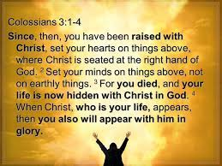
3 Since you have been raised to new life with Christ, set your sights on the realities of heaven, where Christ sits in the place of honor at God’s right hand. ² Think about the things of heaven, not the things of earth. ³ For you died to this life, and your real life is hidden with Christ in God. ⁴ And when Christ, who is your^{[a]} life, is revealed to the whole world, you will share in all his glory. That’s the text. 4 applications.
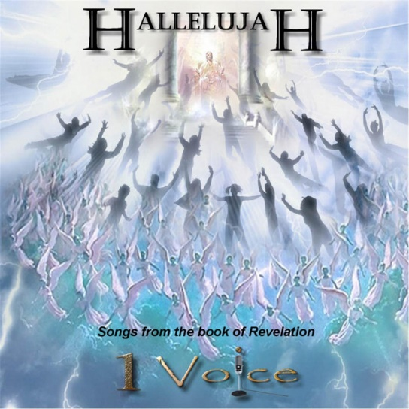
First, our praise life.
Hallelujah is the common word believers from all cultures will sing in heaven. Revelation 5 and 7 speak of the praise sung continually in heaven:
Rev. 5:11-12: Then I looked again, and I heard the voices of thousands and millions of angels around the throne and of the living beings and the elders. ¹² And they sang in a mighty chorus:
“Worthy is the Lamb who was slaughtered—to receive power and riches and wisdom and strength and honor and glory and blessing.” ¹³
Rev. 7:9-12: ⁹ After this I saw a vast crowd, too great to count, from every nation and tribe and people and language, standing in front of the throne and before the Lamb. They were clothed in white robes and held palm branches in their hands. ¹⁰ And they were shouting with a great roar, “Salvation comes from our God who sits on the throne and from the Lamb!”¹¹ ( You know, heaven is going to be noisy!:))And all the angels standing around the throne with the elders and the four living beings. . .sang “Amen! Blessing and glory and wisdom and thanksgiving and honor and power and strength belong to our God forever and ever! Amen.”
Can you picture it, beloved? How amazing this is. So, every time we lift our voices in praise, we are joining the multitudes in heaven in their worship. This is why we opened our gathering songs and Hymn of adoration with the theme of praise. (What I call happy, clappy music!)
I got a small taste of heavenly praising several years ago when I was invited to preach at a very large church in Bangkok Thailand.. People were all mostly Asians, of course, but they were still of diverse cultures, ages, and languages. Yet during the service where I was a participant and not the preacher, I experienced the most amazing worship as people began simultaneously to all sing in the Spirit – their voices blended in perfect harmony, the praises lifted in crescendo, then quieted and then swelled again – still all simultaneously without any accompaniment. That praise sang through my whole body and soul. I am hoping for more of that kind of praise as we are all tuned into God’s frequency!!

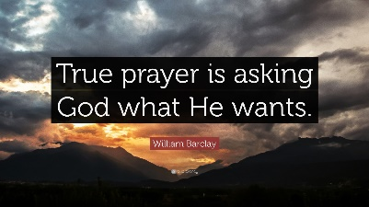
Second, we need to be tuned into God in our prayer life. Two quotes help us. 1. True prayer is asking God what he wants. And 2. Prayer is the act of seeing reality from God’s perspective. As God has called me to a prayer ministry over the years, I have so many stories of how that has worked. God’s answers have always come when we have asked first, “What is on Your heart, Lord? Help us see things from Your point of view and use us to pray these things into our current reality.” Romans 8 says the Spirit prays for us and can lead us to pray tuned into heaven’s frequency. ( a ML paraphrase of the famous verse in Rom. 8:26!) Then, as God works, in answer to prayers, all the glory goes to Him! We become His conduits through which God’s kingdom agenda goes forward. It's an enormous privilege!

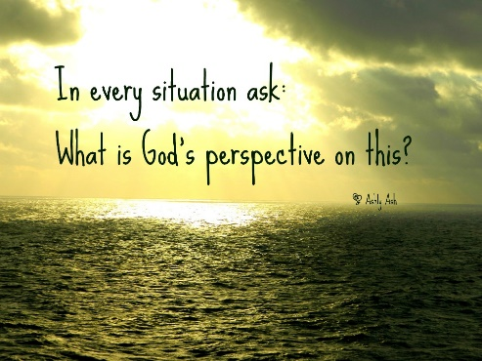
Third, on a larger scale, our priorities. In every situation ask “What is God’s perspective on this?” This has enormous implications for us because it is framed in that biblical way of being all-inclusive! IN EVERY SITUATION. So it’s about how we spend or save our money, about who we choose as friends, about how we spend our time and invest in the people and projects that are on God’s heart, about career choices and relationship choices. It’s about how we handle conflict and the sufferings of life. I love the hymn which describes His focus: “All for Jesus! All for Jesus! All my being’s ransomed powers, all my thoughts and words and doings, all my days and all my hours. Let my hands perform his bidding, let my feet run in His ways; let mine eyes see Jesus only; Let my lips speak forth His praise. “(words: Mary James, music: John Stainer – Hymns, IVP 1952). A single-minded focus in every situation is what it means to be tuned into God’s frequency!

And finally, application #4: we see things with a perspective of hope. This is critical because so many issues in the world and even within us as a people are working to unhinge us – to plunge us into a permanent sense of helplessness or despair. Or, into a “c’est la vie” attitude, as the French say – shrugging our shoulders and saying resignedly “This is life! What can we do?”

But that is not a heavenly perspective. That is, in fact, a very limited human perspective. Our Scripture text today resounds with the fact that we are raised above such a pessimistic view of fate. We are risen with Christ, seated with Him right now in heaven. In this privileged place we can share His confidence, His peace, His hope and God’s plans for all of history, including our immediate future. We can know God’s purposes will come to pass. All His promises have always been Yes and Amen in Jesus Christ. And Jesus IS coming back to reign on earth and bring an end to all the sin and evil and despair and chaos. His reign will usher in righteousness and justice and joy and peace. Where the lion WILL lay down with the lamb and sorrow and sighing will flee away. Until then, hope in God’s certain future becomes like an anchor of our soul in the midst of life situations which can make us feel like we are in a small lifeboat in the midst of a raging ocean storm

This week Keith went into hospice care. For many people that is a time of wringing of the hands and a feeling of fear of impending death. But for us, we are praying that his death comes soon because it will be a wonderful release for him from the ravages of Alzheimers, his own body wearing out and the deterioration of his heart. So we don’t grieve as those with no hope – we celebrate his coming deliverance and becoming completely whole, just as God intended from his creation. Jesus has promised eternal life when we trust in Him. He has promised to have a place in heaven reserved for us. Keith will go join Him and all God’s people he knows and has yet to meet in heaven. And he will hear and join in the singing beyond his wildest imagination. God’s hope is the anchor of our soul

Summary
Tuning into God’s frequency helps us appreciate praise and join in the choruses of joy that resound in heaven all day long. It helps us pray on God’s agenda so we can participate in God’s miracles on earth. It rearranges and then sustains the godly priorities of our life so we can walk with the Lord in confidence, wisdom and love. And it gives us the needed anchor for our soul in the midst of uncertainty, suffering and a seemingly very unstable future. Our assurance of all these things is based on Colossians 3:1-4 - the Word of the Lord for the people of God. So we can say: (or maybe even shout?! Thanks be to God. Shall we try it?) Repeat: Leader: This is the Word of God for the people of God. People: Thanks be to God. Amen. Dr. M.L. Codman-Wilson 7 17 22. Let us pray.

Our theme for next week is “God’s Empowered Forgiveness” and our text is Col. 3:13.

For today our song of going forth is My Hope is Built on Nothing Less than Jesus’ Blood and Righteousness. Our anchor is Jesus. It is His blood and righteousness. It is his love and mercy and power. We can leave here together with God’s shield around us, His glory on us and our heads raised in confidence and a firmly established heavenly perspective. Hymn #379, v. 1 and 2. Please stand.

Pastoral benediction.
Congregational song of hope and faith: Because He lives.

