New Hope Global Sermon A Daniel Fellowship?

Introduction
This week I am reading and reviewing A Burning in My Bones – a biography of Eugene Peterson. One theme that comes throughout is Eugene’s relentless pursuit of God and what God had called him to be and do. He wanted to be a saint who could bring its truths of God’s Word alive in the daily lives of the people. He had success in academia and with the translation of The Message. And he was a faithful pastor in a small church for thirty years (more on his life and character is forthcoming in my review posted later this week). But toward the end of his life, he just felt the insistent call to be a writer and so he and Jan, his wife, chose to return to North Dakota – the place where his spirit could soar and he could fulfill his calling of writing, and shepherding leaders from their “monastic” retreat house name Selah in Flathead Valley at the edge of Flathead Lake.

I resonate with Peterson’s passion to be God’s man and to fulfill his calling – a passion that kept resurfacing throughout his career - and am still seeking to steward God’s calling in my own life. My passion focuses on caring for international students, prayer, discipleship and building a multicultural community. Alex and my book Supracultural Gospel is the fulfillment of one part of that calling. And the dear, deep connections to people in prayer from many parts of the world is another. But I have a fire in my own bones to finish out my time on the planet in multicultural community.

This past weekend we had 24 people in person and through zoom internationally who were part of our house blessing for our new home in Wheaton at 1514 N. Washington. We had a time of prayer together for God’s purposes and anointing in this house. It was also a time to thank the Lord for the amazing evidences of his provision for us here. And, of course, it was a multicultural community who shared this experience together – Christians from China, Japan, Indonesia, Brazil, South Korea, Singapore, and the US. One small window into the joy of multicultural community occurred when we were all praying together. As the prayers of thanksgiving were spoken, I heard the voice of three-year-old Nathaniel talking and singing. Bing, Nathaniel’s father, had been on staff at New Hope and so little Daniel and his mother were in our house fellowship since his birth. We can all recall Nathaniel’s clapping, singing, taking the mic and dancing to the music even as a toddler. Last night he continued his participation! After the meeting was over, his Mom Emily came up to me and said, “Nathaniel was singing ‘Thank you, Lord. Thanks for all the yummy food’ in Chinese!” It made my heart sing. All ages, all cultures praising God together.

A Calling
But I don’t believe last Saturday night was to be a one-time special event here. It just rekindled the joy of my own call and so I am asking God for the next step. What has come is the vision to have a Daniel Fellowship here in our home. It can be a smaller version of our house churches in the past and I would not be the main leader and preacher, but I believe it is right for this time in my life, and right for Keith with his progression in Alzheimers. It is not really possible to take him out to any large church gatherings anymore, but he can still welcome people and engage in a limited basis here at home. I long to host an international gathering where there is healthy, “yummy” food we can share together plus fervent prayer for each person’s and nation’s needs and praise and worship as we honor the Lord and respond to His Spirit’s promptings together.

But, for this to happen, I believe God needs to bring 3 main elements together:
- The top priority is to find a young man with a Daniel kind of heart and gifts to preach and lead, whom I can mentor, encourage and partner with.
- A small gathering of internationals who are also seeking intimacy and a walk with God in a global context. I appreciate Peterson’s idea that the church ‘s role “is to invite people into a new reality ruled by the kingdom of God.” (Winn Collier, A Burning in My Bones, Waterbrook, 2021, p. 125.) Revelation makes it clear that the Kingdom of God spoken of centers around Jesus Christ with believers of every tongue and tribe and nation praising Him. (Rev. 5 +7). That’s the standard.
- And the financial backing from other Christians who could provide a very modest stipend of a few hundred dollars a month for the Daniel preacher/leader.

Let me fill out this vision a bit more.

A Daniel leader.
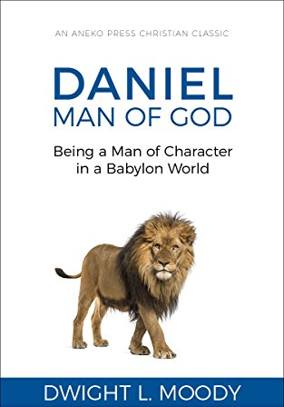
The aspects of the biblical Daniel’s life that seem right for this time and place are first his integrity and the steadfastness of his walk with God. As a young Jewish captive in Babylon, Daniel was given a place of privilege in the king’s court. But his first resolve was not to defile himself with the royal food and wine. (Dan. 1: 8). This is a simple boundary line in Daniel’s life but it has rather substantial ramifications in the American culture where eating carbohydrate-laden, large portions of rich foods is creating a culture of obesity. The food I would serve as the fellowship meal each week would be healthy, light fare of soups and salads and light casseroles. In Daniel’s context, there was pushback to Daniel’s request by the chief official and guard assigned to him and his three friends.. But Daniel persisted: (Daniel 1:12-16): ¹¹⁻¹³
“Daniel appealed to a steward who had been assigned by the head of the palace staff to be in charge of Daniel, Hananiah, Mishael, and Azariah: “Try us out for ten days on a simple diet of vegetables and water. Then compare us with the young men who eat from the royal menu. Make your decision on the basis of what you see.” ¹⁴⁻¹⁶ The steward agreed to do it and fed them vegetables and water for ten days. At the end of the ten days they looked better and more robust than all the others who had been eating from the royal menu.
As the co-host with Keith, I will gladly expand the menu beyond vegetables and water but will keep within the parameters of healthy living! Fellowship around a meal is a great value in all cultures globally and a blessing relationally!

Daniel’s steadfast loyalty to his God was also seen in a sterling part of his character. Even when jealous Babylonian officials wanted to get rid of Daniel, Daniel remained faithful in worshipping God as the Jewish religion prescribed: Dan.6:6-12 :
⁶⁻⁷ The vice-regents and governors conspired together and then went to the king and said, “King Darius, live forever! We’ve convened your vice-regents, governors, and all your leading officials, and have agreed that the king should issue the following decree: ‘For the next thirty days no one is to pray to any god or mortal except you, O king. Anyone who disobeys will be thrown into the lions’ den. ‘⁸ “Issue this decree, O king, and make it unconditional, as if written in stone like all the laws of the Medes and the Persians.” ⁹ King Darius signed the decree.
¹⁰ When Daniel learned that the decree had been signed and posted, he continued to pray just as he had always done. His house had windows in the upstairs that opened toward Jerusalem. Three times a day he knelt there in prayer, thanking and praising his God. ¹¹⁻¹² The conspirators came and found him praying, asking God for help. They went straight to the king and reminded him of the royal decree that he had signed. “Did you not,” they said, “sign a decree forbidding anyone to pray to any god or man except you for the next thirty days? And anyone caught doing it would be thrown into the lions’ den?” “Absolutely,” said the king. “Written in stone, like all the laws of the Medes and Persians.” The Message

So Daniel was cast into the lions’ den for his loyalty to God, and you know the story: God shut the mouths of the lions and Daniel was not harmed.Dan.6:16-23. Instead, King Darius elevated him in leadership in Babylon. Being a man of character in a Babylonian world is still needed in leadership among God’s people today.

Daniel’s also had a passion to know God’s Word and to understand and interpret its meaning. Daniel 9:1-22. It was God who gave him that understanding, but it was Daniel who sought God so fervently in the scriptures and prayed in response to what he understood. That passion for God’s Word needs to be deeply embedded in the young man I hope to find who can lead the Daniel Fellowship with me in the manner Peterson himself discovered:
“Scripture had always been Eugene’s spiritual center. For as long as he remembered, he had read Scripture with rigor and discipline, even memorizing vast sections outright. The Bible had been the turf where, as a young Pentecostal, he would spar (good-naturedly) over doctrine with others. But for all its influence, the Bible had always seemed somehow external to him. . . No one had guided him into the wonder, beauty, and artistry of the ancient pages. It had been a thing to use, to master.” But, he learned to “see Scripture as a world to be entered” (Collier, Ibid, p. 68).
We want to help our people internalize the transforming power of God’s Word so they can thrive and become God’s history-makers as God sends them out in the world from Wheaton. This is what has happened from our house church since 2010 and is still the passion of my heart.

Finally, Daniel was also committed to prayer. I do believe any fellowship that is created at our new house has to include God’s heart of a house of prayer for all nations. Prayer in Jesus’ name is powerful globally but is also the oxygen needed in each believer’s walk with God.

A Small Fellowship
Secondly, God would need to put in place a few others who share this heart for a global international fellowship devoted to God, to prayer, to God’s purposes in the world, and to one another. Monocultural churches already abound in Wheaton and activities and good causes proliferate for Wheaton folk. But if this is God’s idea, then there will be some who share the vision and want to become Daniel-style, global disciples who care deeply for one another. Interestingly, since we had to close our house church in 2019 when we moved to Florida, this mutual care among our members at our 911 Washington St. house has prompted us to continue to meet weekly with members from around the world on Zoom so we can share praises and pray deeply for one another.

Partners in Support
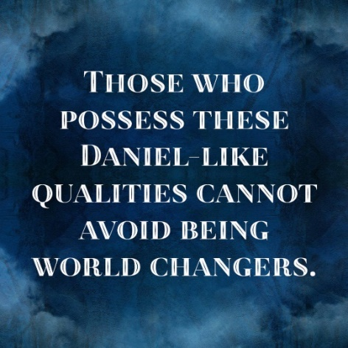
And finally, if this is God’s calling at this time, then I am trusting God will stir other people’s hearts to join me in providing the small funding necessary to reimburse our Daniel leader with a very modest stipend each month. This can happen if several of us will donate $50 – 100 every month so we can make this stipend possible. None of the money will go for me and the maintenance of the fellowship. It would all go for cash salary for the Daniel leader.

A multitude of godly counselors
Any vision and calling from God is totally dependent on the Holy Spirit to bring it into being. So, each of these three components need to be in place for a Daniel Fellowship to begin this year in Wheaton. Since “there is wisdom in a multitude of counselors“ (Proverbs 15:22), I now seek your wisdom and prayers as we see what God wants to do. Another adventure to share together, perhaps, in our journey with the Lord.? Can we continue to multiply Daniel type world-changers in our midst? Please get back to me with your responses.

Bless each of you.

Dr. Mary Lou Codman-Wilson
Pastor New Hope Global Fellowship
February 14 2022

