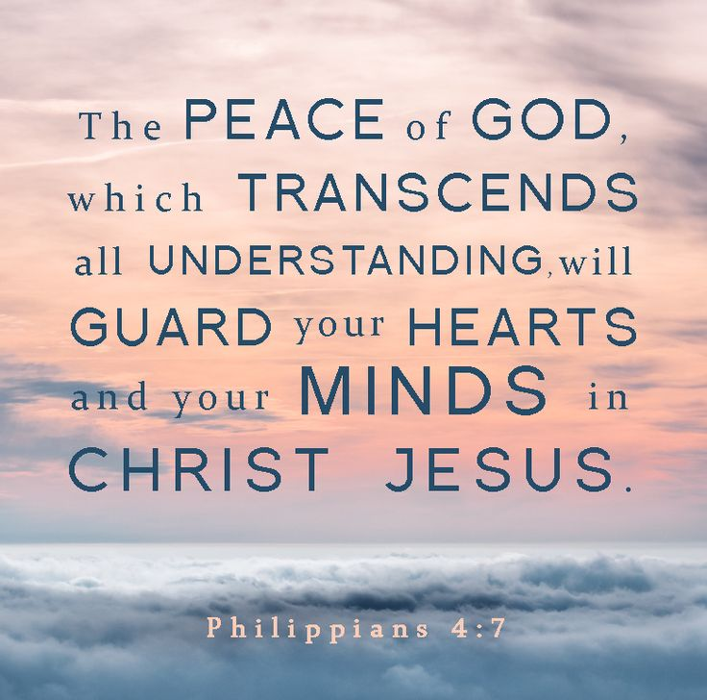
Sermon 8 14 Ogden Dunes “Reigning Peace”

The past 3 weeks were perhaps the most stressful in my life in a very long time. First, because of a crisis a his previous Memory Care Center, Keith had to return home and his next steps were in limbo; we faced the crises of his behavior, the need to find a more suitable memory care center for him, issues in the lives of my caregivers, his initial fall in his new Memory center and another hospital visit, and then 4 subsequent falls within 24 hours that day. He is under watchcare and we had to get special additional caregivers to supervise him through the night. That is continuing this weekend. So, I have been living every word of this sermon, beloved, as I know you each have been living these words in the struggles you are facing. Thank you so much for your prayers. Praise God for His continuing Presence, power and love! His peace has needed to be a guard on my mind and heart!

In that context, as we approach this topic of reigning Peace, I thought you’d appreciate a few different perspective on peace.

Sometimes it takes being creative with a different solution to your problem:
Two rabbits were being chased by a pack of wolves. The wolves chased the rabbits into a thinket. After a few minutes, one rabbit turned to the other and said, “Well, do you want to make a run for it or stay here a few days and outnumber them?”GCFN3/8 02

Or, this advice for the day: If you have a lot of tension and you get a headache, do what it say on the aspirin bottle: “Take two aspirin” and “keep away from children!” (GCFN8/6/02)

But for those who live in the midst of children . ., these words from an experienced mother:
If you hook a dog lease over a ceiling fan, the motor is not strong enough to rotate a 42 pound boy wearing Batman underwear and a superman cape. It is strong enough, however, if tied to a paint can, to spread paint on all four walls of a 20x20 foot room…
. .. You Always look in the oven before you turn it on. Plastic toys do not like ovens.. . The fire department in Austin TX has a 5 minute response time GCFN 7/9 01 The need for reigning peace. Let us pray

Introduction.
Today our text in our sermon series on practically Living Christ is Col 3:15
- Let the peace that comes from Christ rule in your hearts. For as members of one body you are called to live in peace. And always be thankful. NLT
- Let the peace of Christ keep you in tune with each other, in step with each other. None of this going off and doing your own thing. And cultivate thankfulness. The Message
- Let your heart be always guided by the peace of the Anointed One, who called you to peace as part of his one body. And always be thankful – Passion Translation.
Peace that rules in our hearts. Peace that keeps us in tune with each other. Peace that is from Jesus, the Anointed One. When that peace rules, then thankfulness can flourish.

So we start with the simple Cares Chorus in your small hymnal #2215: Song: Cares Chorus
I cast all my cares upon you, I lay all of my burdens down at your feet, and anytime that I don’t know what to do, I will cast all my cares upon you. (words and music: Kelly Willard) #2215 That’s a good song to learn and sing throughout your stress-filled or oppressive or anxiety-ridden day. Let’s sing it again. I cast all my cares upon you, I lay all of my burdens down at your feet, and anytime that I don’t know what to do, I will cast all my cares upon you. Music with words like that keep me centered on God’s perspective.

The 9 ps of peace
So here’s my definition of peace that serves the same purpose: peace described with 9 P’s to make it easier to remember. You will want to write this definition down.
Peace is not predicated on the absence of pain and problems but on the promises, power and presence of the Prince of Peace, our Lord Jesus Christ.

Our starting point is Jesus Christ Himself. He came to earth as The Prince of Peace. Is, 9:6 And so the song of prophesy of Zechariah in foretelling Christ’s birth is that He will guide our feet into the path of peace.” (Lk.1:79 The angels sang at Christ’s birth “Glory to God in the highest and on earth peace to those on whom God’s favor rests.” Lk.2:14.

On earth Jesus Christ is the One who stilled the violent storm on the Sea of Galilee. The storm was so fierce it made his disciples (experienced fisherman whose livelihood was out on the water) thought they would all drown.) (Mk.4:39). Colossians 2:15 says “Jesus Christ is the One who is holding the universe together by the word of His power.”
2 thes. 3:16 says He is the One who now gives His followers His peace at all times by all means.2 Thes. 3:16 And, in the gospel of John we see Jesus bequeath His peace to His disciples both before and after His crucifixion. John 14: The Offertory song sung in our service today is from the very words spoke: “My peace I give unto you. It is a peace the world cannot give. It’s a peace the world cannot understand – peace to know, peace to live, My peace I give unto you. Do not let your hearts be troubled and do not be afraid “(Jn.14:27).
Similarly, as he predicted the scattering of the disciples when he was captured and crucified he said, I have told you these things so that in me you may have peace; in this world you will have trouble but take heart, I have overcome the world Jn.16:33)

Then, before He ascended back to heaven He promised His presence would be with his disciples (then and now) forever. So, “Peace is not the absence of problems. It is the presence of the Lord Christ.”

In the Epistles, Paul tells the Galatians that the peace of God is a fruit of the Spirit that expands progressively in our lives as Christ has more and more control of us. Gal. 5:22. And Paul tells the Philippians that God will grant them His peace when they do two things: submit everything to God with prayer and thanksgiving, and direct their minds to think of positive not negative things, or people or circumstances:
Phil.4:4-6: Don’t worry about anything; instead, pray about everything. Tell God what you need, and thank him for all he has done. ⁷ Then you will experience God’s peace, which exceeds anything we can understand. His peace will guard your hearts and minds as you live in Christ Jesus.
Phil.4:8-9 And now, dear brothers and sisters, one final thing. Fix your thoughts on what is true, and honorable, and right, and pure, and lovely, and admirable. Think about things that are excellent and worthy of praise. Keep putting into practice all you learned and received from me—everything you heard from me and saw me doing. Then the God of peace will be with you. NLT

The Prince of Peace will give us His peace at all times by all means, but we must be in a open frame of mind to receive it and to clear out all the negative forces, worries, distractions, accusations and lies of the enemy that keep us from receiving it.

I have a little book called Red Sea Rules that applies these principles from the Old Testament story of Israel’s flight from Egypt and eventual crossing of the Red Sea in freedom from Egyptian captivity. Here is how God can bring peace in our most dire situation. Remember from the story that God had brought the Israelites out to the desert enroute to the Promised land and guided them in their initial journey. But Pharaoh decided he wanted the Israelites back as slaves so his chariots and horsemen came thundering down on the Israelites as they fere camped by the Red sea. Definitely a stressful situation!!Exodus 13:17-14:31. So here are the 10 Red Sea Rules for your impossible, stress-laded situation: You’ll definitely want to write these 10 rules down:
Rule 1 – Realize that God means for you to be where you are. [God had led the Israelites to the very “cul-de-sac between hostile hills, to the edge of a sea too deep to be forded and too wide to be crossed…If you find yourself in a difficult spot, remember: you are there by God’s appointment, in His keeping, under His training, and for His time” pp.6,13.]

Rule 2 - Be more concerned for God’s glory than for your relief. [The next time you’re overwhelmed, instead of asking, ‘How can I get out of this mess?’ try asking, ‘How can God be glorified in this situation?’…God deliberately orchestrated the Exodus events to demonstrate the power He wields over His enemies and the elements” pp.19-20.]

Rule 3 – Acknowledge your enemy, but keep your eyes on the Lord. [There are strong parallels between Pharaoh and Satan. Satan “pursues you with the intensity of Pharaoh...He tries to trap you in difficulty, to entangle you in trouble, to corner you in impossible situations, to lure you into temptation… Acknowledge Satan’s activity but don’t be intimated by him. You can resist him in the power of God and by the blood of Jesus Christ” (pp.32-33)…We always make a mistake when we acknowledge the Lord but keep our eyes on Satan… Keep your eyes on Christ. He will see you through. He will make a way” pp.37-38.]

Rule 4 – Pray! [“When we can’t press forward, move sideward or step backward, it’s time to look upward and to ask God to make a way...Focus not on your negative feelings but on God’s assurances and promises, pleading in faith for “God to grant mercy and imparts grace to help in time of need” pp. 40,48.]

Rule 5: Stay calm and confident, and give God time to work. [“Moses told the people: ‘Fear not, stand still and see the salvation of the Lord which He will work for you today…The Lord will fight for you’” (Exod.14: 14). The Lord still does that.]

Rule 6: When unsure, just take the next logical step by faith. [Day by day and step by step God promises to lead us…“Our main business is not to see what lies dimly at a distance, but to do what lies clearly at hand…When you don’t know what to do next, cast out fear and seek light for the next step” p.65.]

Rule 7 – Envision God’s enveloping presence. [“For His children God serves as both Guard and Guide. He both precedes us and protects us” (p.71). The pillar of fire and cloud followed the Israelites through the wilderness. Then at the Red Sea the pillar moved behind the Israeli army, giving light to them and darkness to their Egyptian pursuers.]

Rule 8 – Trust God to deliver in His own unique way. [“We must have God’s perspective on deliverance, for He doesn’t always view things as we do…There is deliverance by miraculous intervention, by ordinary providential ways and by God’s mysterious ways…Charles Spurgeon once quipped, ‘We believe in the providence of God but we do not believe half enough in it’” pp.80-94.]

Rule 9 – View your current crisis as a faith builder for the future. [“We don’t know why God allows problems but we know he intends to use them to heighten our maturity and deepen our faith…Faith has a cumulative quality to it…We grow it and lay it in store for future times…God gives us a promise then takes us into a desperate situation “to see if we will apply His promise to our problem…Faith is simply finding and claiming the promises of God in every situation, and, based on those promises…being fully persuaded that God has the power to do what He has promised” pp.96, 102,104.]

Rule 10 – Don’t forget to praise Him. [“Our tough situations give us the opportunity to sound
forth His praises. God expects our gratitude for His deliverance…Develop the perspective of praise…It’s our typical expression of joyful confidence and triumphant thanksgiving at what God has done, is doing, and is going to do”(The Red Sea Rules, Robert J. Morgan, Thomas Nelson, 2001 , pp.107,110, 112 )

How can you apply these rules in your situation, beloved? Or the situation of your friends or family member or city or church or our nation? If you live out these rules, then You will live through the challenges with Christ’s reigning peace and you too will celebrate God’s deliverance in your situation and have your mind kept calm and steady by His peace. It will all depend on whether or not you trust Him.

I’ve given you a definition of Christ’s peace. I’ve given you key verses from the Bible. I’ve given you 10 rules to apply. Now, I close with a missionary story demonstrating that kind of trust. This one comes from meditations from Bernie May, a jungle missionary pilot who has flown small single and twin engine planes throughout the Andes mountains in South America to service the missionaries of Wycliffe Bible Translators and the nationals in the villages they are reaching with the gospel. His book is called Climbing on Course. The story actually takes place when he was home on furlough, piloting a small twin engine plane from Dallas to Houston Texas in the US.
“The controller’s voice from Houston Center was calm. “We understand,” he said. One engine has failed. We have you on radar. Montgomery Airport is 45 minutes southeast of your position. Would you like vectors?
For the last half hour I had been enjoying the bright Texas sky as we cruised high above an overcast. Below us, rain and fog blanketed the ground between Dallas and our destination, Houston. Then, BANG! One engine on the Cessna sputtered and stopped. The dead prop on my right looked strange and ominous. I could still fly – one of the joys of twin engines- but I was not overly ecstatic about making a single-engine approach into an unknown airstrip in weather that had the ducks walking.
I glanced over at my two passengers. They were staring, transfixed at the motionless propeller. “We’ll soon be on the ground at another airport,” I said, in a weak effort to allay their anxieties. But who was around to comfort me? I reached for the mike and soon the reassuring voice of he Houston controller filled he cabin. “Okay, Houston,” I responded. “I’m with you. Requesting vectors to Montgomery Airport.” “Turn left,” he said. “Heading 110 degrees. Descent to 4,000 feet.” I followed his directions implicitly, trying to keep the airplane firm and level at the same time. At 4,000 we entered the clouds, fling blind through the mist and rain. “Descend to 3,000 and turn right five degrees,” the steady voice instructed. “Descend to 2,000 and turn left five degrees. . .Now turn right30 degrees and descend to 1,500 feet.”
As we dipped into the rainclouds, I could barely see the tip of my wing. But I knew he knew where I was. That was enough. I didn’t know his name. I had never seen his face. But I knew I could trust him. I had no other choice- unless I wanted to try and make it on my own.
Suddenly we broke out of the clouds and there it was: a mile of wet asphalt glistening in the rain. I’d never known asphalt to look so beautiful.
I’d been more than willing to entrust my life to a faceless voice speaking complete directions through the fog. Touching down, I thought of another voice. Calm, patient, ever present when over the years blinding mists have thrown carefully wrought plans into chaos. God’s voice.
Did I really trust that voice? As much as I trusted the stranger in Houston? Would I be willing to follow exacting instructions when I couldn’t see any farther than the end of my nose?
Good questions. Questions which have to be answered. . .on a regular basis. . .like every morning. I Peter 1:8 “Though you have not seen him, you love him, and even though you do not see him now, you believe in him and are filled with an inexpressible and glorious joy. (Bernie May, Climbing on Course, Multnomah Press, 1978, pp.”A Voice in the Storm,” pp. 39-40)

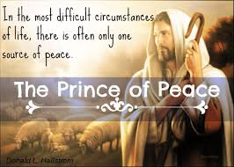
Lots of times our lack of peace is because we get into situations we can’t navigate ourselves and when a major piece of that situation becomes dysfunctional, we react with anxiety and fear. But trusting in the Shepherd’s guidance, as He says turn right or turn left or wait, that trust, beloved, is becomes the grounds for our peace. Actually, for living in His peace. As the graphic says, “In the most difficult life situations, there is often only one source of peace: The Prince of Peace.”

Let’s trust Him, beloved so His peace reigns in us. Amen. Let us pray.
Dr. Mary Lou Codman-Wilson 8/14/22

Knowing the keeping power of God’s peace, we will go out singing: “I’ve got peace like a river…I’ve got joy like a fountain, I’ve got love like an ocean in my soul.!” This is a song of thanksgiving we can sing in the midst of our impossible, stress-laden situations.

Pastoral Benediction: Now may the God of peace Himself give you His peace at all times by all means.” Amen! So be it! 2 Thes. 3:16

