Sermon A Colossians 3:16 Being in God’s Transforming Presence – the power of worship august 21

**Introduction**

I love worship and I love worship in community. When it’s in a church sanctuary there is even more possibility for color and liturgy and movement and the full use of all our senses. Richard Foster once said true worship is meeting God in His Shekinah Glory in the sanctuary. This kind of engaging with God’s Presence is truly transforming and that is one of the major purposes of our coming together each week. But I have read some sad commentaries on the state of our modern worship that I want to set out as warnings of models we don’t want to follow.

Lament One:

For many, worship becomes the time when God is supposed to meet our needs rather than a time when we give glory to God. . .Worship is not about us but about God. The Word is God’s, the wisdom is God’s, and thanks are due to God alone. [But] we have blown up balloons, danced in the aisles, marched behind banners, we have turned to jazz and sung ditties whose theological content makes a nursery rhyme sound like Thomas Aquinas. . .[All efforts to try to fan the flame in a dying church]. We can do better than that, and we must, for then the truth of God as made actual in Christ and attested in the gospel evokes the truthful praise of Christ. . . Worship that resembles a three-ring circus may attract many people and result in many responses, but the people who respond may only have a superficial relationship to Christ..

Lament two:

“The supreme test for many people really is whether they have found the hour in church enjoyable, whether the music was good, the singing hearty, the decorations no offense to the eye, the curtains the right shade, the building beautiful {so] they come away “feeling better.”. . .I have sometimes caught myself wondering whether aspirin would not have served as well.” (Both come from David Garlands *Colossians, NIV Application Commentary*, Zondervan, pp.235-236, 239. )

Describing some praise music as “ditties whose theological content makes a nursery rhyme sound like Thomas Aquinas” and “maybe aspirin would have served as well’ are red flags we need to heed. May they never be said of us! But what are people experiencing at our church when they join our community in worship? Let us pray.

**Worship in heaven**

A.W. Tozer, a famous preacher of the previous century, made this statement: “Any man or woman on this earth who is bored and turned off by worship is not ready for heaven.” Now that’s thought-provoking! But he has a point. One of the greatest joys for me in going to heaven WILL be the worship – the music, the loud singing, the multitudes of people from every tribe and tongue and culture and nation singing praise to Jesus Christ, the Lamb of God. That was our Scripture passage this morning: 5

“Look, the Lion of the tribe of Judah, the heir to David’s throne,[[a](https://www.biblegateway.com/passage/?search=Revelation+5%3A5-8&version=NLT#fen-NLT-30746a)] has won the victory. He is worthy to open the scroll and its seven seals.” . . .. 9And they sang a new song with these words: “You are worthy to take the scroll and break its seals and open it. For you were slaughtered, and your blood has ransomed people for God from every tribe and language and people and nation. 10And you have caused them to become a Kingdom of priests for our God.  And they will reign[[a](https://www.biblegateway.com/passage/?search=Revelation+5%3A9-13&version=NLT#fen-NLT-30751a)] on the earth.” 11Then I looked again, and I heard the voices of thousands and millions of angels around the throne and of the living beings and the elders12And they sang in a mighty chorus: “Worthy is the Lamb who was slaughtered to receive power and riches and wisdom and strength and honor and glory and blessing.” That is going to be absolutely spectacular, beloved.

Or, singing with others the word Hallelujah! That is a universal word of praise that is used in every language.

So, to get us more ready for heaven, we will start today with a taste of heaven’s worship here as we sing these two triumphant songs. The hallelujah song is Halle, Halle, Halleluja #2026, sung to a lively Caribbean tune!

After experiencing this taste of heaven’s worship, then we will focus on how we bring that praise down to earth at church!

**Transforming Presence**

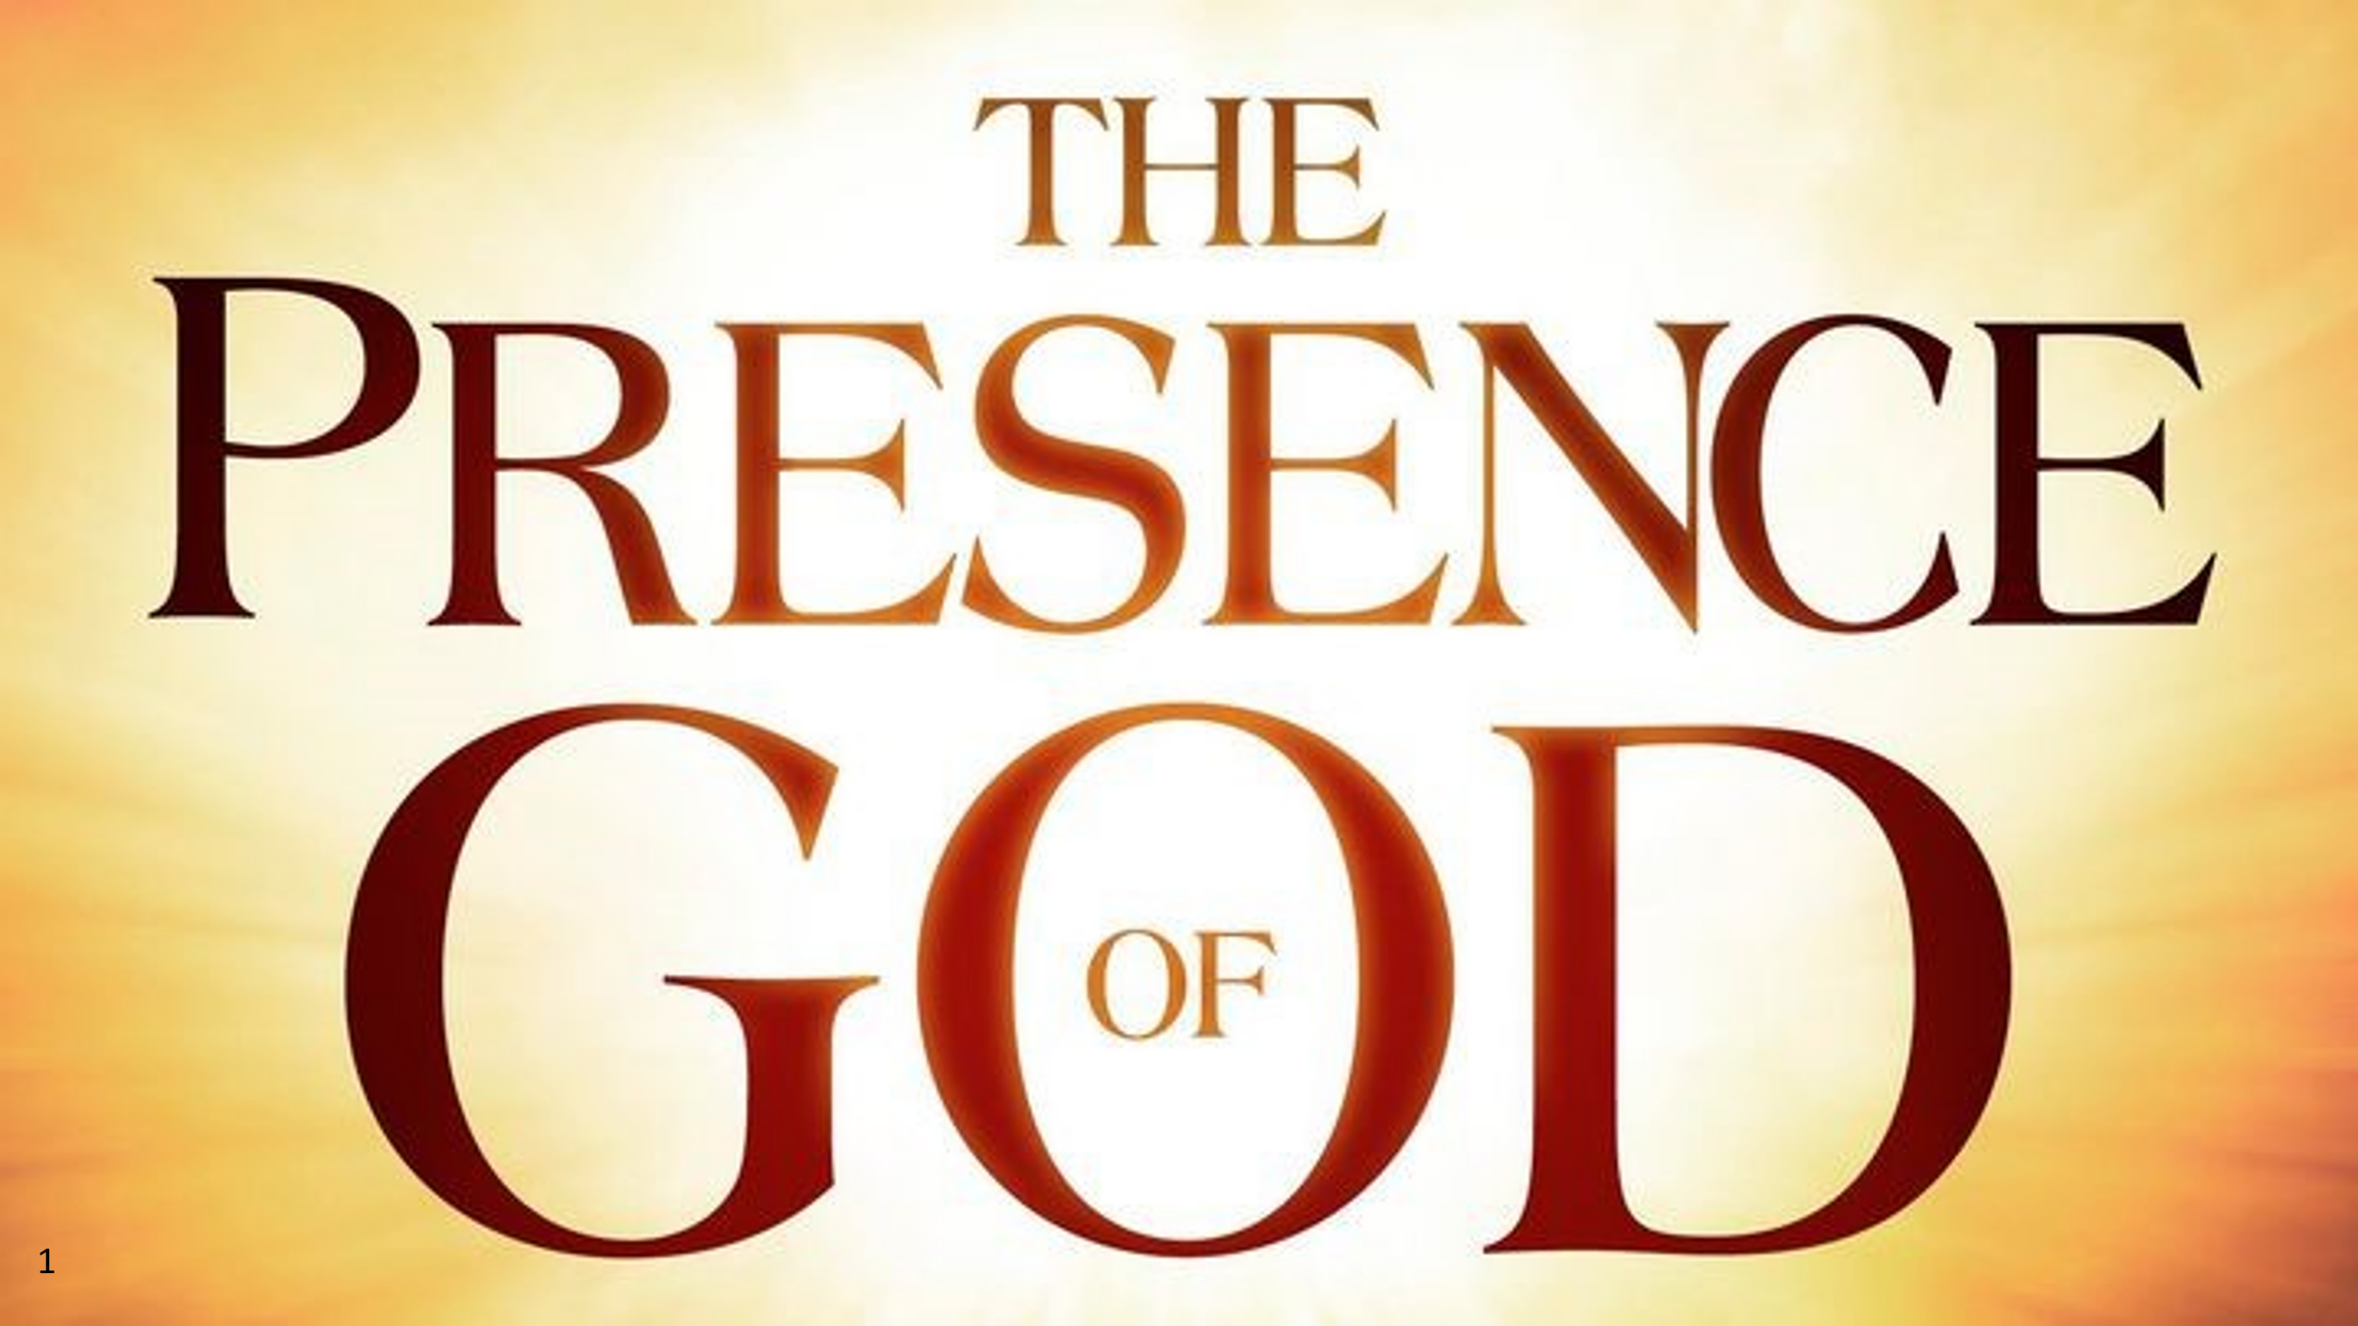Our foundational starting point for worship on earth is The Presence of God. This is promised to all believers when we gather in Jesus’ name. This means that worship is the opportunity to experience God’s Transforming Presence directly and wonderfully. This does not mean seeking some spiritual high in entertainment. Nor just coming to worship to seek what God can do for us. There should be enjoyment and even delight in the worship liturgy and experience, but I am talking about something even deeper. I believe after we have spent an hour with the Lord together, we should be changed in some way – we could have “take-aways” of a word that God has spoken to us; we could have new realizations or wisdom or experiences of God’s love that we would not have had if we had not been here; we could have new reasons for gratitude in receiving the abundance of God’s grace and peace, even in our hard, struggling times. Transforming Worship comes from the sense that we have been with God and experienced His reality. God’s Transforming Presence brings new joy in our relationship with Him and each other and a confirmed conviction of His guidance and care in our lives.

**The Colossians 3:16 model**

Our text from Colossians today which has inspired this theme is Colossians 3;16. You know, 3:16 Bible verses sometimes are quite memorable in the Scriptures:

* John 3:16; For God so loved the world that he sent His one and only Son that whoever believes in Him should not perish but have eternal life.”
* 2 Thes.3:16 Our benediction from last Sunday: “Now may the Lord of peace himself give you peace at all times and in every way. The Lord be with you all.”
* 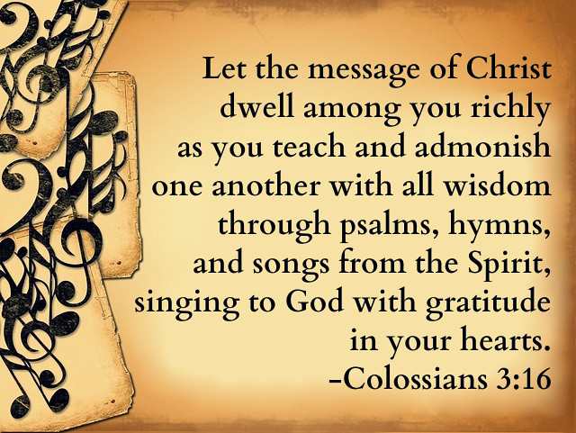I jn.3:16 “This is how we know what love is: Jesus Christ laid down his life for us. And we ought to lay down our lives for our brothers and sisters.

I believe Colossians 3:16 ranks right up there with these signature verses.

* “Let the message of Christ dwell in you richly as you teach and admonish one another with all wisdom through psalms, hymns and songs from the Spirit, singing to God with gratitude in your hearts.”

Let’s unpack what happens when these truths characterize our worship. I want to highlight 4 reasons why worship can be transforming.

First,

When we come to our Sunday service with the expectation of hearing from God. His presence has been promised, but what is needed is our readiness to hear and receive what God wants to say to us. So we focus on letting His Word penetrate our hearts and minds. We adopt the attitude of “Speak, Lord for your servant is listening.” And as we sing, we sing with our hearts as well as our minds, intentionally meaning what we are singing!! All the music we choose for every Sunday is all around the theme of the morning,; it is all based on scripture so the message of Christ can get through to us.

Then, second , it will be transforming when we are alert to how the Holy Spirit is doing His transforming work in us, changing us from the inside out. Third, often, this involves leaving old things, old ways of thinking and acting and being behind us as you pursue God’s message. It involves genuine renewal each week.

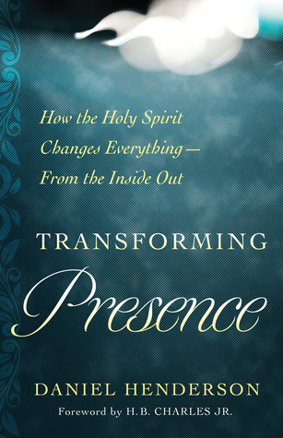

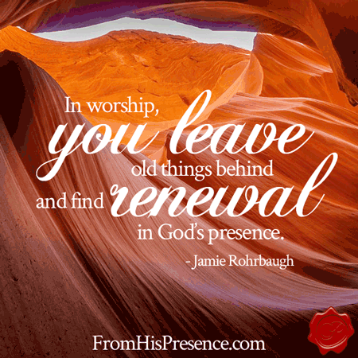

Monday night I got a text message from one of my prayer partners, the Susan from Florida who visited our church a couple of weeks ago. She was on a walk and invited me to call her so we could talk and pray together. She said she was also singing in her head a song she will lead for the Wycliffe Associate weekly worship time on Thursday. I know the area where she is walking and asked, “how ‘bout if you just sing it out loud as you walk? That would make it even more firmly implanted in your mind.” After we hung up, she did just that. She sang her song outloud in worship to the Lord. Finding renewal in God’s presence Monday night gave her new freedom to sing outloud during her exercise routine as she walked alone without people nearby. Lovely.

Now Susan does lead a worship team at her church in Florida, but you don’t have to be a trained singer to sing outloud to the Lord. In fact, the King James translation of the Scriptures in the Psalms say “make a joyful noise unto the Lord!”- Psalm 66:1, 81:1, 95:1 -2, 98:4,6 and 100:1. In my early days as a Christian that translation was put to music in a delightful round. “Make a joyful noise unto the Lord, all ye lands. Make a joyful noise unto the Lord!” Any of us can make a joyful noise!! Of course, the real musicians among us may cringe a bit so the translators have cleaned it up in our more contemporary translations – to shout with joy, or sing jubilant songs. But the real issue is what is in your heart as you sing to the Lord? As we are renewed by His Spirit, joyful music is usually present – on or off key!

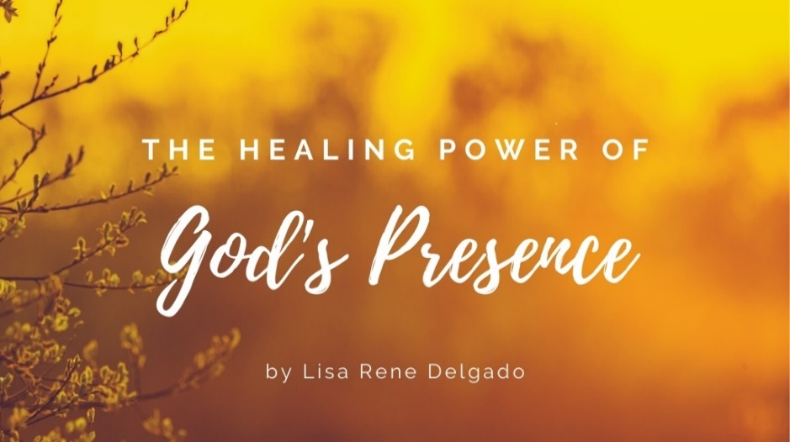And fourth, this kind of singing psalms and hymns and songs led by the Spirit are part of the healing power of God’s Transforming Presence. Can you think of times, beloved, when you came to church deeply sad, or sick, or hurting in some way and God lifted those emotions as His Spirit helped you focus on the Lord and not on your problems?

Malachi 4:2 says “For those who revere my name, the sun of righteousness will rise with healing in his wings. And you will go out and leap like calves released from the stall.” I’ve quoted that back to God many times over my lifetime. And quoted the many examples of Jesus’ healing in the gospels such as when Jesus asked blind Bartimaeus ‘What do you want me to do for you?” “Lord, I want to see,” Bartimaeus replied. “Go”, said Jesus. “Your faith has healed you ‘Immediately he received his sight. Mk.10:46-52. Or the healing of the paralytic whom 4 friends brought to Jesus, or the healing of the woman who had been bleeding for 12 years, or the healing of Jairus’s daughter (Luke 8). or experiencing the promise of the Messiah to “bind up the brokenhearted” Isa. 61:1.

There is healing power in God’s Presence, beloved and that’s why worship can be called Being in God’s Transforming Presence.

I believe the Lord is doing and will do wonderful things here in our midst as we worship here at Ogden Dunes, so let’s say this scripture in unison as we worship and praise our God.

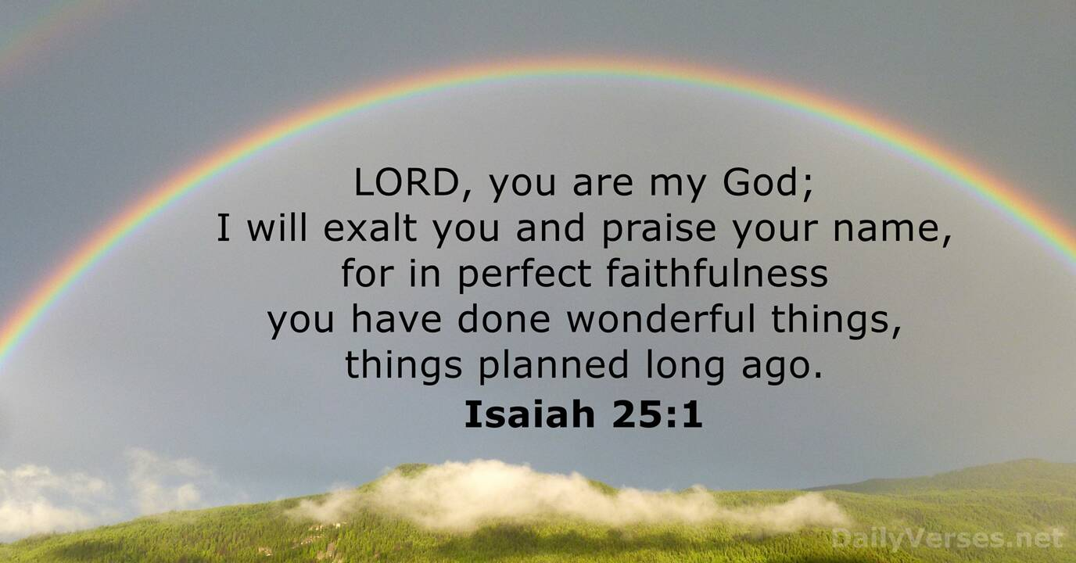

Hallelujah Amen. Let us pray.

Dr. Mary Lou Codman-Wilson

Guest Preach at Ogden Dunes Community Church

8/21/22