New Hope Sermon December 1 2011 God’s Recipe for Christlikeness

Introduction:
I love to cook. Eating together is personal and intimate and is one of the ways we practice joyful hospitality in Christian community. In fact, I have enjoyed meals with most of you who receive this sermon! It’s no surprise, therefore, that during 20 years of my pastoring in two different churches, each church had a high-quality cookbook professionally printed and sold. The one from Christ Community Church is From the Hearth, with the explanation “A place of warmth, nourishment and genuine community…the hearth was the heart of the home. We invite you to join us by the hearth.”

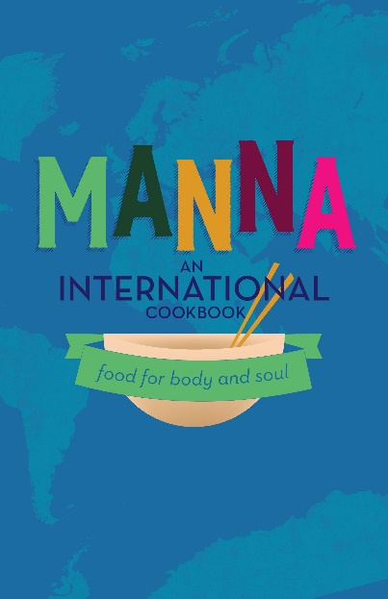
The second is Manna International Cookbook, food for body and soul, from our New Hope Bible Fellowship house church. The Manna Cookbook has stories, pictures, facts and recipes from the 15 different countries of our members: Austria, China, Ecuador, France, India, Italy, Indonesia, Jordan, South Korea, Liberia, Madagascar, Malawi, Peru, Philippines, United States and Vietnam. Each week at church or at Bible study during the week we would appreciate the unique flavors of these recipes as we ate together in global community. (Just as an aside, I still have multiple copies of that cookbook available for purchase. They are not available on Amazon but can be purchased through our church website newhopebiblefellowship.net.
Like the recipes from our global cookbook, God’s recipe for Christlikeness will look and taste different according to people’s different ethnic backgrounds, experiences, perspectives, spices, ways to prepare food and eating traditions. However, though the combination of ingredients and spices vary widely, many of the ingredients are essentially the same.
These ingredients are all part of God’s goal to develop Christ’s character in every Christian. The Apostle Peter calls this “participating in the divine nature” (2 Peter 1:4). The Apostle Paul says it is attaining to the “whole measure of the fullness of Christ” (Eph 4:13). Today I want us to think about how God uses these ingredients to create Christlikeness in us. Our main text is 2 Peter 1:5-10 ⁵

So devote yourselves^{[a]} to lavishly supplementing^{[b]} your faith with goodness,^{[c]} and to
goodness add understanding, ⁶ and to understanding add the strength of self-control, and to
self-control add patient endurance, and to patient endurance add godliness,^{[d] 7} and to
godliness add mercy toward your brothers and sisters,^{[e]} and to mercy toward others add
unending love.^{[f]} Passion

Adding ingredients one after another is how recipes are often described. This is what connected in my mind the text and cooking. Using this analogy, one more ingredient is needed in God’s recipe for Christ-like character. Most main dish recipes require salt, so we would add: Col.4:6 and Mt. 5:13

NLT: Let your conversation be gracious and attractive^{[a]} so that you will have the right response for everyone. 4:6 Greek and seasoned with salt.
Mt. 5:13Your lives are like salt among the people. But if you, like salt, become bland, how can your ‘saltiness’ be restored? Flavorless salt is good for nothing^{[a]} and will be thrown out and trampled on by others.

Developing Christ-like character
The ingredients of Christlikeness are consistently described throughout the New Testament. Notice that this recipe starts with faith – always the foundation for our transformed lives. But the addition of the other ingredients show that the faith is not just an intellectual affair. It is rooted in how we treat others and grow in maturity of character.

To faith, God wants to develop the virtue of goodness in us. Goodness speaks of a positive kindness toward others; it is seeking others’ welfare. It is holding out hope and thinking the best, not the worst about someone. It is seeking ways to bless people. This jewel of character encompasses the other traits of mercy, godliness and unending love from our text to each encounter and relationship. It is the opposite of self-absorption or negativity. Someone with a spirit of goodness will find ways to turn life’s lemons into lemonade. (See Sermon on this) In fact, this combination of goodness, mercy, godliness and love is the mark of heaven that brings God’s presence and redemption to any encounter and circumstance. It is an outward manifestation of God.

The perseverance, self-control and patient endurance are more inner qualities that have to do with how we manage ourselves and control our own reactions to difficulties.

And the salt deals with our words so they are gracious, timely and in the right proportion for the moment. Our conversation is to be “gracious and attractive.” Or, as Paul adds in Eph. 4. our words should always build up not tear others down (Eph.4:29).

The ingredients in this recipe then lead to another part of this cooking analogy. Most main dishes require heat of some sort – baking, steaming, grilling, slow-cooking over a fire or a stove. This kind of heat in the Bible is referred to as discipline, as a painful but needed process in our character transformation. So, we are to “think it not strange, beloved, at the fiery ordeal that overcomes you, as though something strange is happening to you, but rejoice in as much as you are participating in Christ’s sufferings” (I Peter. 4:12-13). The heat of these trials in the cooking process is likened to gold refined by fire. [But it comes out of God’s ultimate goal:]. “Those whom I love I rebuke and discipline” (Rev.3:18-19).

For many of us that cooking process is painful and can feel l-o-n-g and difficult. But this goes right back to the first ingredient in our transformation process – the role of faith. When we can cooperate with God in adding goodness, mercy, painful endurance, godliness and love to the mix, God can make us a witness in the world where the suffering seems never-ending and neither goodness nor hope nor God is in sight. Then we can give testimony to the God who is with us in the process and brings us through. It reminds me of the hymn:
“When through fiery trials thy pathway shall lie, My grace all sufficient shall be thy supply. For I will be with thee, thy troubles to bless and sanctify to thee thy deepest distress.” (Hymn: How Firm a Foundation. From Rippon’s Selection of Hymns, 1787), My journey with Keith’s Alzheimers has certainly been that. Day by day I know it is only God’s goodness and mercy to me that enables me to have patient endurance and love and a deep appreciation of God’s forgiveness. So let God stir up things for you as He adds the character traits you need as a witness of His. May our lives tell the story of His glory and grace. Amen.
Dr. Mary Lou Codman-Wilson, New Hope Global Fellowship 12 1 21

