New Hope Sermon Growing into Christ-Likeness

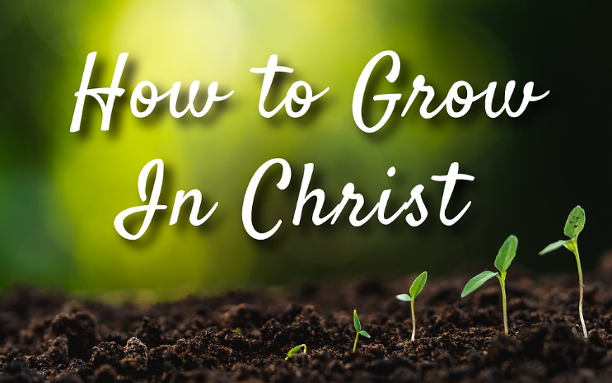

Introduction
What do people see when they see you? We hope they see Jesus. Some people wear tangible symbols to help others understanding their identity. So, many priests wear collars. But. . .
“A priest was invited to attend a house party. Naturally, he was properly dressed and wearing his priest's collar.
A little boy kept staring at him the entire evening. Finally, the priest asked the little boy what he was staring at. The little boy pointed to the priest's neck.
When the priest finally realized what the boy was pointing at, he asked him, "Do you know why I am wearing that?"
The boy nodded his head yes, and replied, "It kills fleas and ticks for up to three months" (3/10/15 GCFN).
Ah me!

What would it take for people to see Jesus in us? It’s not a matter of outward symbols but of the character and life of Christ lived out in us by the Holy Spirit. Colossians 2:6-7 gives us a prescription for how we can grow that Christian character within us, so people can experience the presence of Jesus when they see us.

What would it take for people to recognize Jesus in us? The first answer is they recognize the love of Christ that God can pour out through us . As the refrain to the song They’ll Know We are Christians says “and they’ll know we are Christian by our love, by our love; yes, they’ll know we are Christians by our love.” Each verse of that hymn describes the acts of love specifically, i.e., when we live in the unity of being one in the Spirit, when we “work with each other side by side, guarding each one’s dignity and sparing each one’s pride,” when we “walk with each other, hand in hand as we spread the news that God is in our land” – Then people will know we are Christians by our love, “by our love, yes they’ll know we are Christians by our love” (words and music: Peter Scholtes).

Given the increase in mass murders – whether on a national level by Russia in Ukraine, or in the violent shootings in the US, the killers do NOT see each person’s dignity and value. To them people are expendable, so killing them only meets a distorted, evil goal in the minds of the perpetrators.

Christians must be different. Jesus Himself said that our love for each other was to be THE MARK by which people will know who are His disciples John13:34-35: “A new command I give you. As I have loved you, so you must love one another. By this will all people know that you are my disciples if you love one another”. When he reiterates that command in John 15:13, he explains that that kind of love is to “lay down our lives for our friends”.

I personally don’t believe this is a command we keep every day – even for portions of every day. So, we need to tend to our personal lives to insure this growth of Christ-likeness in us.

Growing into Christ likeness
Colossians 2:6-7 describes this growth process through 6 verbs:
And now, just as you received Christ Jesus as your Lord, you must continue to follow him. ⁷ Let your roots grow down into him, and let your lives be built on him. Then your faith will grow strong in the truth you were taught, and you will overflow with thankfulness.

Received, continue to follow Him, grow your roots into him, be built on Him, grow strong in the truth, overflow with thankfulness. Today, I invite us to unpack those action verbs – since they put us on the path to Christ being formed in us.

First, receiving Christ. This is not the head knowledge of simply believing things about Christ. This is the process of becoming His disciple through an act of faith. John 1:12-13 says: “ To all who did receive him, who believed in his name, he gave the right to become children of God, ¹³ who were born, not of blood nor of the will of the flesh nor of the will of man, but of God.” It involves a relationship that begins when you come into the family of God through faith in Jesus Christ. You become his son or daughter, a beloved child of the Father God, indwelt by the Holy Spirit.

But that’s only the first step – what Jesus describes as being “born again” (Jn.3). From there the growth process of transformation starts. So, we are urged to continue to follow Him. We are to learn who Jesus is, how to follow His leading, how to become who He wants us to be, individually and corporately as a Body of Christ. We have to follow Him. We study the gospels to see who He is and what He does and then trust Him to make us the same – since he said those who love him will do greater works than He did. Like a child with her father, we grow as we learn to obey His directions. We observe His behavior and we imitate what our parent does and what the parents helps us to do.

If you remember, the key characteristic that the religious leaders noted about the early apostles was that they “had been with Jesus”(Acts 4:13). The majority of the apostles were humble fishermen, but because of Jesus’ influence on them, they could face the same religious leaders who had Jesus killed and stand strong for His name in the healing that they performed. They actually became people “who turned the world upside down.” Being with Jesus is the key to our process of transformation into His image.

In that process, we are to let our roots grow down deep into His love and grace. Paul actually prayed that for the Christians in Ephesus: that “they would know Christ better and better and be rooted in His love:
⁶ I pray that from his glorious, unlimited resources he will empower you with inner strength through his Spirit. ¹⁷ Then Christ will make his home in your hearts as you trust in him. Your roots will grow down into God’s love and keep you strong. ¹⁸ And may you have the power to understand, as all God’s people should, how wide, how long, how high, and how deep his love is. ¹⁹ May you experience the love of Christ, though it is too great to understand fully. Then you will be made complete with all the fullness of life and power that comes from God. NLT

So, beloved, this is another key to our growth as Christians- letting your roots go down deep into God’s love. Study a gospel like Luke and see all the ways Jesus demonstrated love in his relationships with people, and in his ultimate sacrifice of himself on the cross for us. Spend time reading the Bible every day and start to memorize portions of it – like the Gospel of John chapter 15. As you know Him better, You will love Him more.

And you’ll know the difference between Jesus’ left hand and right hand: “Little Bobby was spending the weekend with his grandmother after a particularly trying week in kindergarten. His grandmother decided to take him to the park on Saturday morning. It had been snowing all night and everything was beautiful. His grandmother remarked ‘doesn’t it look like an artist painted this scenery? Did you know God painted this just for you?’ Bobby said, ‘Yes, God did it and he did it left handed. This confused his grandmother a bit and she asked him ‘What makes you say God did this with his left hand/’ ‘Well, said Bobby, ‘we learned at Sunday school last week that Jesus sits on God’s right hand’”(5/12/00 GCFN).

Knowing who Jesus is and participating in the miracles He wants to bring into your life and church will build up your faith and make you and those in your community strong in God’s truth. The command to be “let your lives be built on Christ “implies that believers are still under construction and not yet a finished product.” (David Garland, NIV Application Commentary, Colossians, Zondervan, 1998, p. 140). It reminds me of the saying “Please be patient, God is not finished with me yet.” We are all a construction in progress!

The final trait Paul mentions in being Christ-like is gratitude or thankfulness. When your faith grows strong, you will “overflow with thankfulness.” Just as luxuriant green leaves are a sign of a healthy plant, profuse thanksgiving is the unfailing mark of a healthy spiritual life” (Garland, Ibid, p. 140). It is a mark of maturity because we are no longer just serving ourselves, or focused on our own troubles, our plans, or even our celebrations. We are aware of the Lord’s kindness and goodness and mercy and grace. We are focused on him and bringing joy to his heart by giving him the honor he deserves.

Jeremiah 17:6-8 says: “Blessed are those who trust in the Lord and have made the Lord their hope and confidence.
⁸ They are like trees planted along a riverbank, with roots that reach deep into the water. Such trees are not bothered by the heat or worried by long months of drought. Their leaves stay green, and they never stop producing fruit.”

That fruit and the ways God uses us to bless people leads us to abundant thankfulness. Commentator David Garland says:
Thanksgiving is more than a happy feeling that causes one to bubble with joy. . .It is something we can decide to do. Therefore, it can become a discipline in which we can grow.. . True Christians experience God’s grace intensely and allow their gratitude for what God has done in Christ to shape their whole life. The gratitude makes life richer, happier, and more wondrous. According to Henri Nouwen, ‘Gratitude in its deepest sense means to live life as a gift to be receive gratefully.” (Garland, Ibid. pp.77-78).

People who are growing in Christ-likeness bring God’s presence, hope and healing to the world around them. No wonder Paul told the Colossians that he gave thanks for them because he had heard how their testimony was changing their world. May ours do the same.
Dr. Mary Lou Codman-Wilson
Pastor, New Hope Global Fellowship 6 2 22

